**Chapter 5 Billing**

This section manages and keeps track your billing details.

You can generate bill easily with predefined bill template and you can check your service tax amount at any time.

*In This Chapter:*

* 1. **Create New Quotation**

-**Create Quotation with adding items manually**

-**Create Quotation with Load Bill Template**

-**Create Quotation with Load Time Cost**

- **Create Quotation with Load Payment Voucher**

* 1. **Manage Quotation**
  2. **Quotation Posting**
  3. **Manage Bill**
  4. **Bill Undo Posting**
  5. **New Time Cost Record**
  6. **Manage Time Cost**
  7. **New A/R Credit Note**
  8. **Manage A/R Credit Note**
  9. **New A/R Debit Note**
  10. **Manage A/R Debit Note**
  11. **New Past Bill**
  12. **Manage Past Bill**

**5.1 Create New Quotation**

* To open New Quotation, on the **SmartLeg@l** navigation, click **Billing** and go to **New Quotation**.

## **Bill link with file:**

* Choose a file from File Master by clicking the browse button:

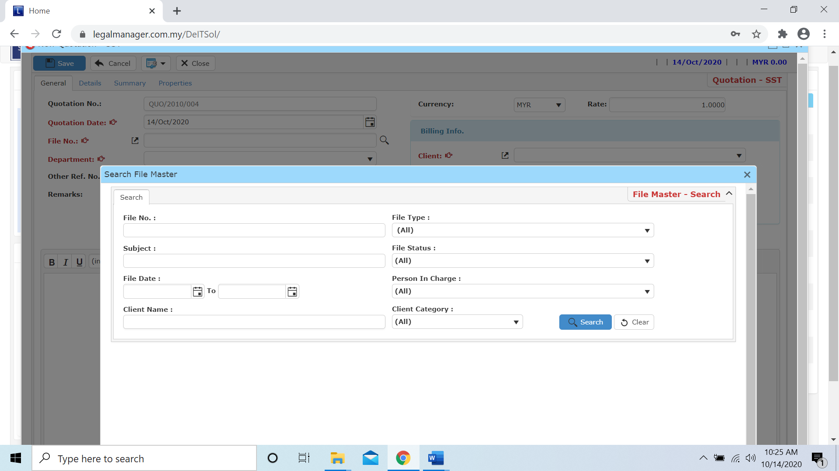

Note: If you fill the file information more completely, after you choose the file field like Client, Department and Quotation Date will be auto filled.

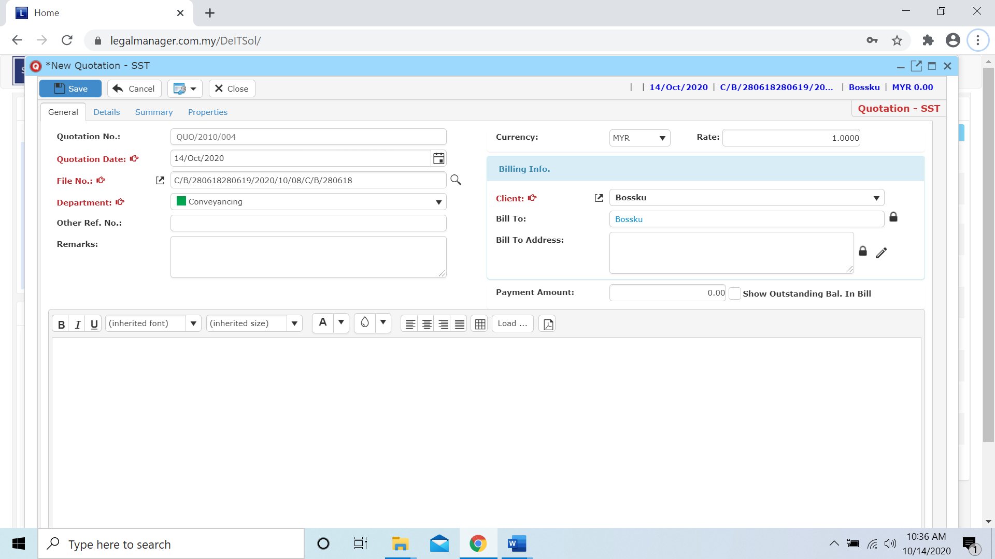

## **Create Bill Items / Bill Template:**

* Go to **Details** tab

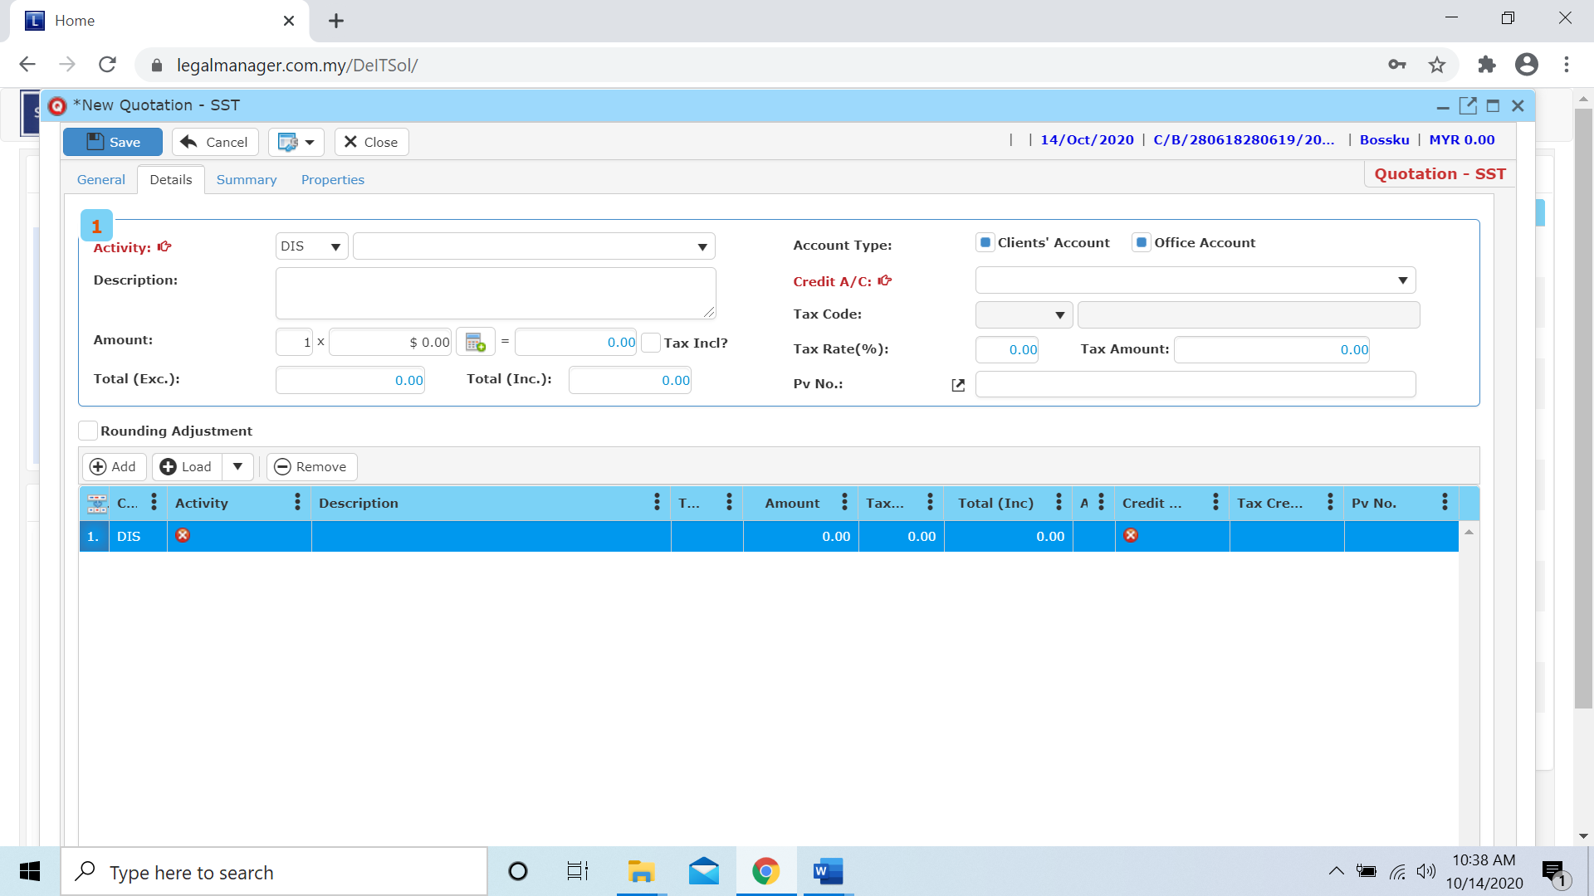

Go to Details tab to add bill items.

To add bill items manually from Activity Code.

To select Bill template or load PV or Time Cost

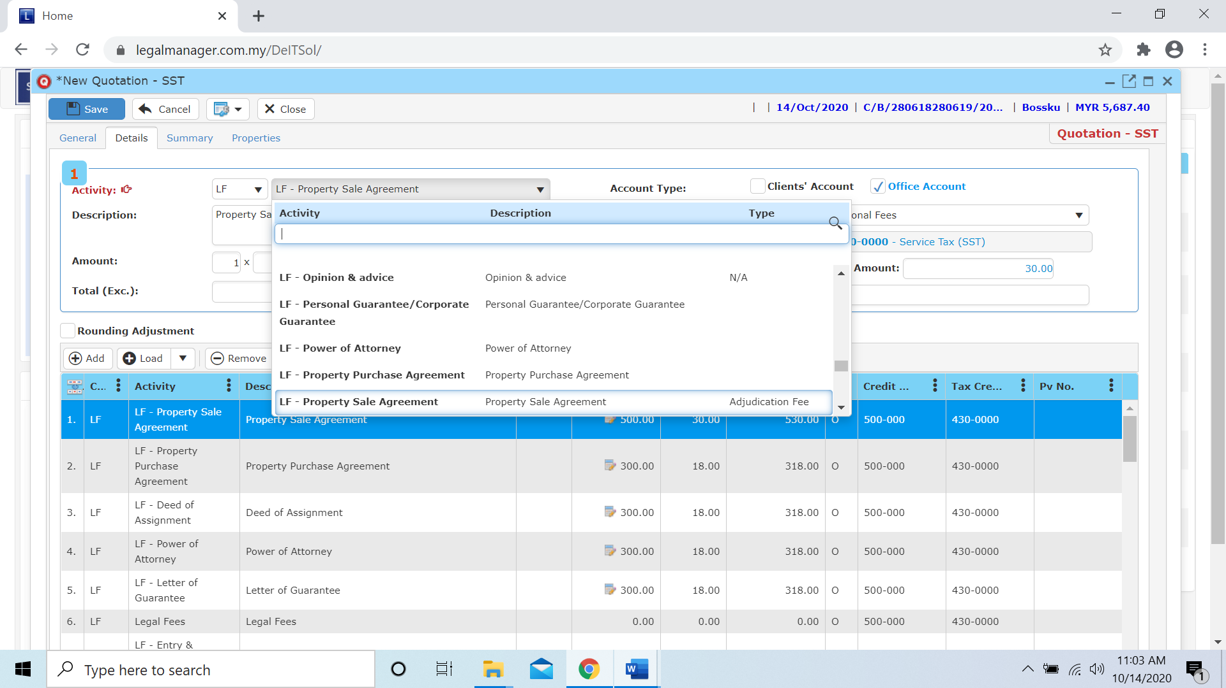

Figure: New Quotation – Details, Activity Code

* You can edit the amount or type in a new amount by select the activity
* Moreover, you can choose the calculation by choosing a calculator
* You can ‘**Tick**’ to select account type either client or office account

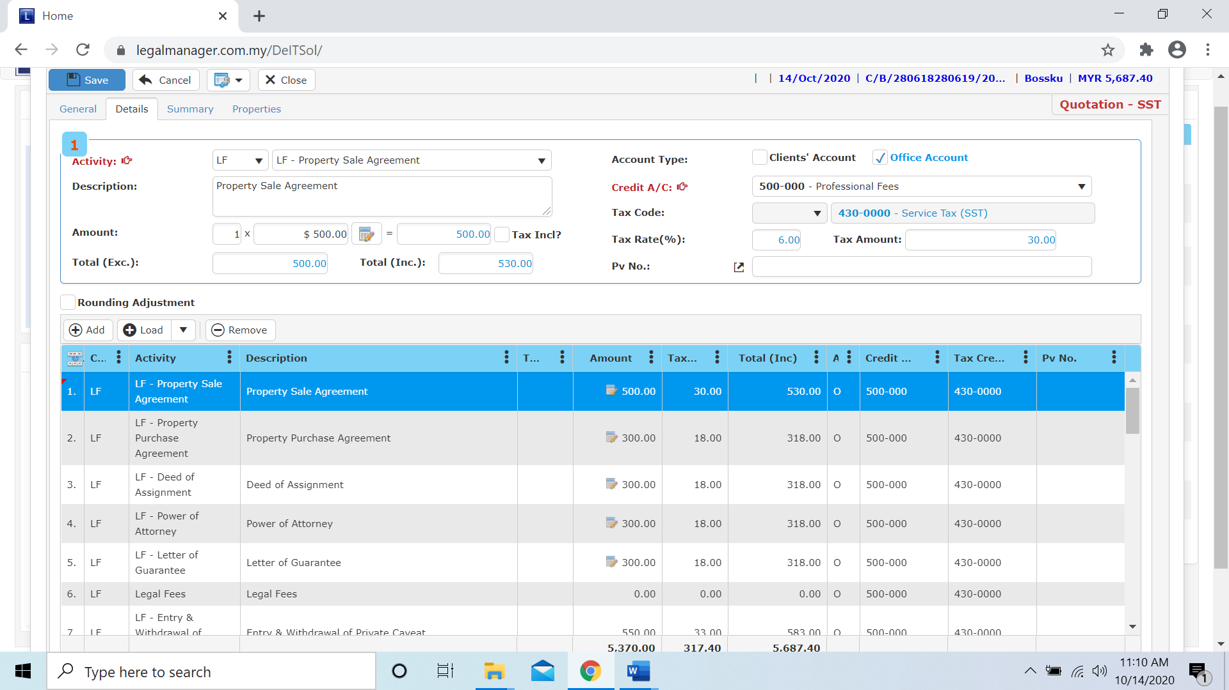

Select a calculation by choosing a calculator

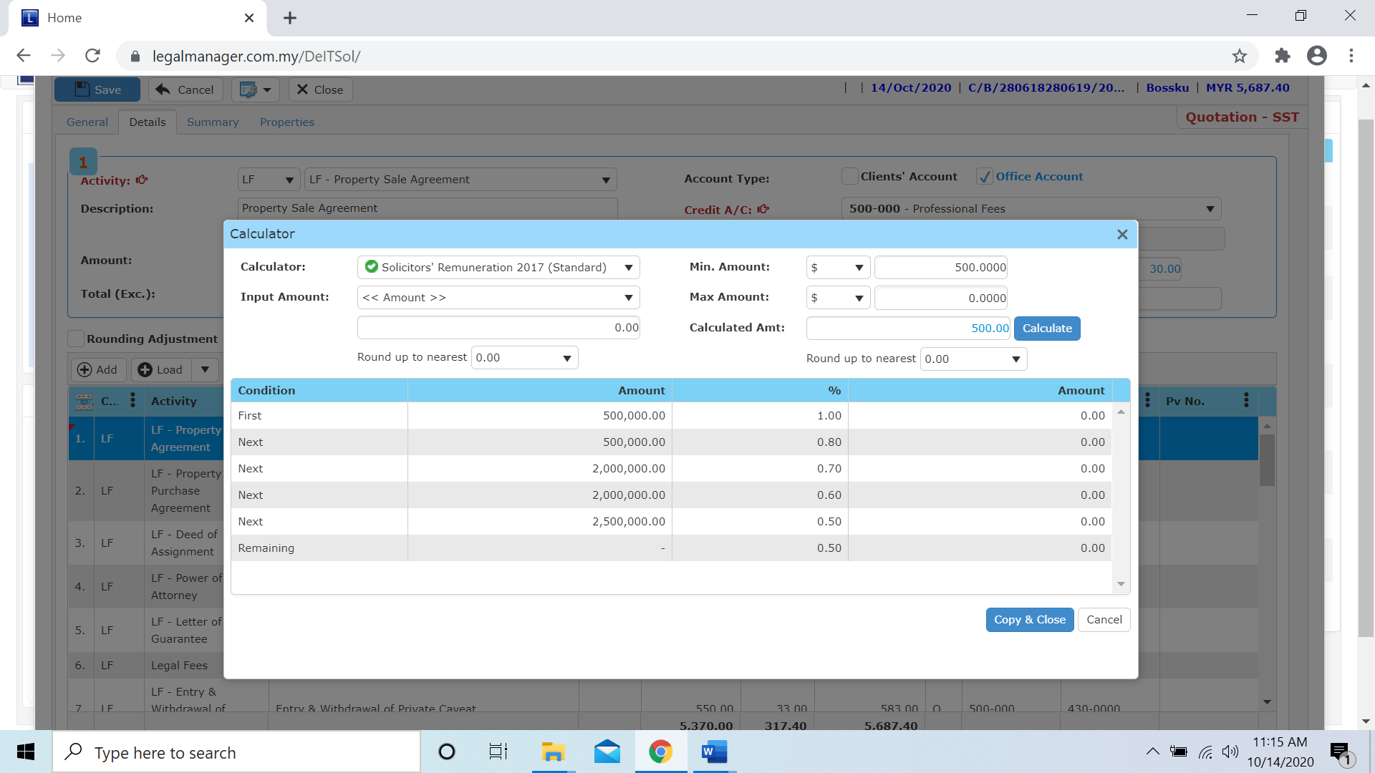

Figure: Calculator

**Create Quotation with adding items manually**

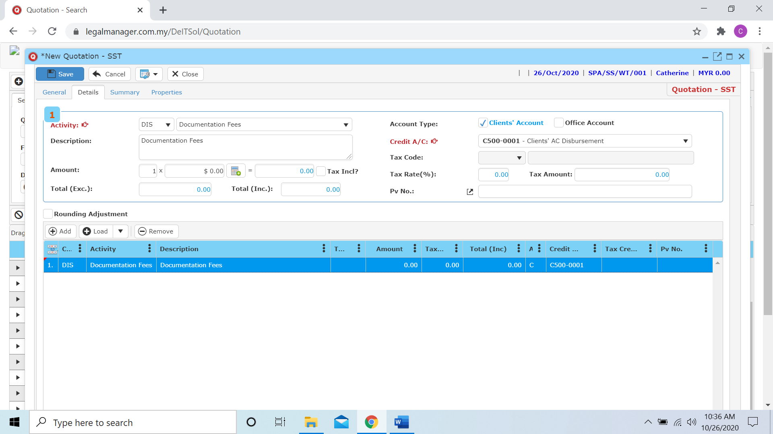

* When you click add, it will add in a row allow you to select activity and key in amount

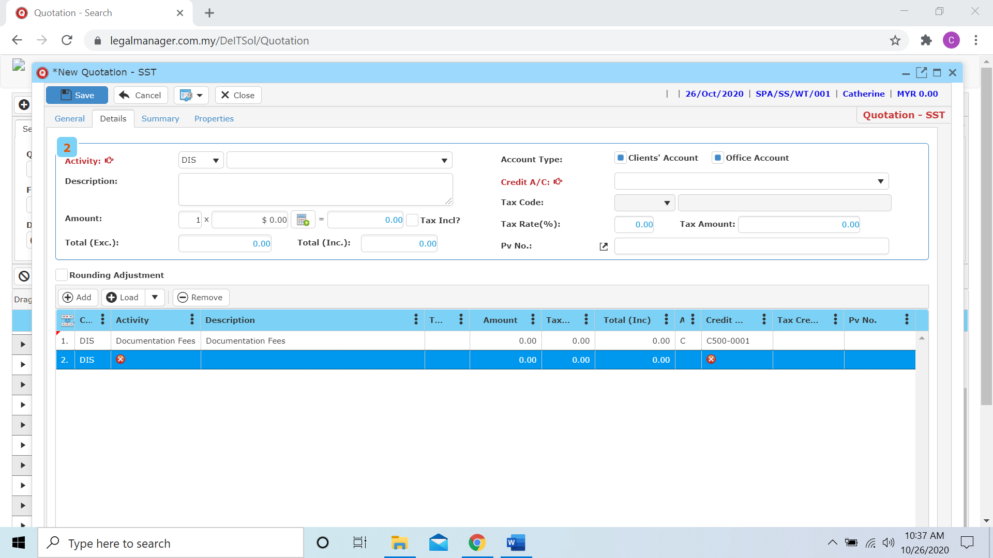

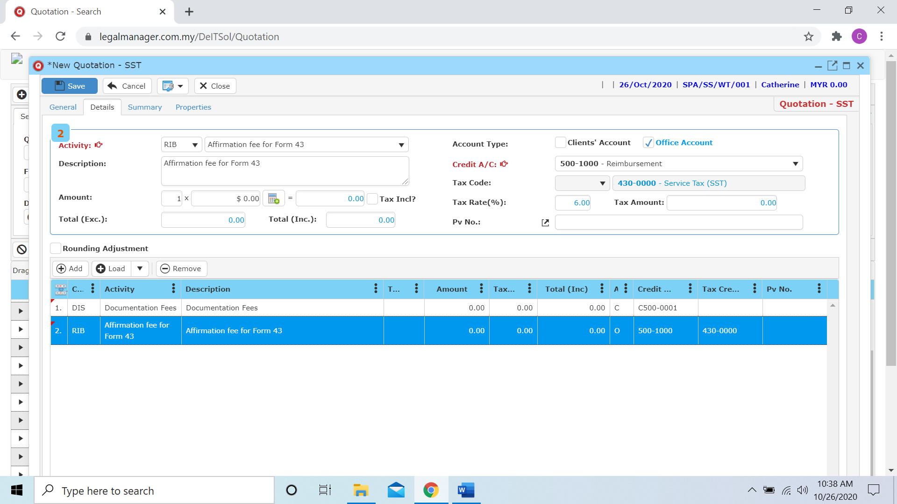

**Create Quotation with Load Bill Template**

To load a bill template, you can click to load  and you can select bill template it will shown template sample as figure below

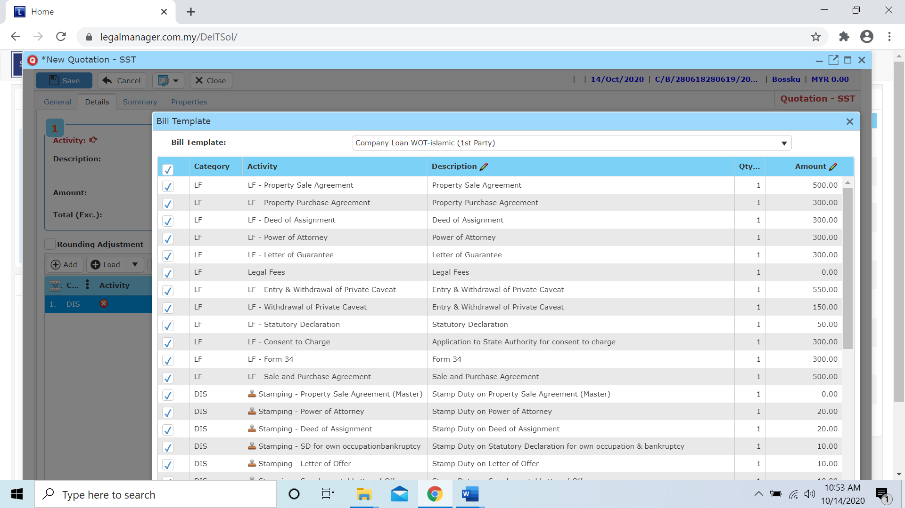

Figure: New Quotation – Details, Load Bill Template

**Create Quotation with Load Time Cost**

* To load a time cost, you can click to load  and you can select time cost of the file you selected in general

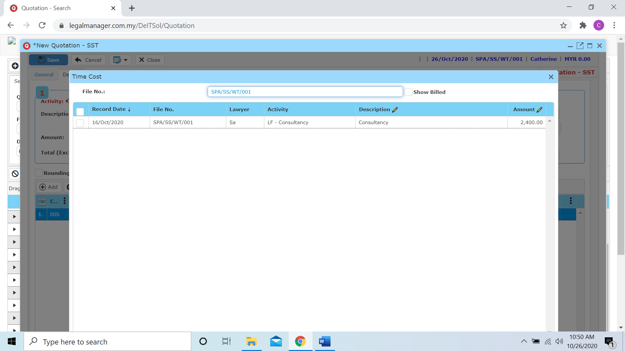

* After you select the record, it will categories and add in to the table directly

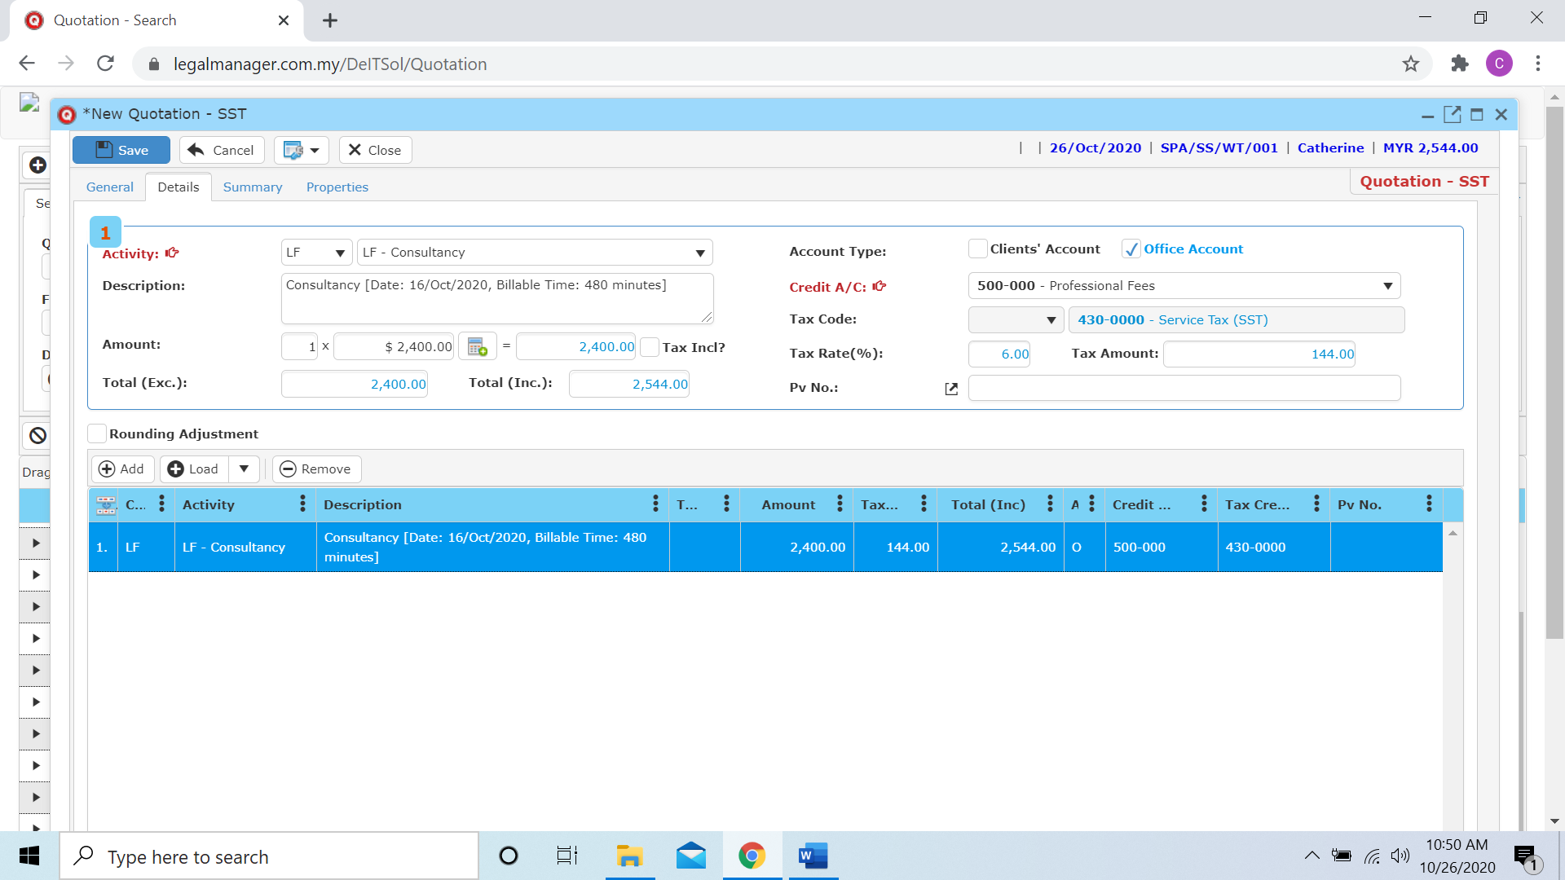

**Create Quotation with Load Payment Voucher**

* To load a payment voucher, you can click to load  and you can select payment voucher of the file you selected in general

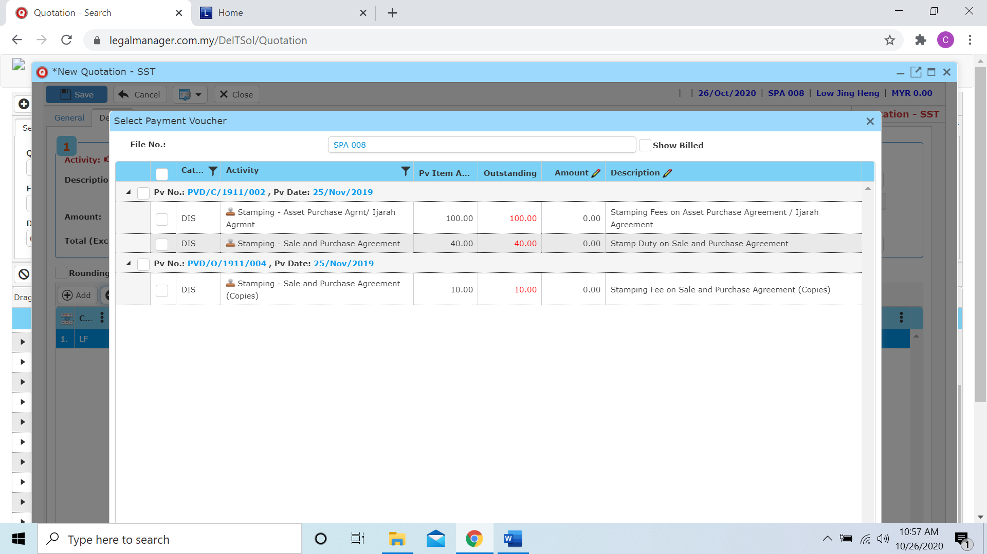

* As well as you load the time cost, when you select the record it will shown in the table list

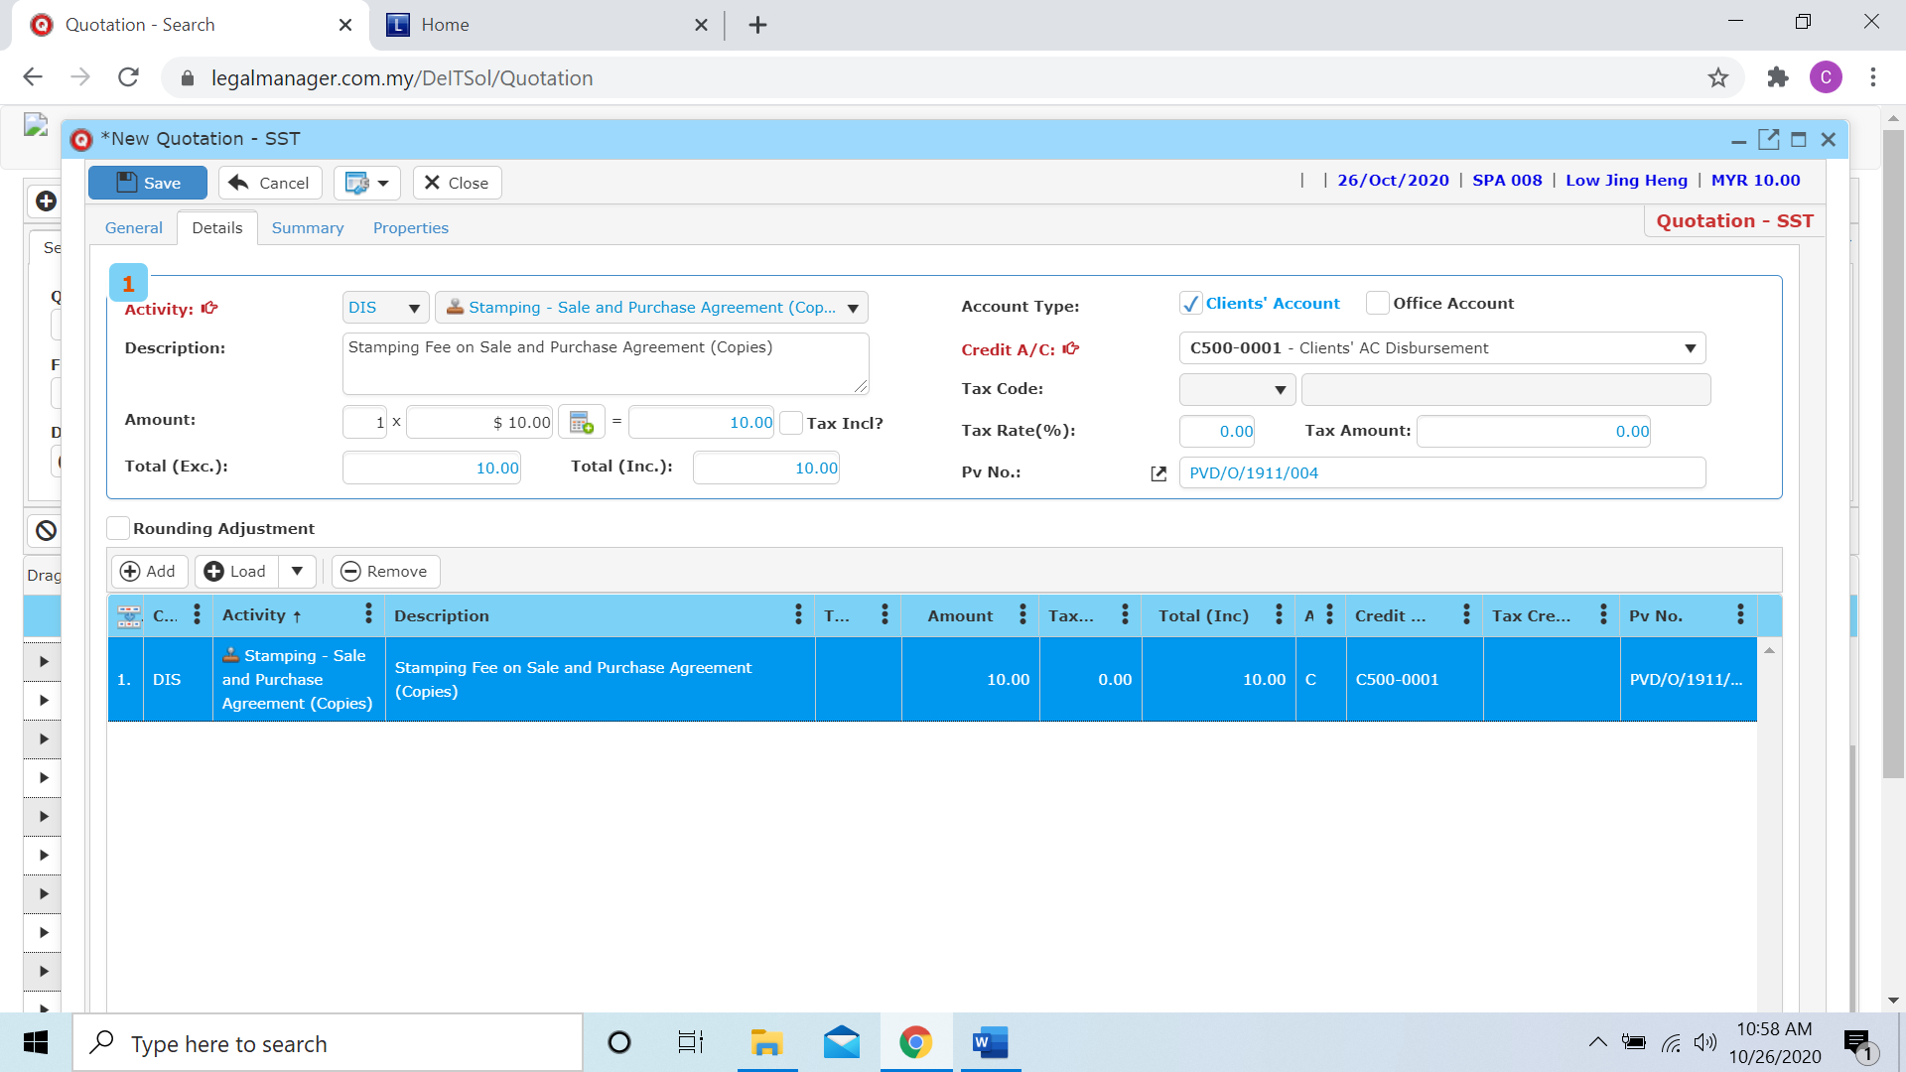

**Arrangement**

* You can drag to re-order bill item sequence for print out.

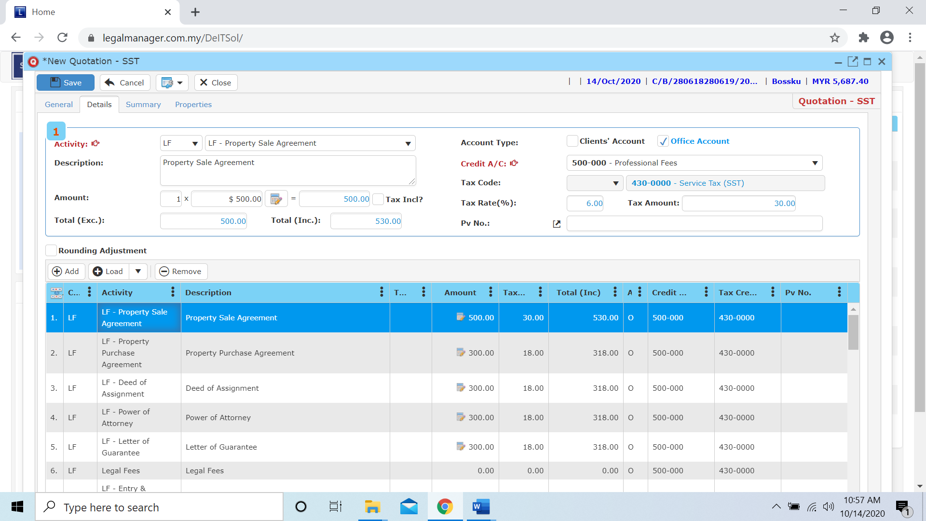

Figure: New Quotation – Drag to make arrangement to print out

* **Create your own items:** Click on **‘Activity Code’** browser button and choose any item you want:
* Click ‘**Add**’ to add item into the record list.
* Click ‘**Remove**’ to remove the item from the record list.

## **Summary to check sum up of categories:**

* Go to ‘**Summary**’tab
* To check figures

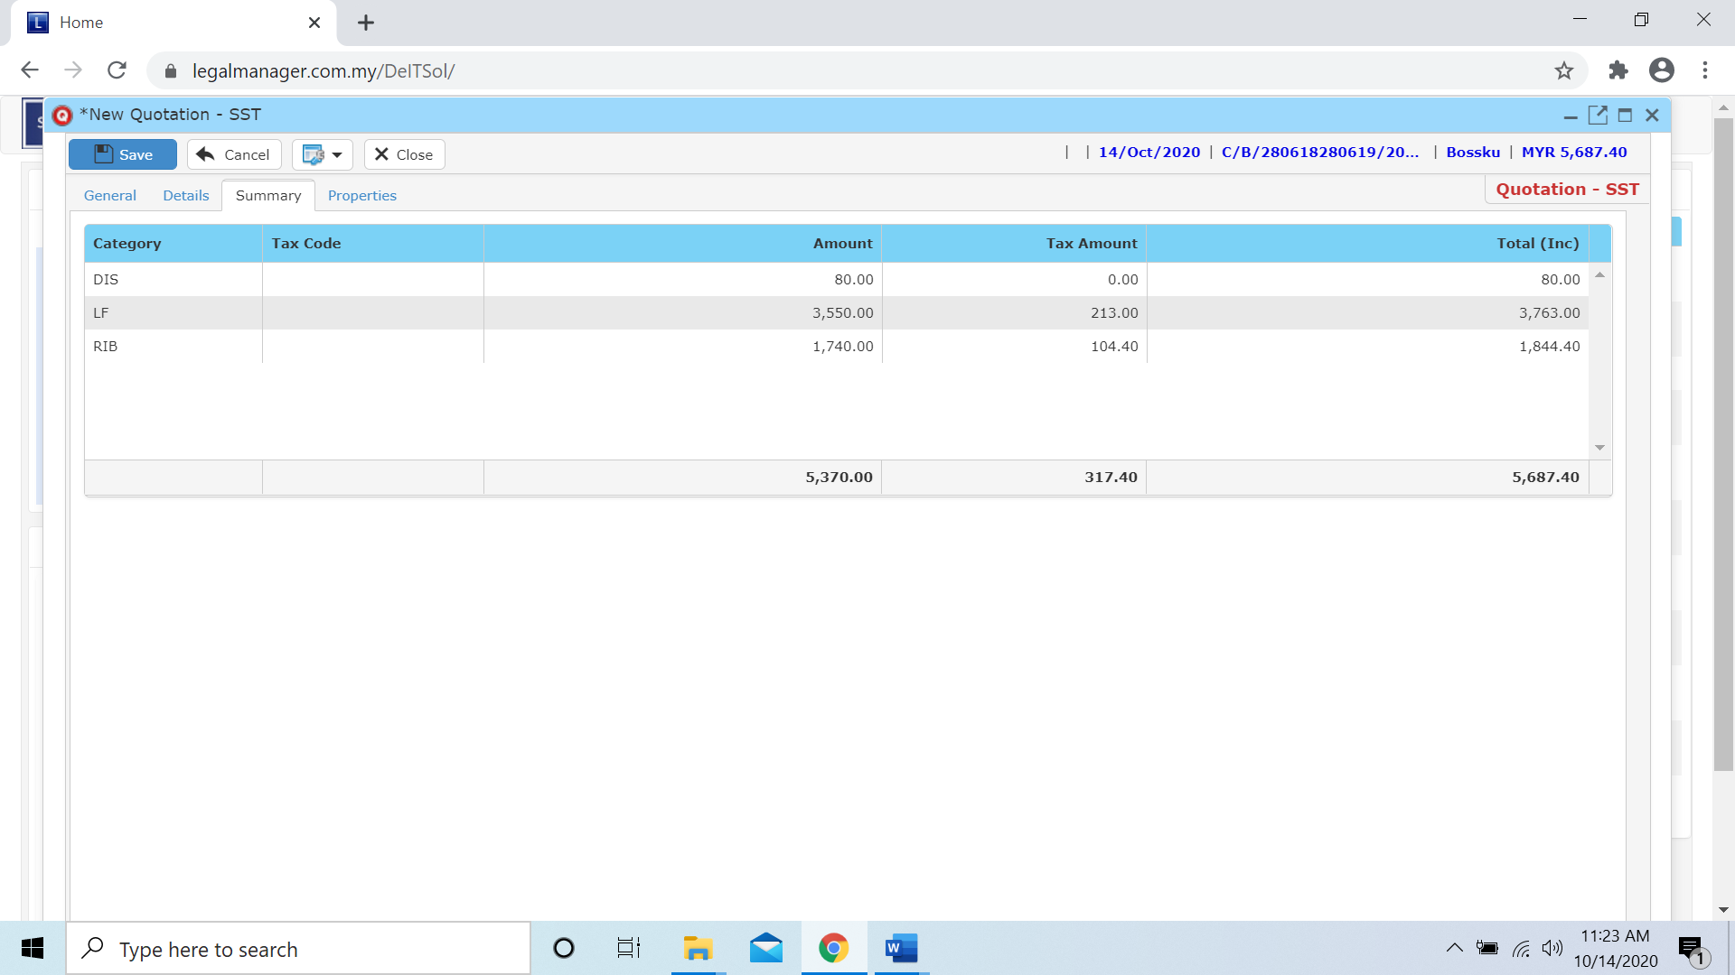

Figure: New Quotation – Summary

* Go to ‘**properties**’ you can view the information of the record once who modify the record then there will show the last modified and modified by who

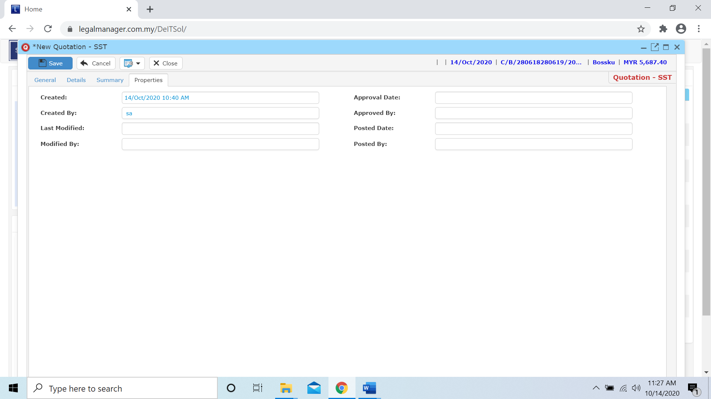

Figure: New Quotation - Properties

* Click ‘**Save**’ to save the new quotation
  1. **Manage Quotation**

This option enables you to add, edit, and delete a Quotation. It also allows you to keep track of Quotation details and all related information.

* To open Manage Quotation, on the **SmartLeg@l** navigation, click **Billing** and go to **Manage Quotation** then search the quotation you wish to modify.

**Manage Quotation**

* Search the quotation you wish to manage through type the search criteria or search by advanced.
* To start a new search or to clear the search results, click ‘**Clear**’.

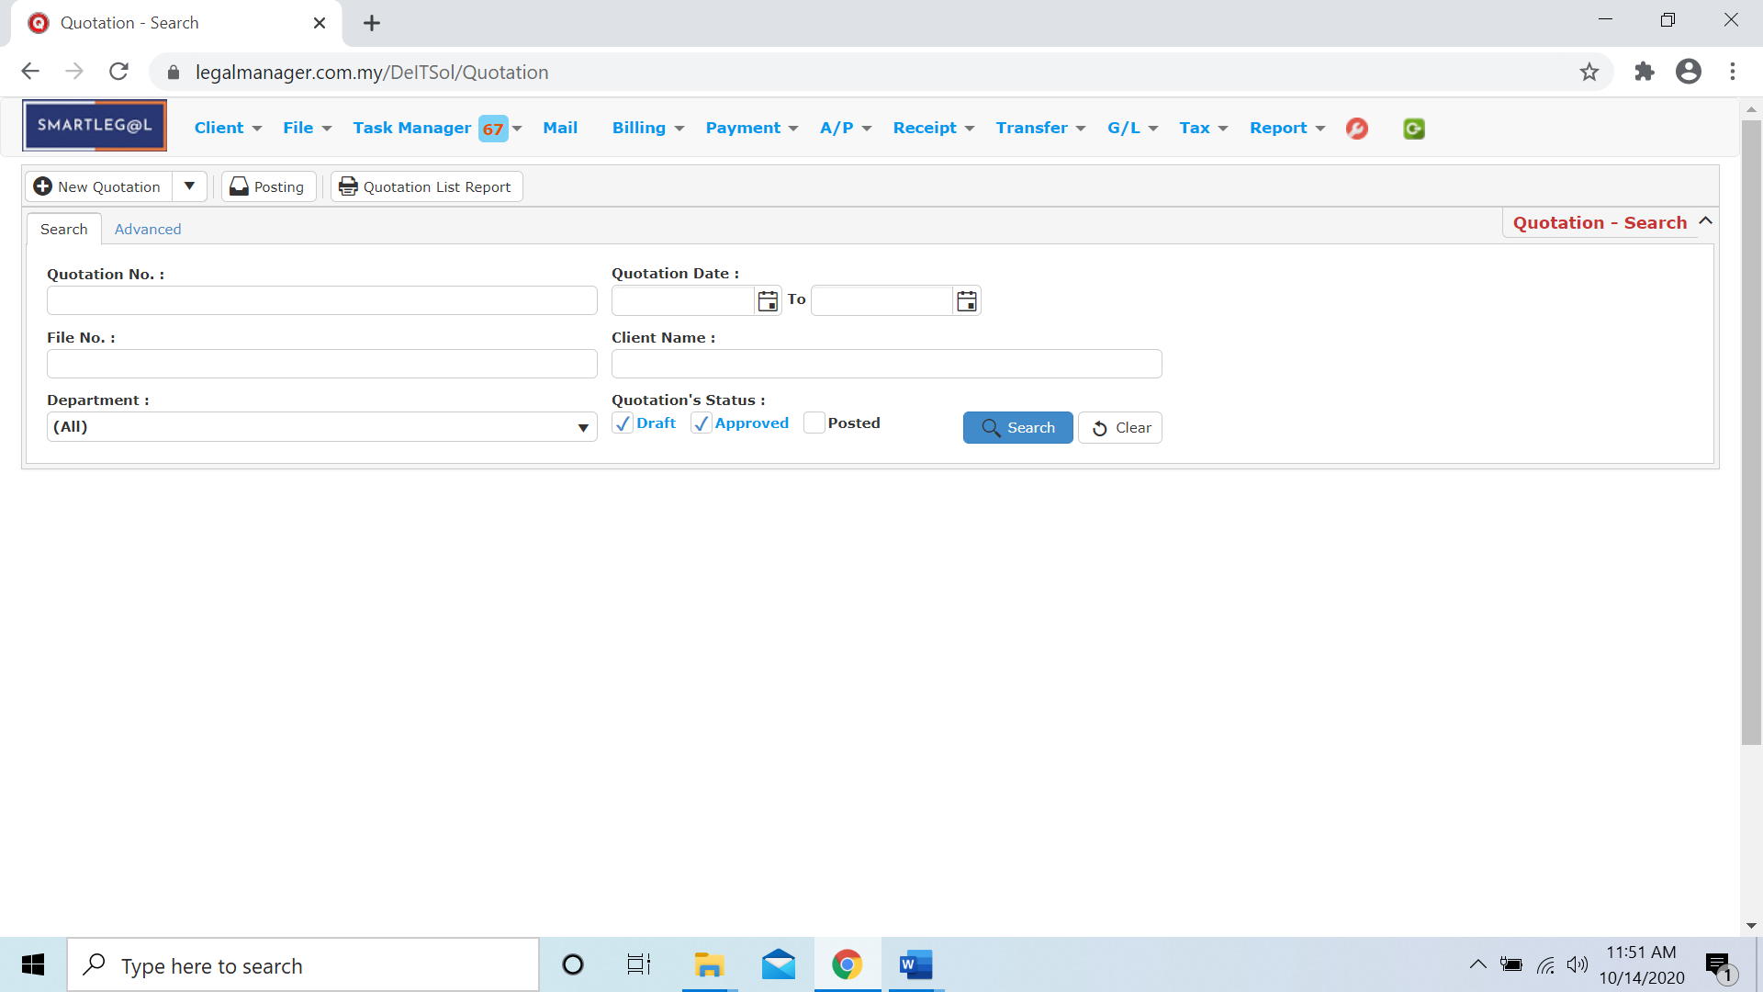

Figure: Manage Quotation - Search

**Advanced Search**

* This function can be used to find a task by searching other information that is not captured in the ‘General’ section.
* Define search criteria:

**- Field** - Choose the field you want to search.

**- Condition** - Search condition

**- Value** - Type in the detail you want to find.

* Click ‘**Add to list**’, to define more than one criteria.
* Click ‘**Find**’, search results will be displayed at search record list. You can open an item in the search results list by double-clicking.
* To start a new search or to clear the search results, click ‘**Clear**’.
* Click ‘**Export**’ to print the desired search results in txt, excel or html format.

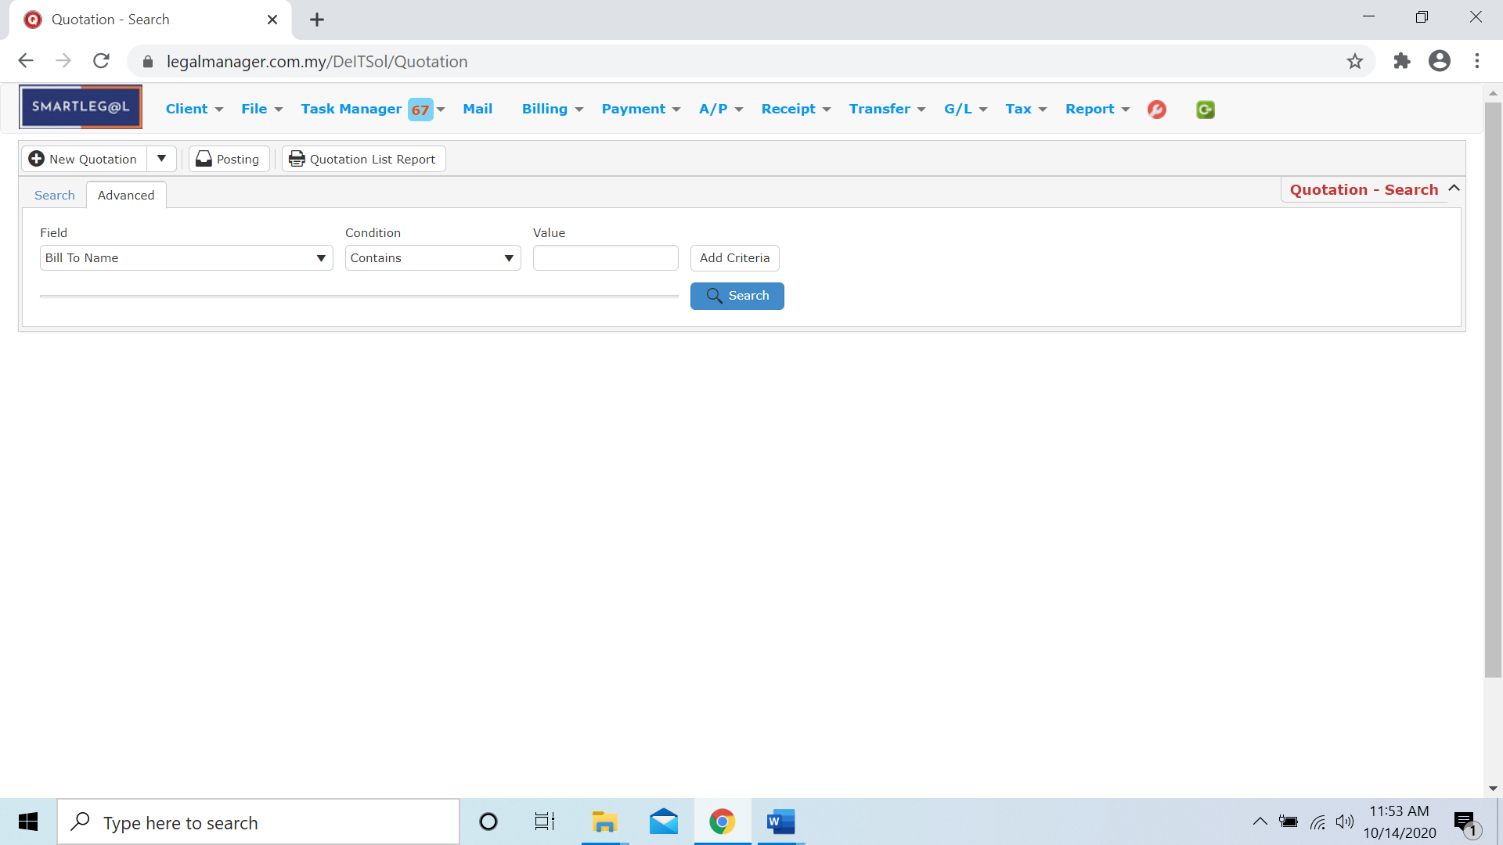

Figure: Manage Quotation – Advanced Search

**Searched Result**

* Click ‘**Search**’ once, to show all Quotations
* The Searched result will appeal at below, otherwise it will shown no record availble if the quotation you searched do not exist.
* Click ‘**Export**’ to print the desired search results in txt, excel or html format.

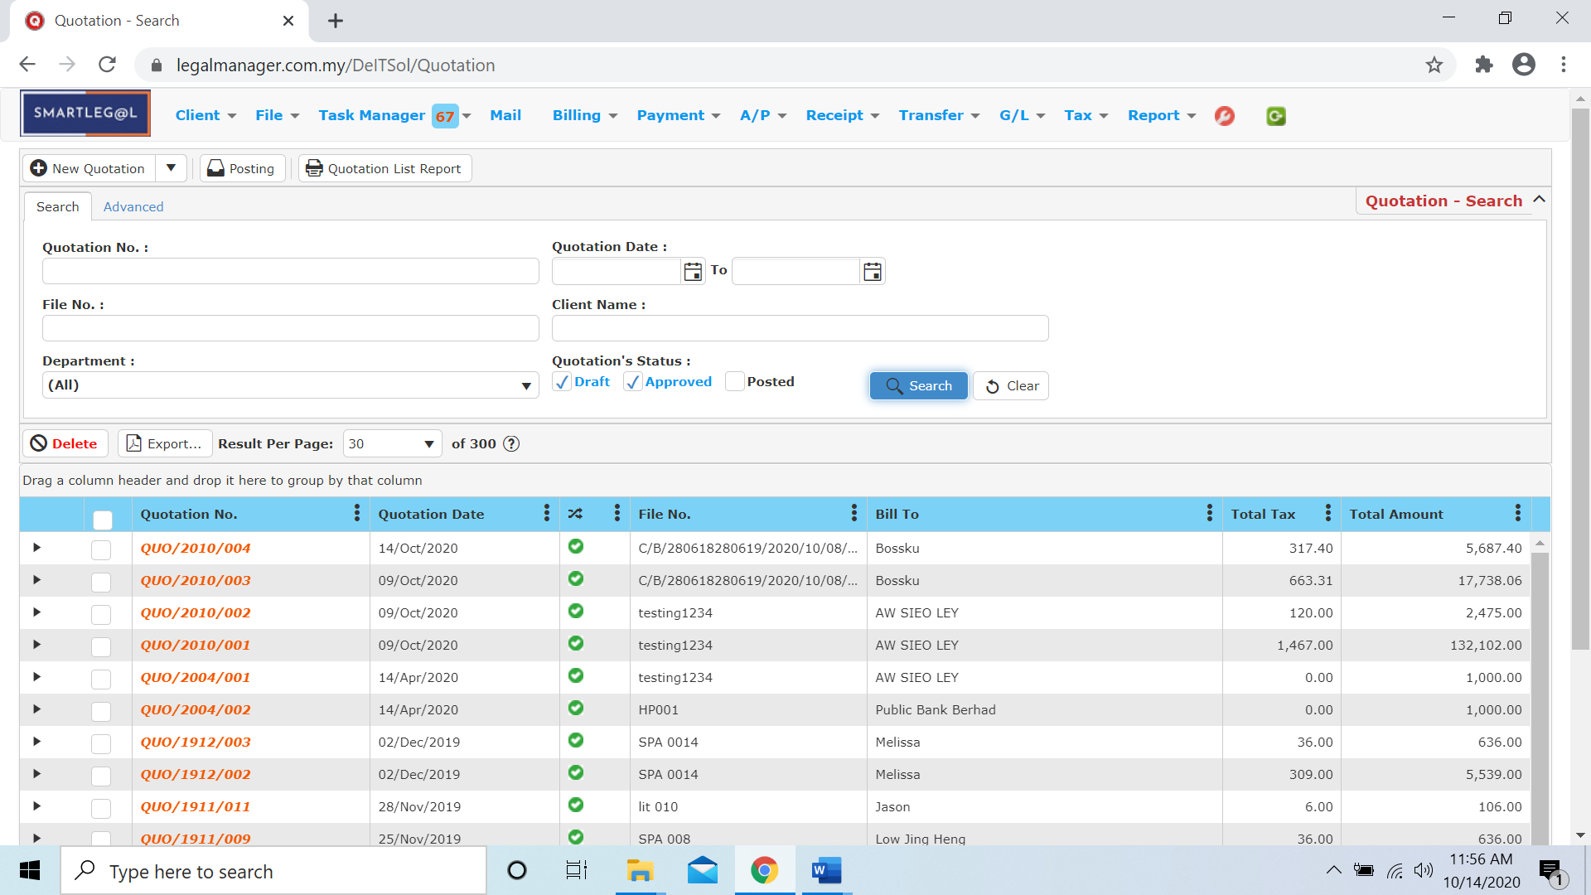

Figure: Manage Quotation – Search All Quotations

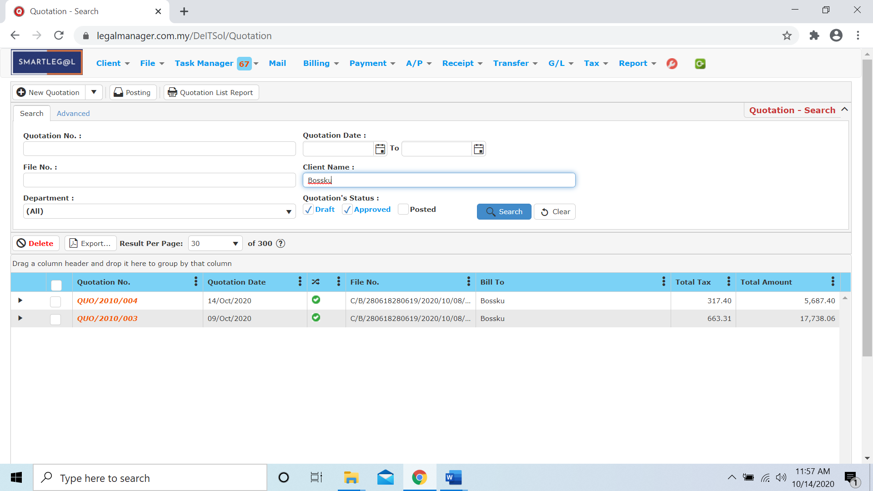

Figure: Manage Quotation – Searched Result

* After the quotation you searched appeal, you can choose to view, edit and preview those details by double-clicking the record.

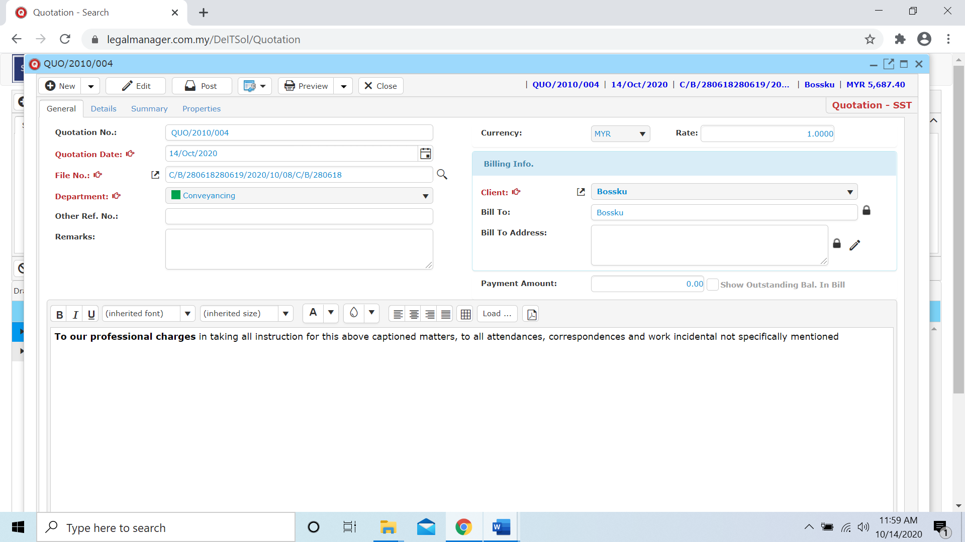

Figure: Manage Quotation – Searched Result, Quotation Info

* 1. **Quotation Posting**

This option enables you to transform quotation to bill. System will show all un-post quotation by default.

* To open Quotation Posting, on the **SmartLeg@l** navigation, click **Billing** and go to **Quotation Posting** then search the quotation you wish to post.

**Quotation Posting**

* Search the quotation you wish to post through type the search criteria.
* To start a new search or to clear the search results, click ‘**Clear**’.

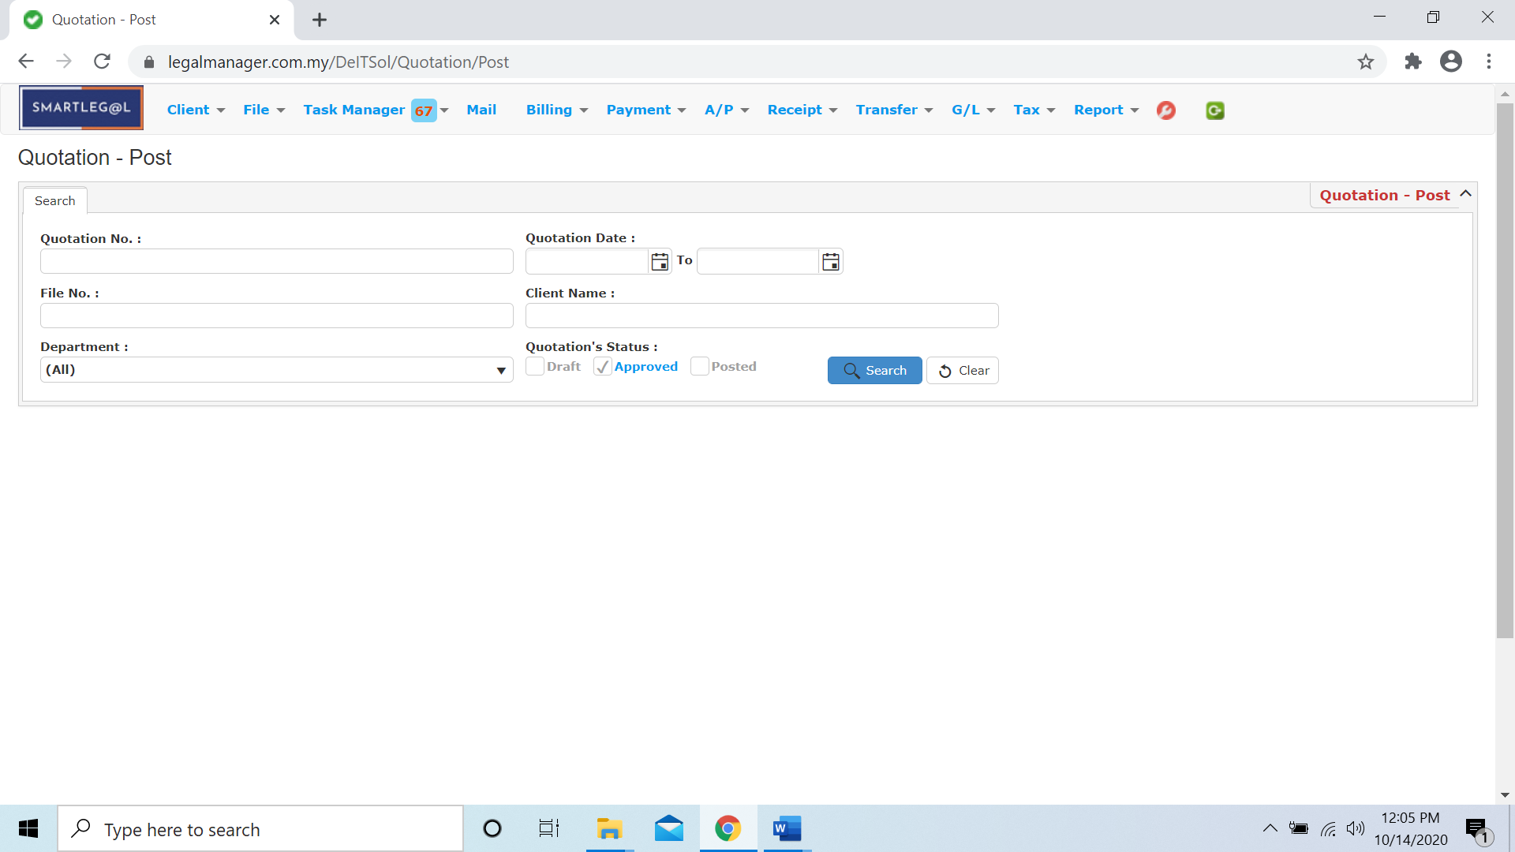

Figure: Quotation Posting – Search

**Searched Result**

* Click ‘**Search**’ once, to show all Quotations
* The Searched result will appeal at below, otherwise it will shown no record availble if the client you searched do not exist.
* Click ‘**Post**’ to post the selected quotation.
* Click ‘**Export**’ to print the desired search results in txt, excel or html format.

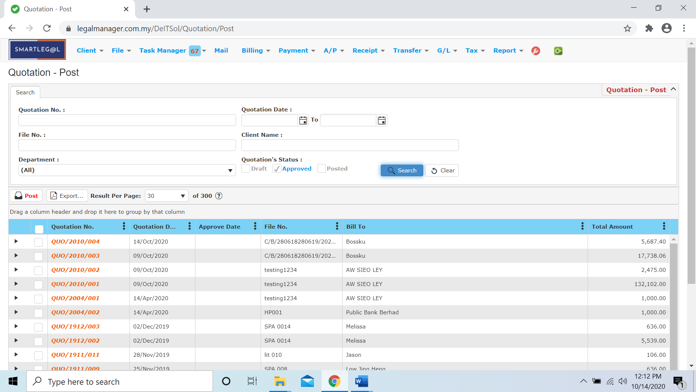

Figure: Quotation Posting – Search All Quotations

* After the quotation you searched appeal, you can choose to edit, post or preview the quotation.

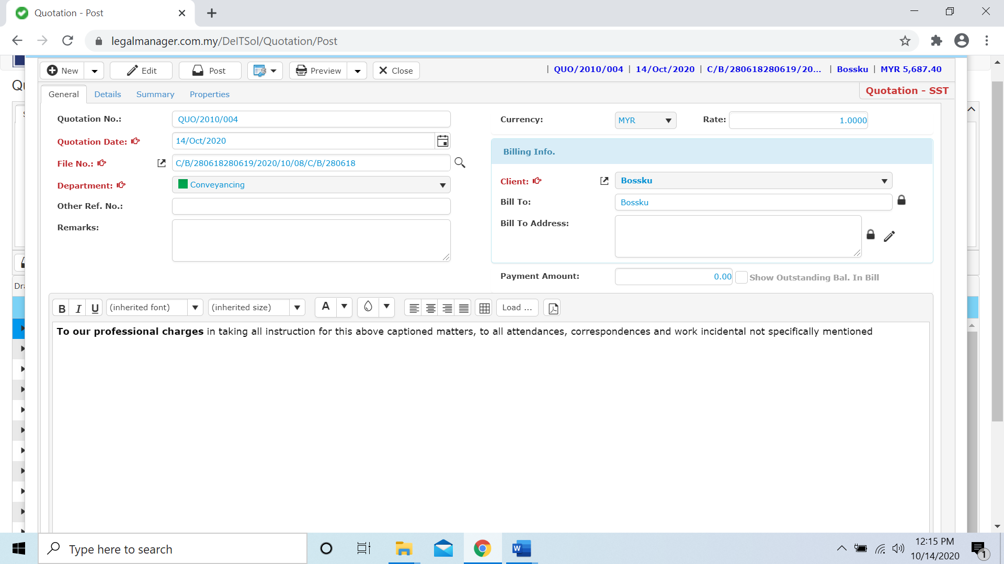

Figure: Quotation Posting – Search Result, Quotation Info

* 1. **Manage Bill**
* To open Manage Bill, on the **SmartLeg@l** navigation, click **Billing** and go to **Manage Bill** then search the bill you wish to manage.

**Manage Bill**

* Search the bill you wish to manage through type the search criteria.
* To start a new search or to clear the search results, click ‘**Clear**’.

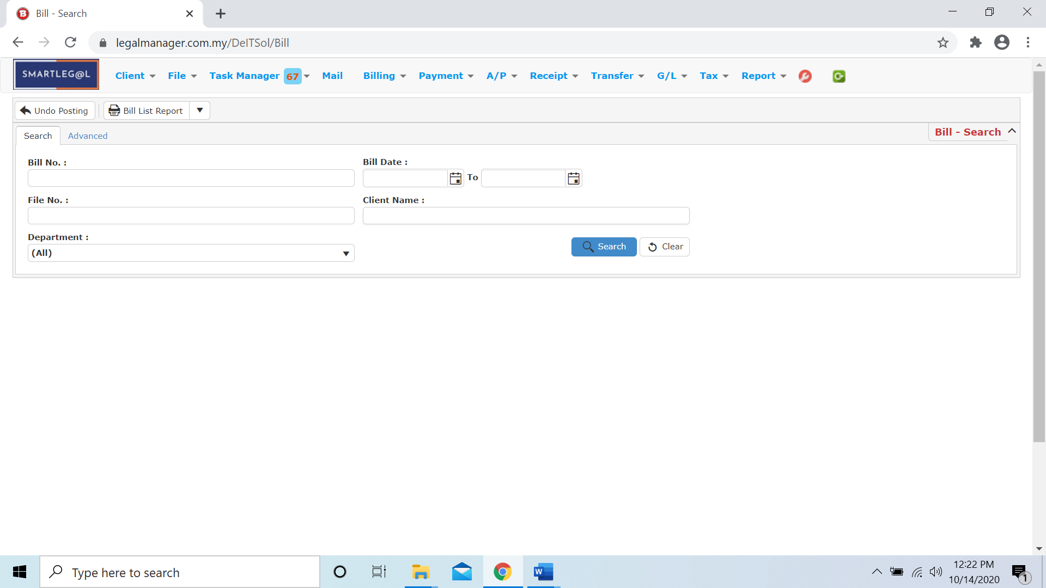

Figure: Manage Bill – Search

**Searched Result**

* Click ‘**Search**’ once, to show all bills
* The Searched result will appeal at below, otherwise it will shown no record availble if the client you searched do not exist.
* Click ‘**Delete**’ to delete the selected record.
* Click ‘**Export**’ to print the desired search results in txt, excel or html format.

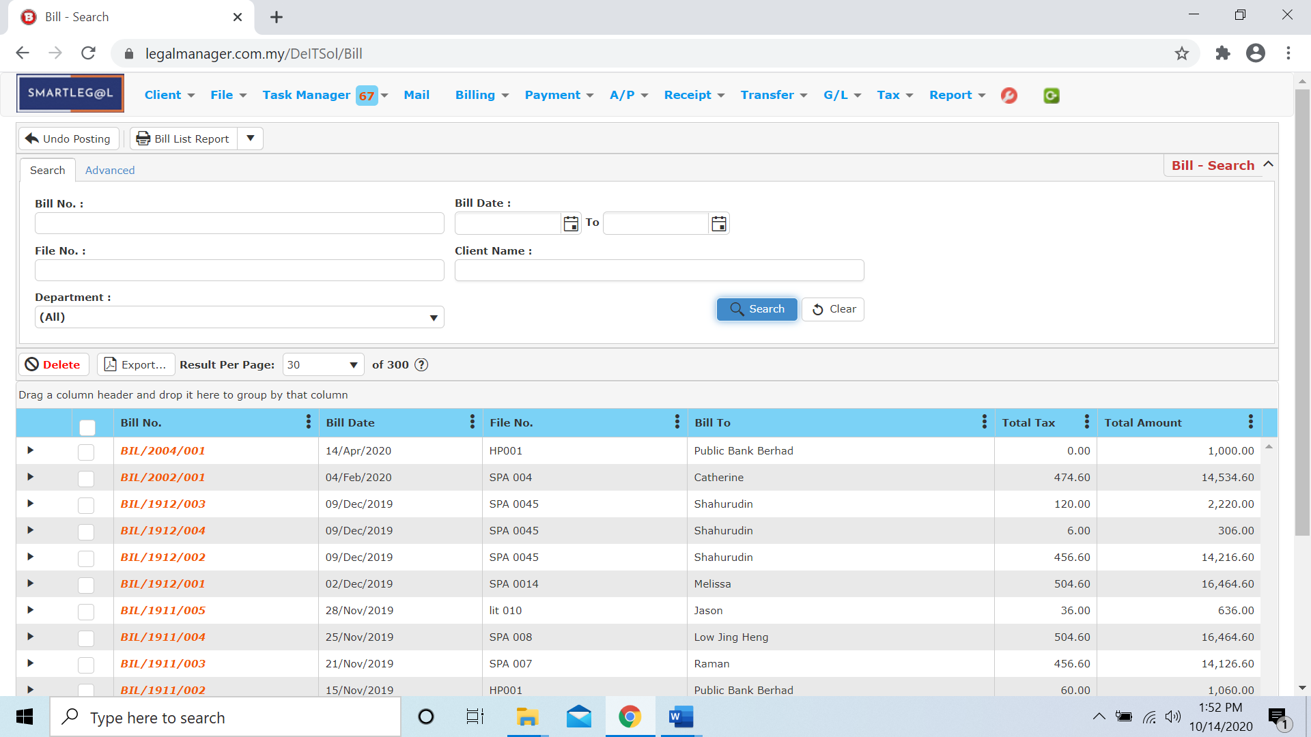

Figure: Manage Bill – Search All Bills

* After the bill you searched appeal, you can choose to edit or preview the bill by double clicking the record.

**General**

* you can modify bill general information.
* Once you have completed, click ‘**Save**’ to save bill information.

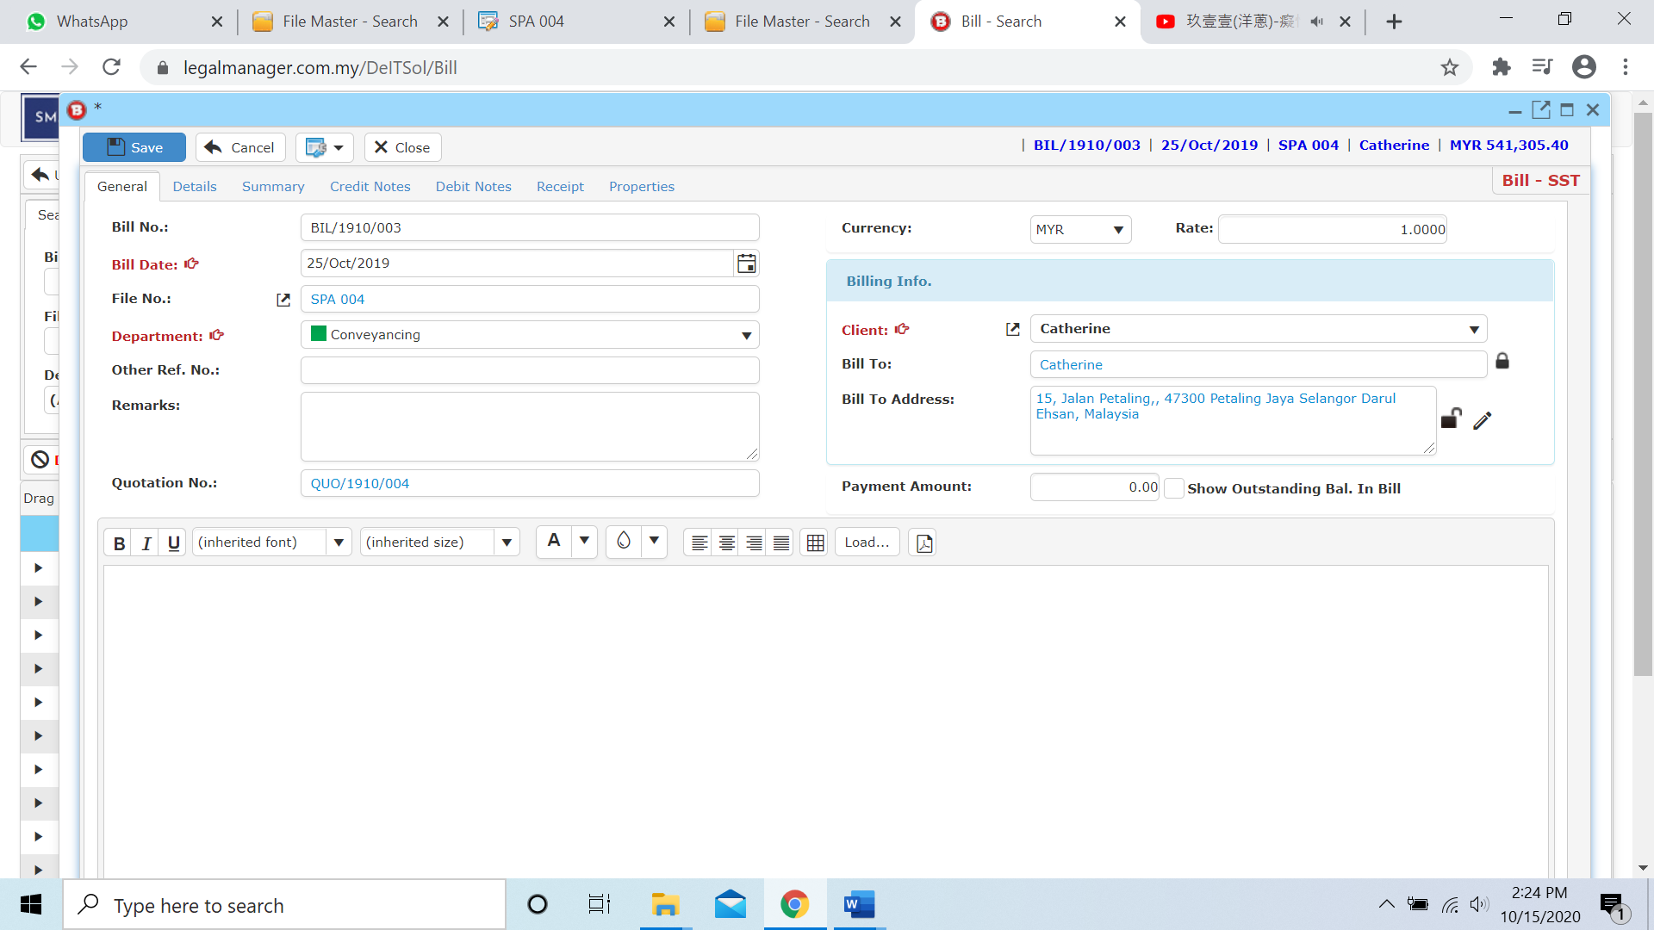

**Details**

* Go to next tab, **‘Details’**

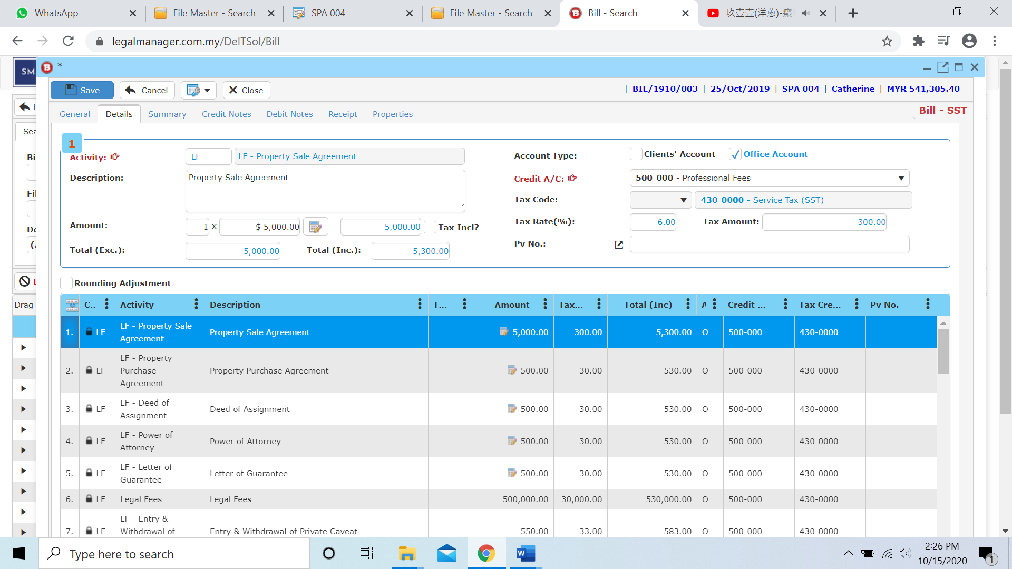

* Here you can view the contents of the bill with its figures.
* To edit the **Bill Account Code**, you just need to select which bill item you want to edit and **double click** on it and you can change the amount then click ‘**Save**’ once finished



**Summary**

* Go to next tab, **‘Summary’**
* Here you can view the figures of the bill with its amount. You cannot change any details at this stage.

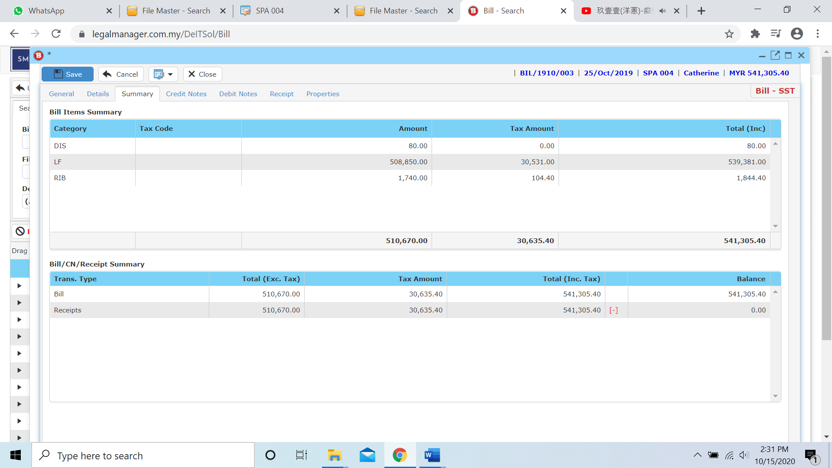

**Credit Note**

* Go to next tab, **‘Credit Note’**
* You can create credit note by clicking the **‘New’** button. Then choose type of account (Clients’ Account or Office Account).

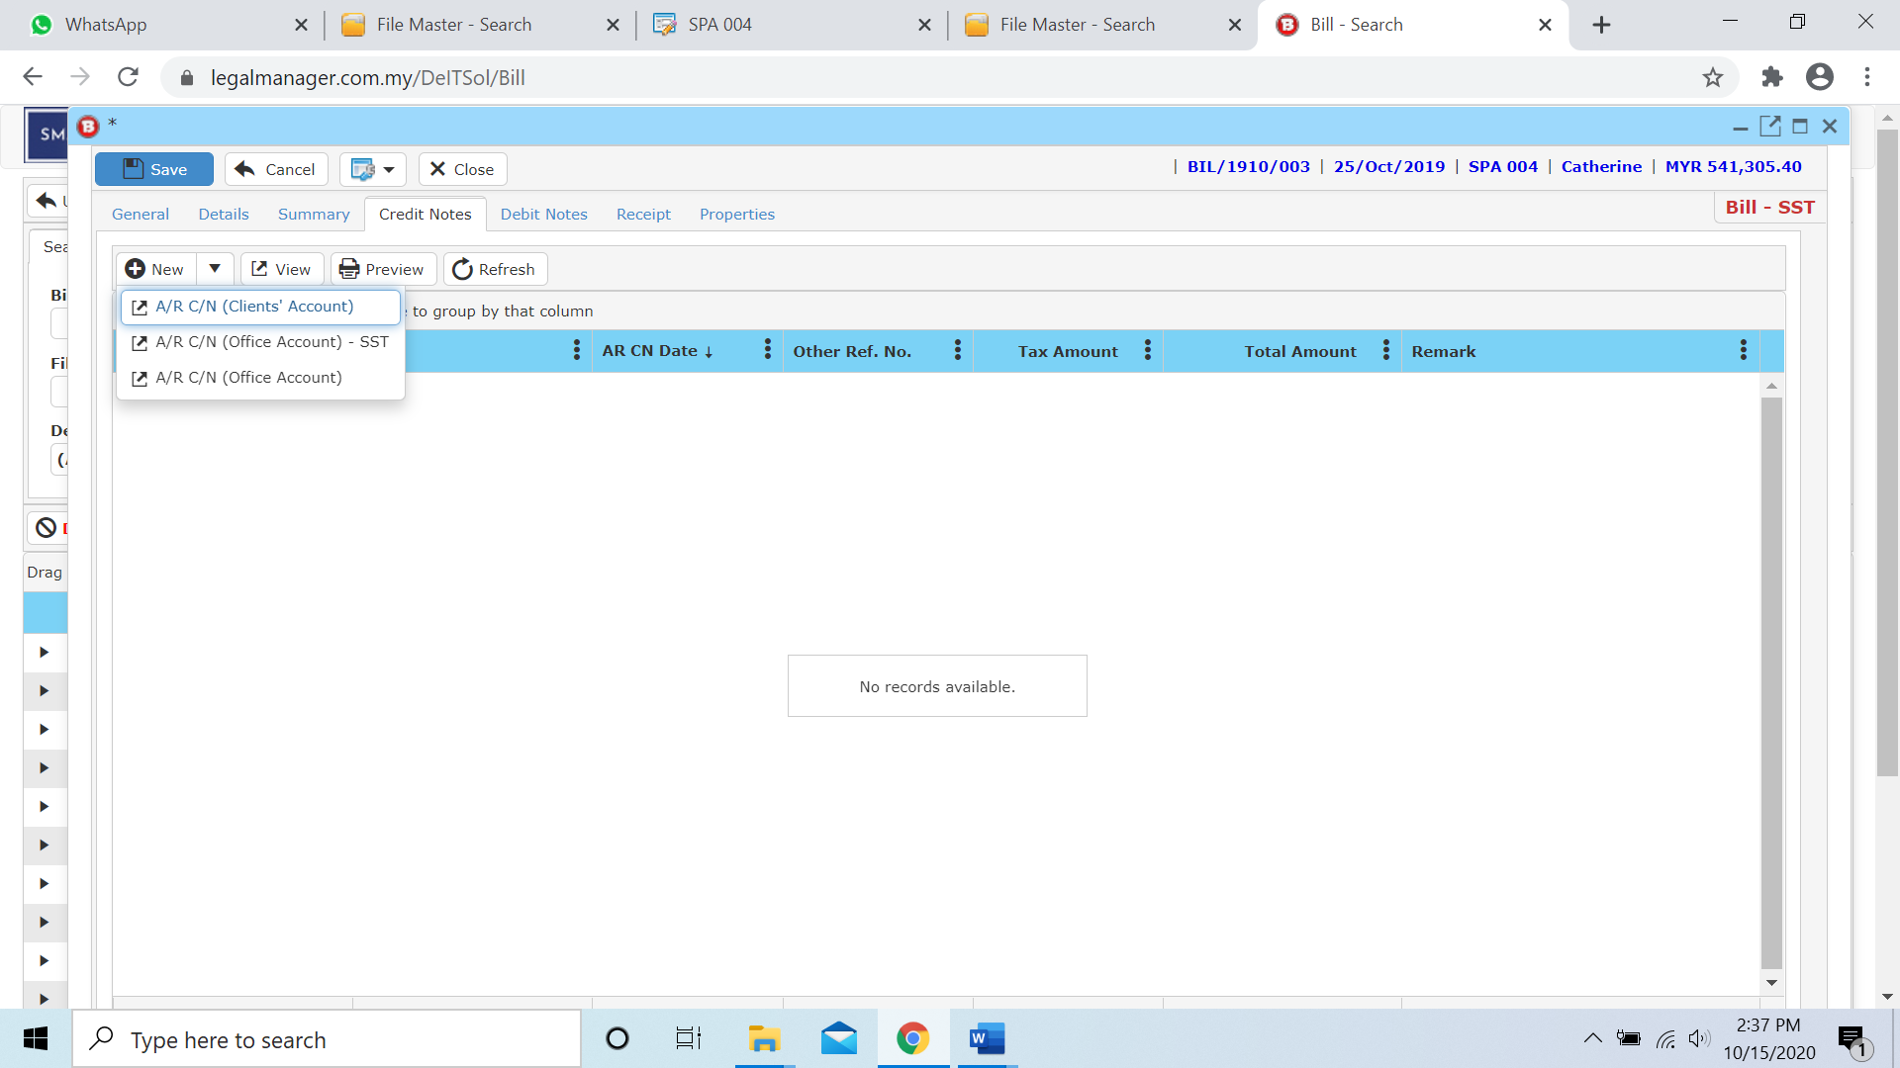

**Debit Note**

* Go to next tab, **‘Debit Note’**
* You can create debit note by clicking the **‘New’** button. Then choose type of account (Clients’ Account or Office Account).

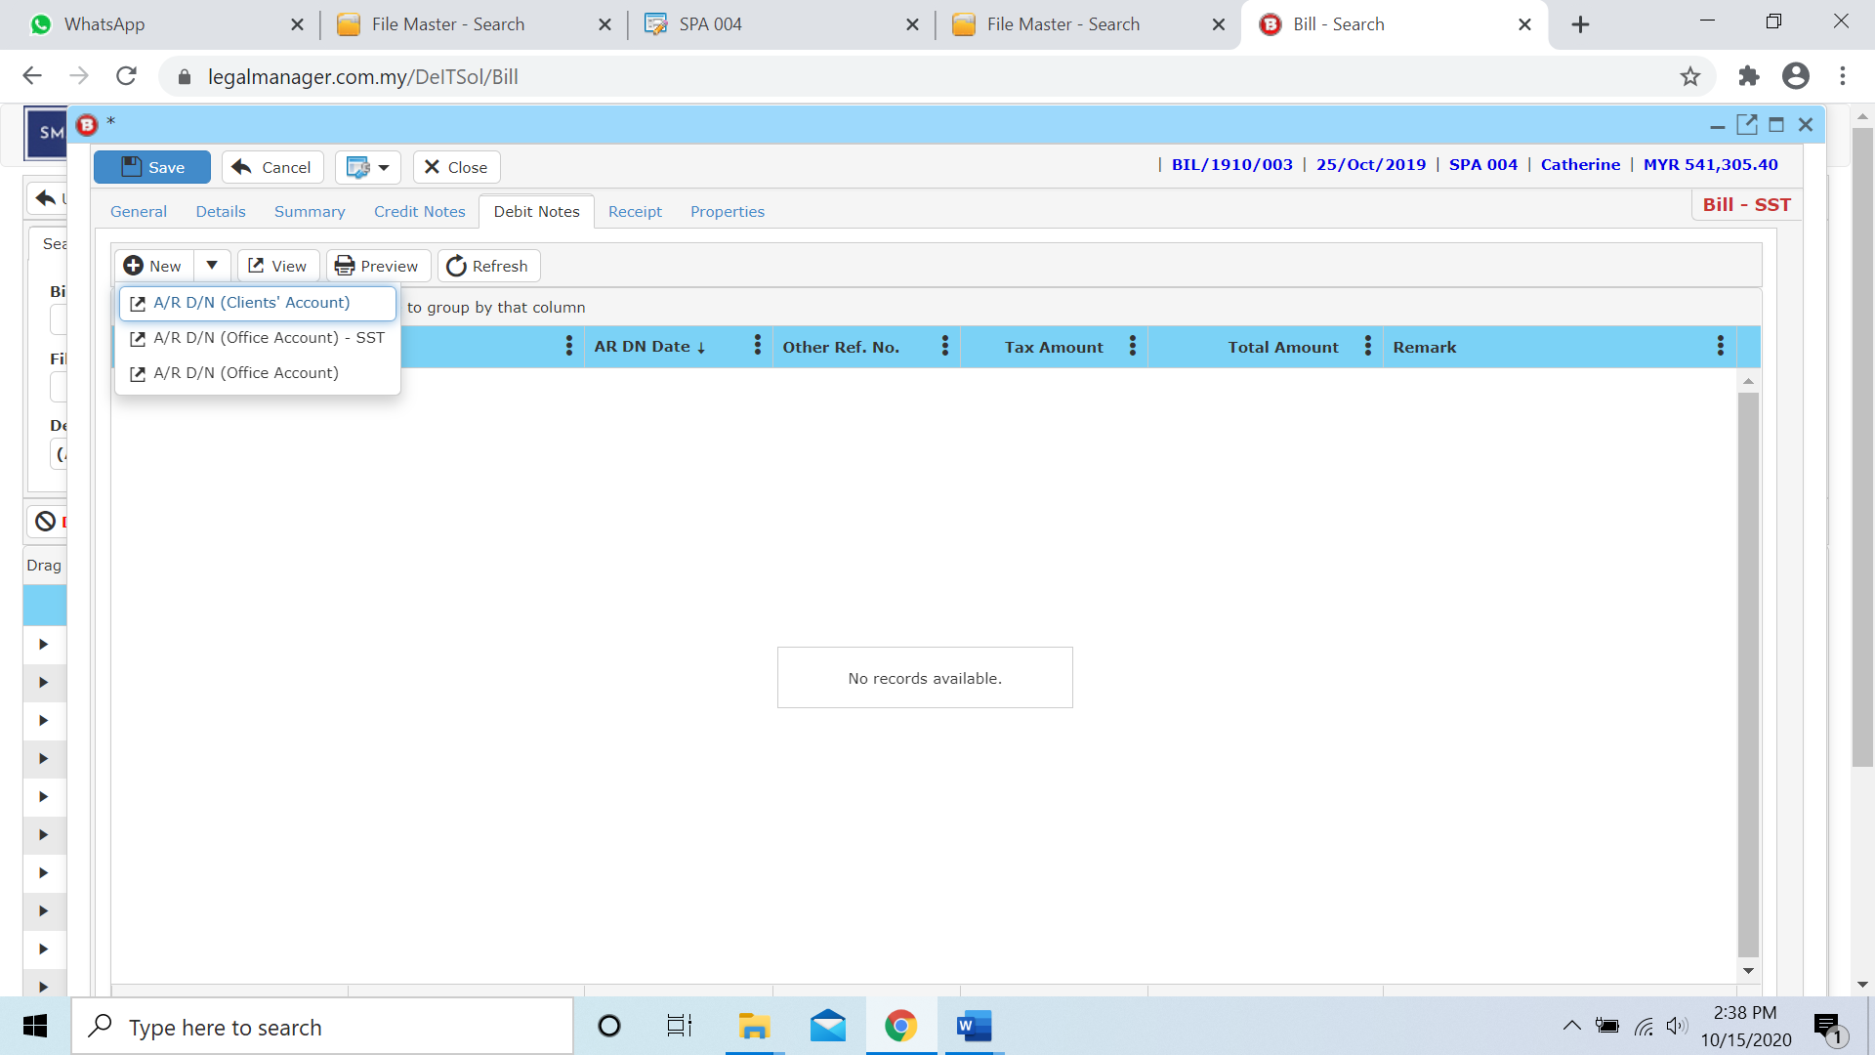

**Receipt**

* Go to next tab, **‘Receipt’**
* You can create debit note by clicking the **‘New’** button. Then choose A/R Receipt or Contra Bill for type of account (Clients’ Account or Office Account).

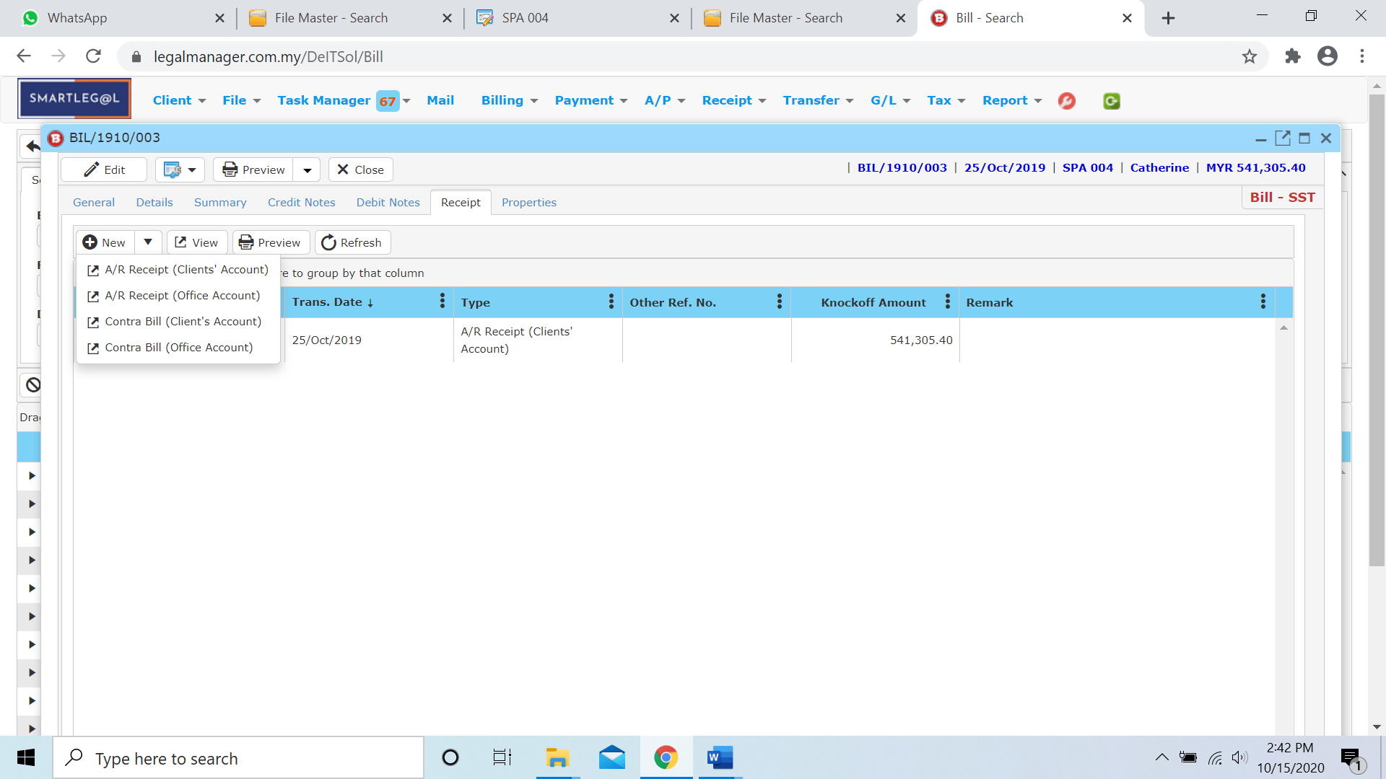

* You can also see other information like, posting details, tax summary and related trans

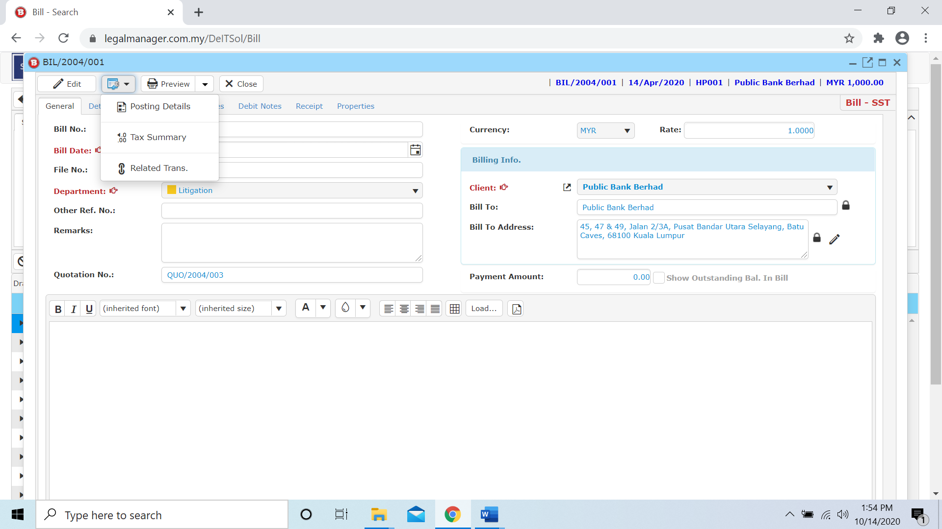

* 1. **Bill Undo Posting**
* To open Bill Undo Posting, on the **SmartLeg@l** navigation, click **Billing** and go to **Bill Undo Posting** then search the bill you wish to undo posting.

**Bill Undo Posting**

* Search the bill to undo posting you wish to manage through type the search criteria.
* To start a new search or to clear the search results, click ‘**Clear**’.

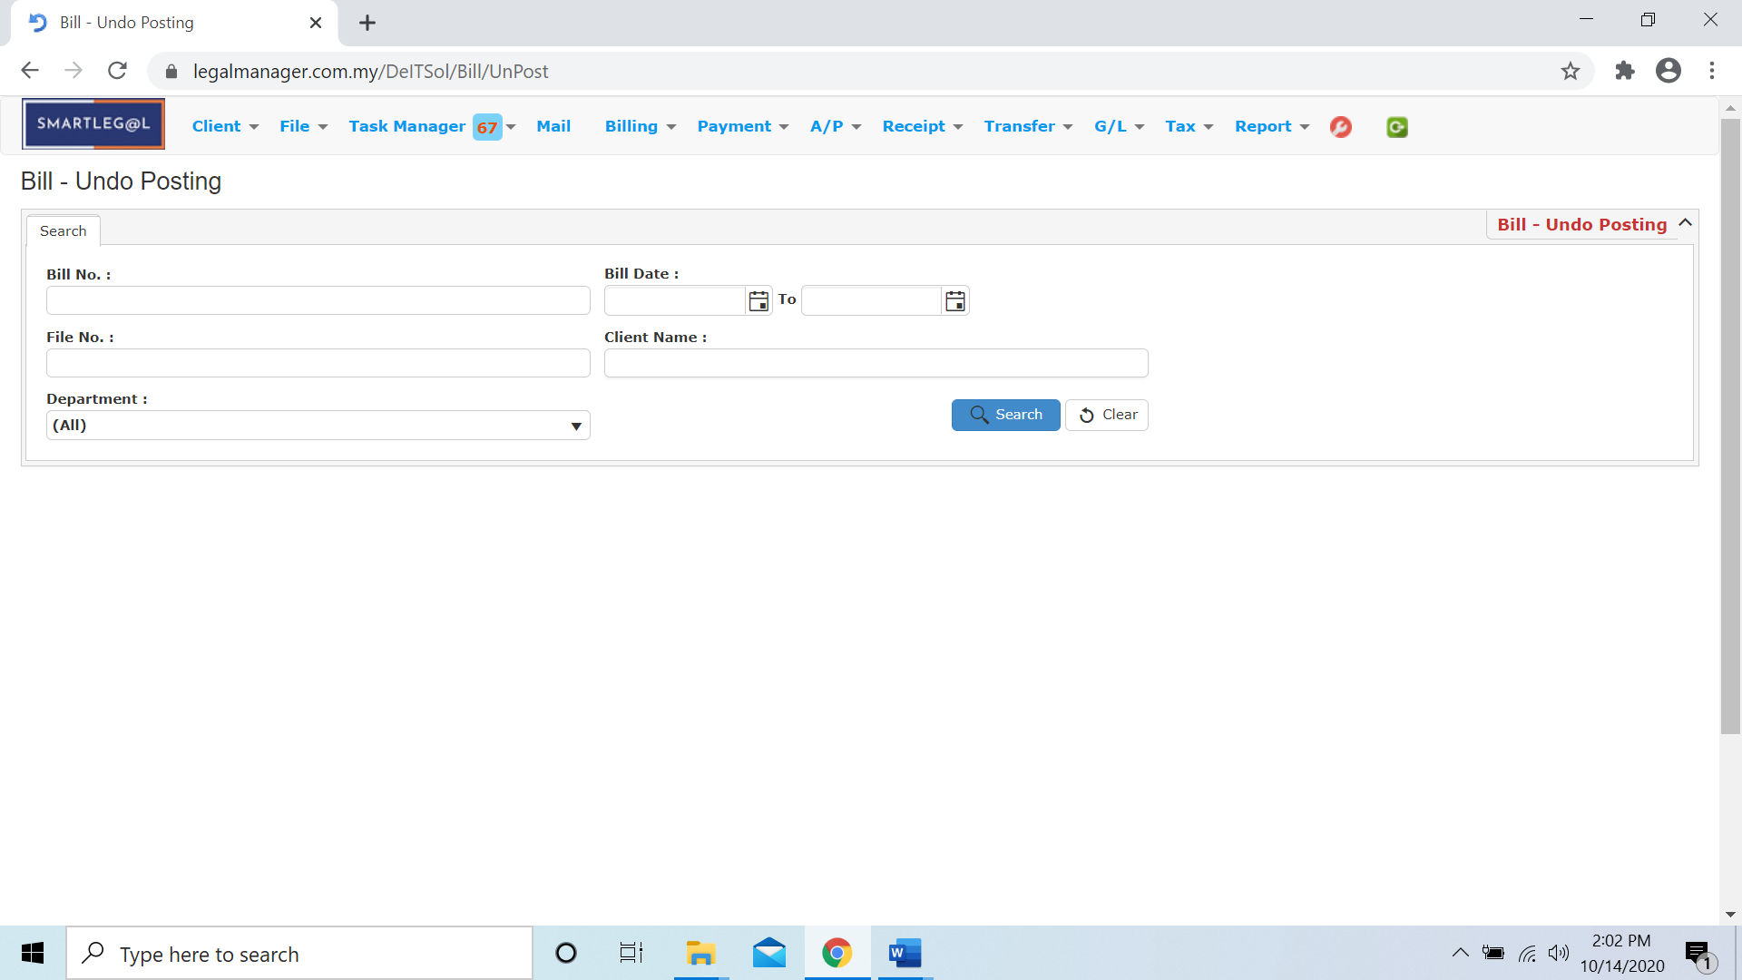

Figure – Bill Undo Posting - Search

**Searched Result**

* Click ‘**Search**’ once, to show all bills
* The Searched result will appeal at below, otherwise it will shown no record availble if the client you searched do not exist.
* Click ‘**Undo Posting**’ to undo posting the selected bill.
* Click ‘**Export**’ to print the desired search results in txt, excel or html format.

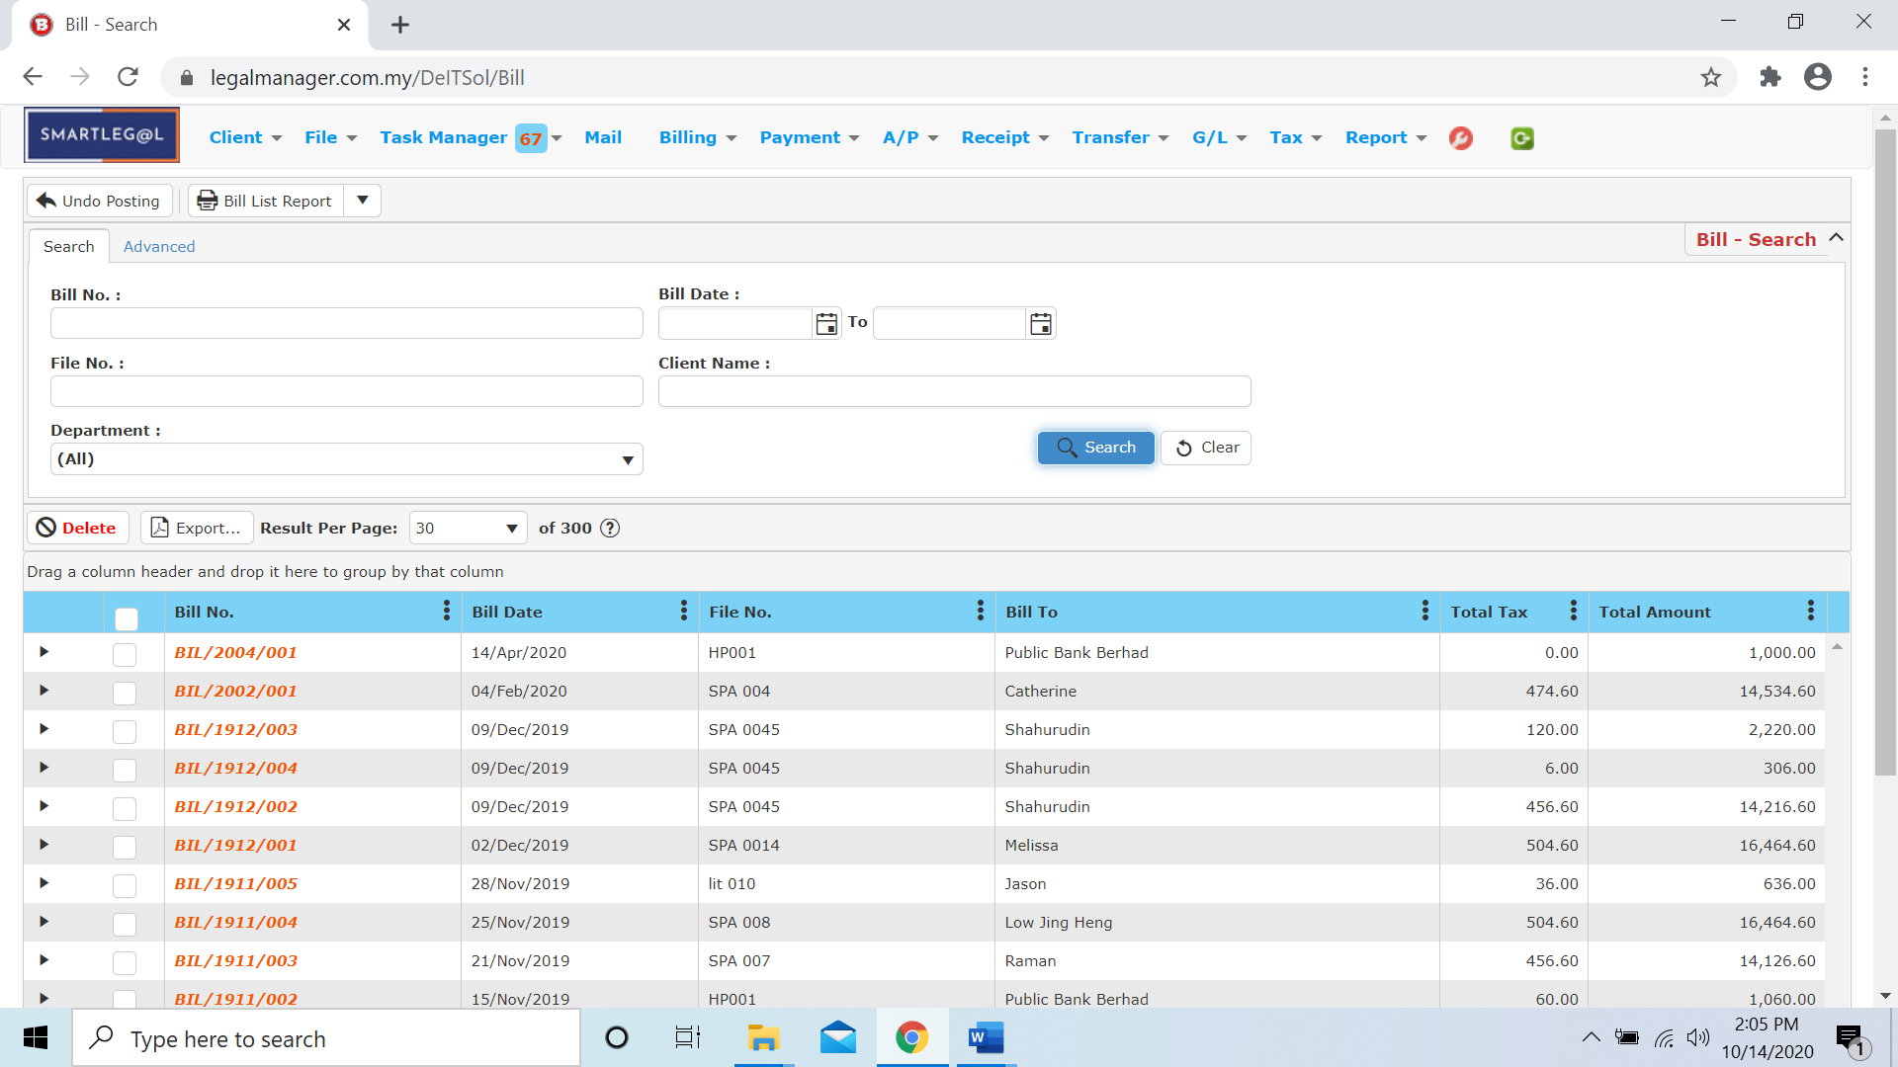

Figure – Bill Undo Posting – Search All Bills

* After the bill you searched appeal, you can choose to edit or preview the bill or see other related information same as in the **8.5 Manage Bill**.

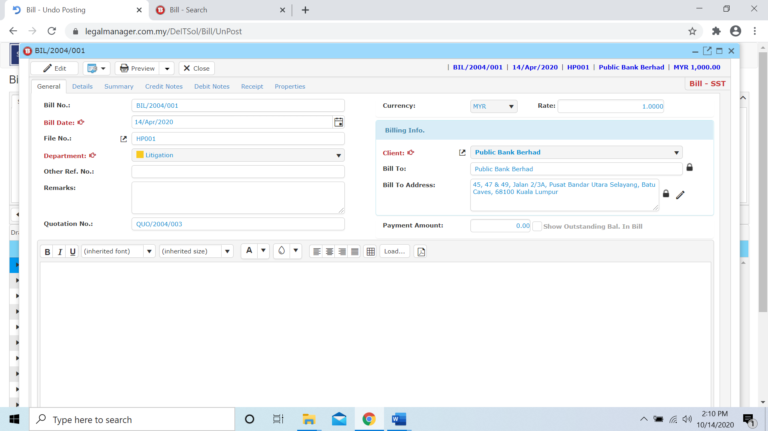

Figure: Bill Undo Posting – Searched Result, Bill Info

* 1. **New Time Cost Record**

This section enables you to setup the hourly rate charge by the lawyer.

* To open New Time Cost Record, on the **SmartLeg@l** navigation, click **Billing** and go to **New Time Cost Record** then create your own time cost record.

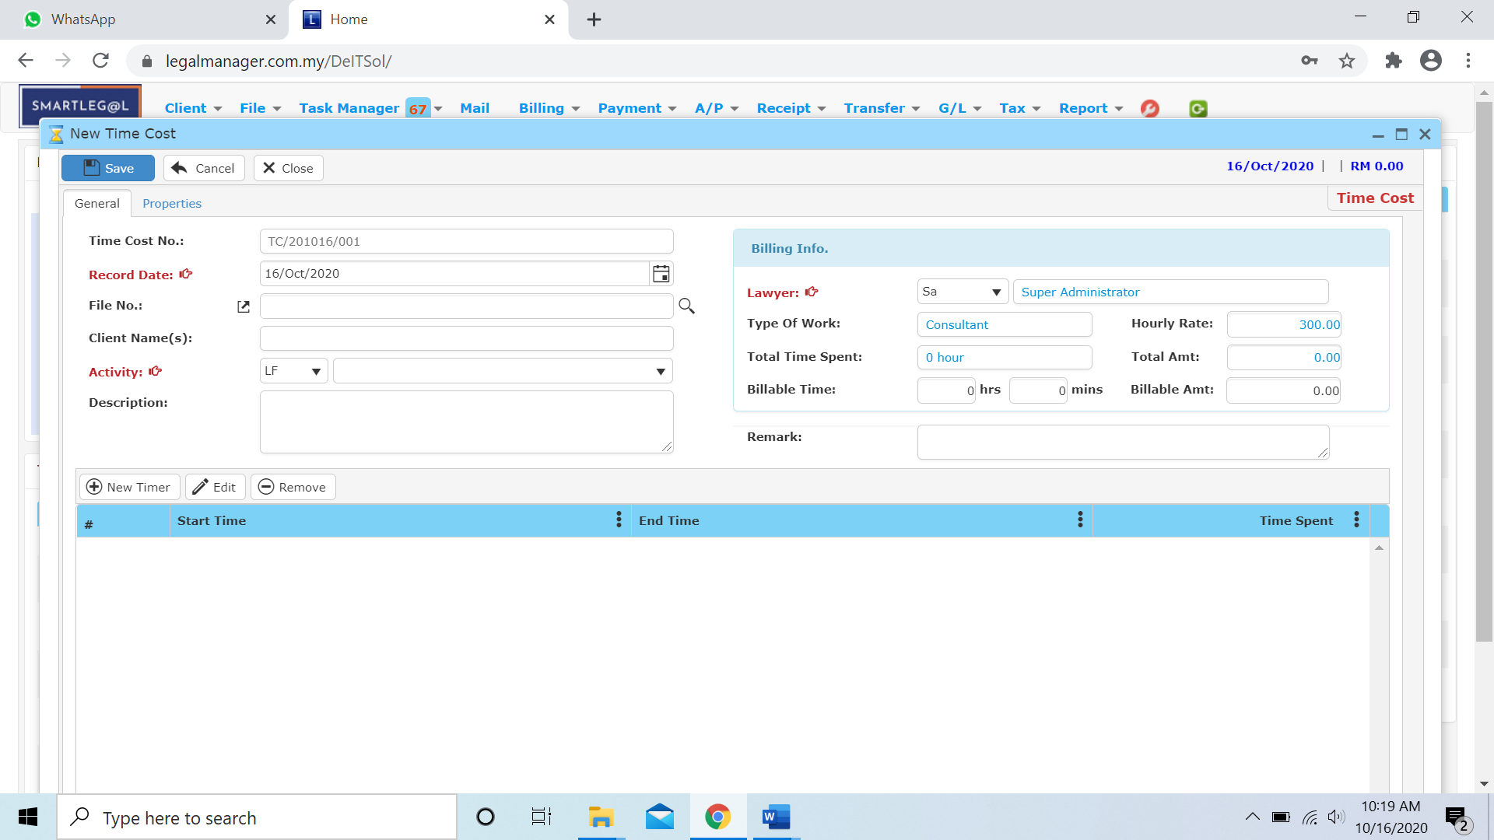

* Enter your Record Date, by default it will be the date you create the record
* Select the Activity from the combo box
* Select the Lawyer in the billing info

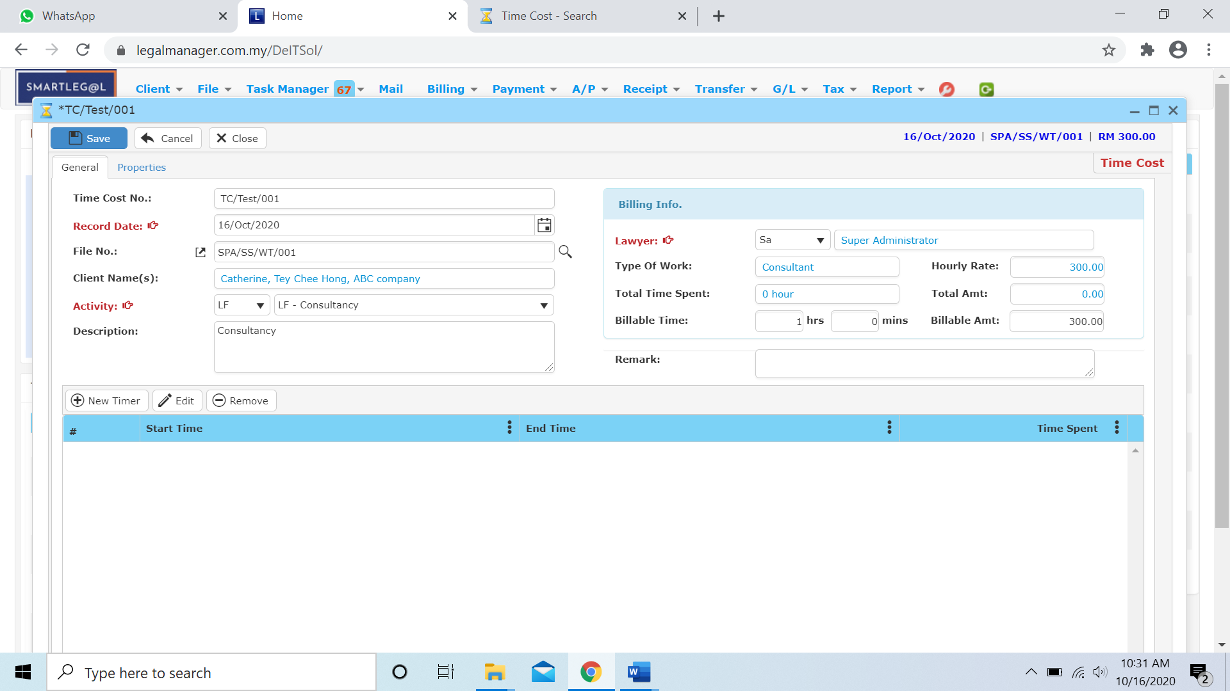

* Click ‘**New Timer**’ to add a timer



* A **Timer** window will appear as below:

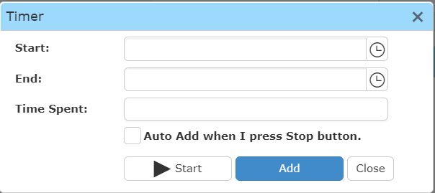

* Click the clock icon  to select your start and end time

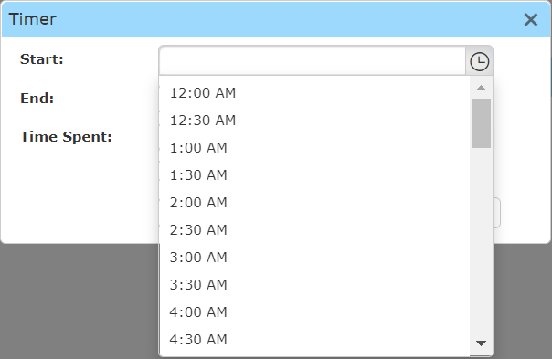

* Click ‘Add’ to add the timer in your record

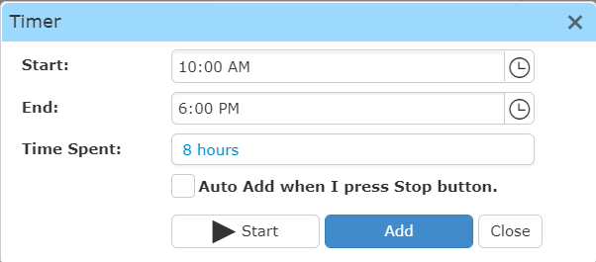



* Click ‘start’ to start the time

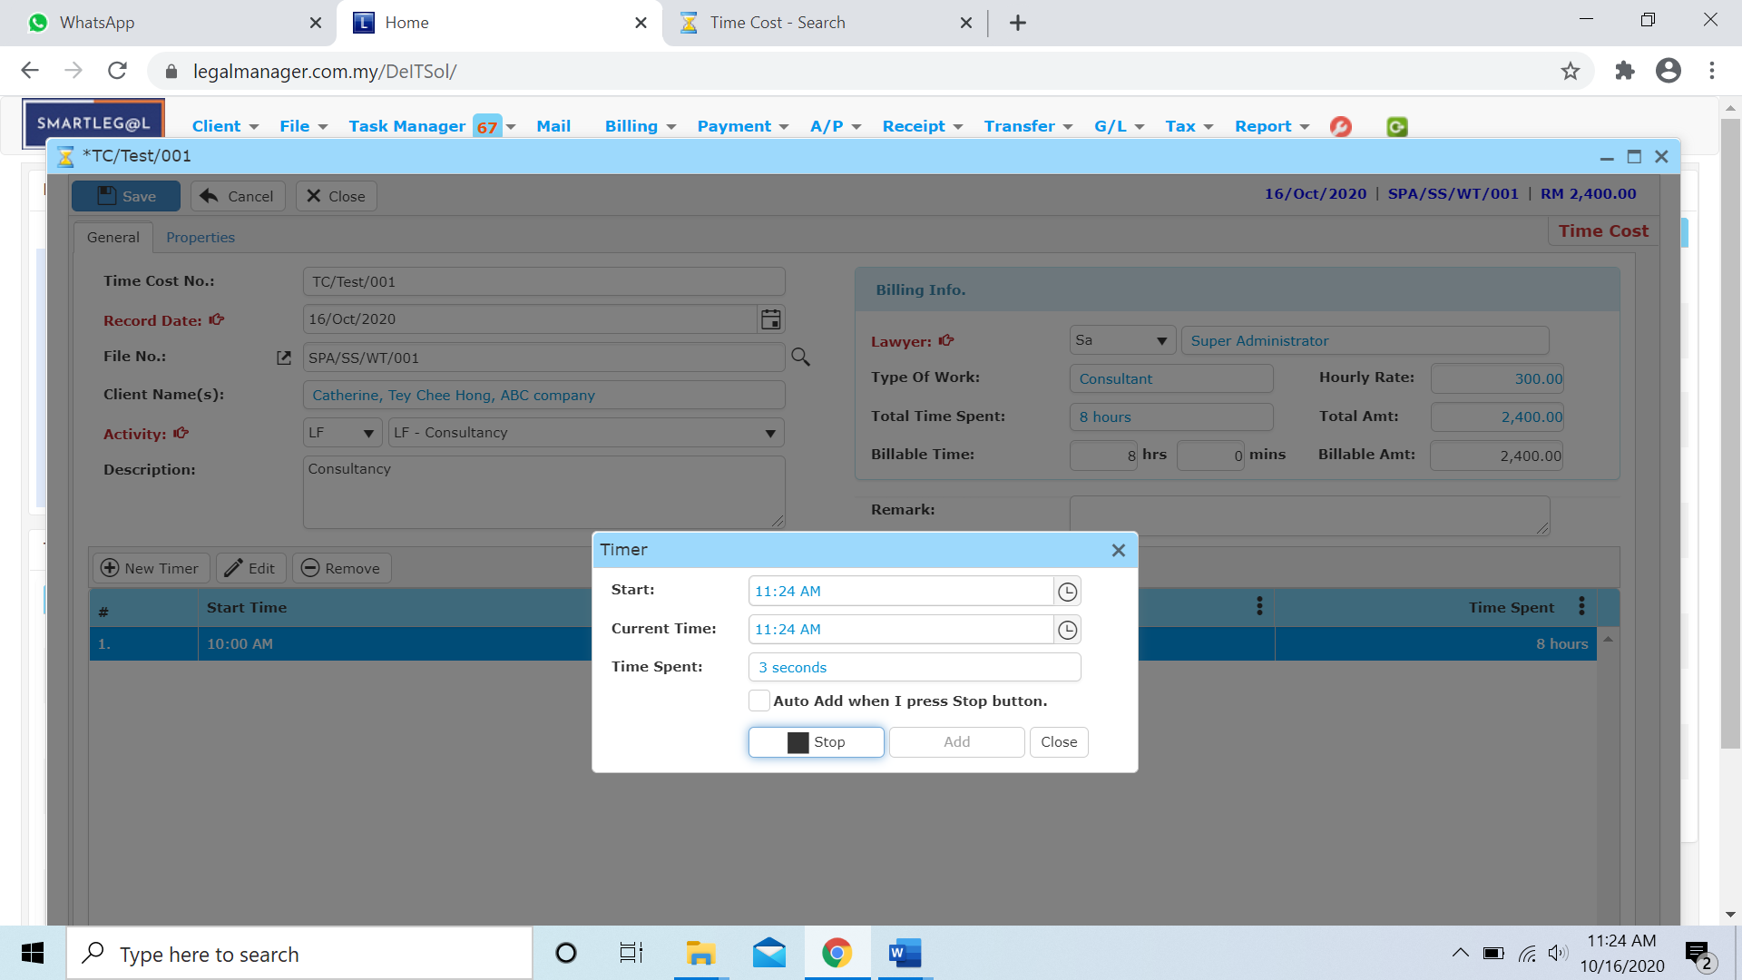

* 1. **Manage Time Cost**

This option enables you to add, edit, and delete a time cost record. It also allows you to keep track of your time cost record details and all related information.

* To open Manage Time Cost, on the **SmartLeg@l** navigation, click **Billing** and go to **Manage Time Cost** then search the time cost record you wish to modify.

**Manage Time Cost**

* Search the time cost record you wish to manage through type the search criteria or search by advanced.
* To start a new search or to clear the search results, click ‘**Clear**’.

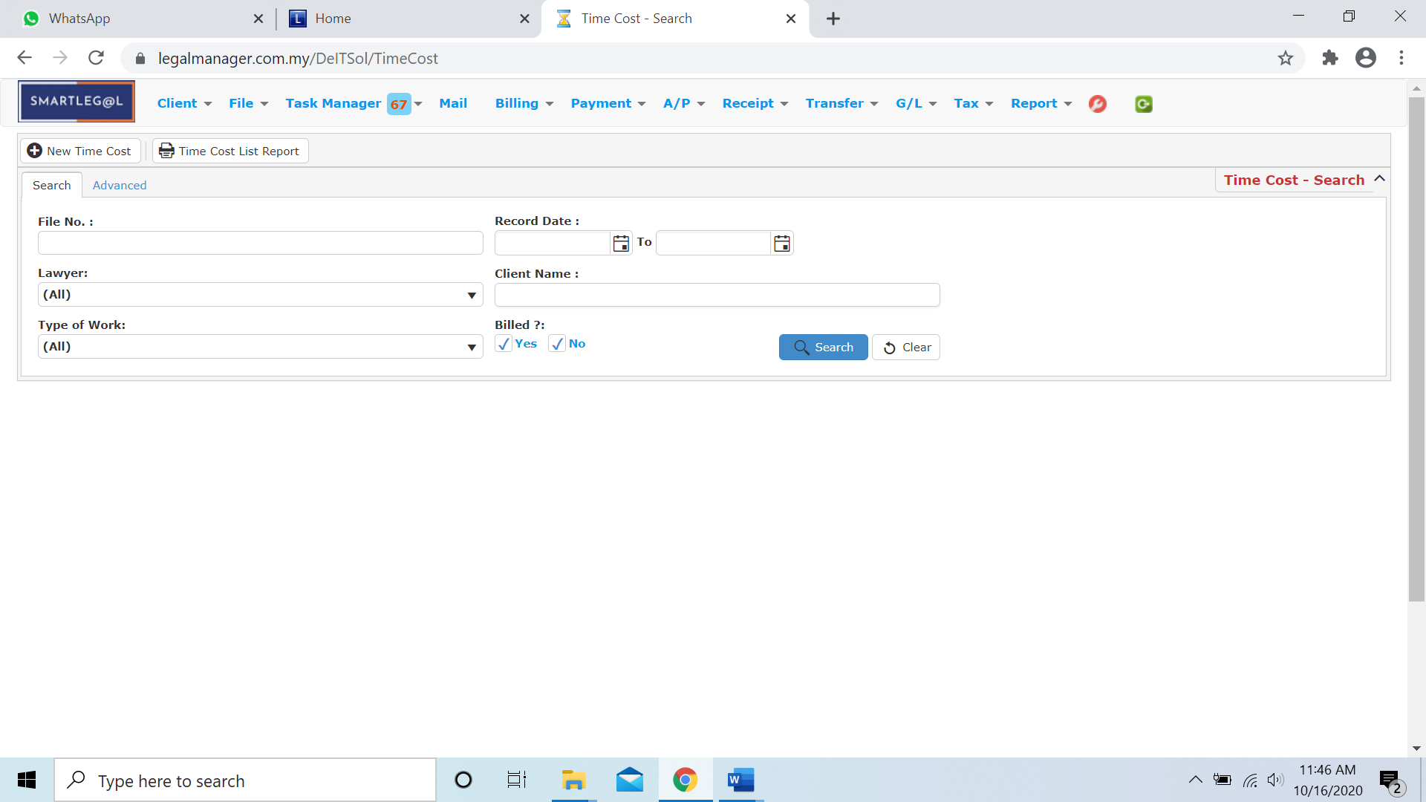

Figure: Manage Time Cost - Search

**Advanced Search**

* This function can be used to find a task by searching other information that is not captured in the ‘General’ section.
* Define search criteria:

**- Field** - Choose the field you want to search.

**- Condition** - Search condition

**- Value** - Type in the detail you want to find.

* Click ‘**Add to list**’, to define more than one criteria.
* Click ‘**Find**’, search results will be displayed at search record list. You can open an item in the search results list by double-clicking.
* To start a new search or to clear the search results, click ‘**Clear**’.
* Click ‘**Export**’ to print the desired search results in txt, excel or html format.

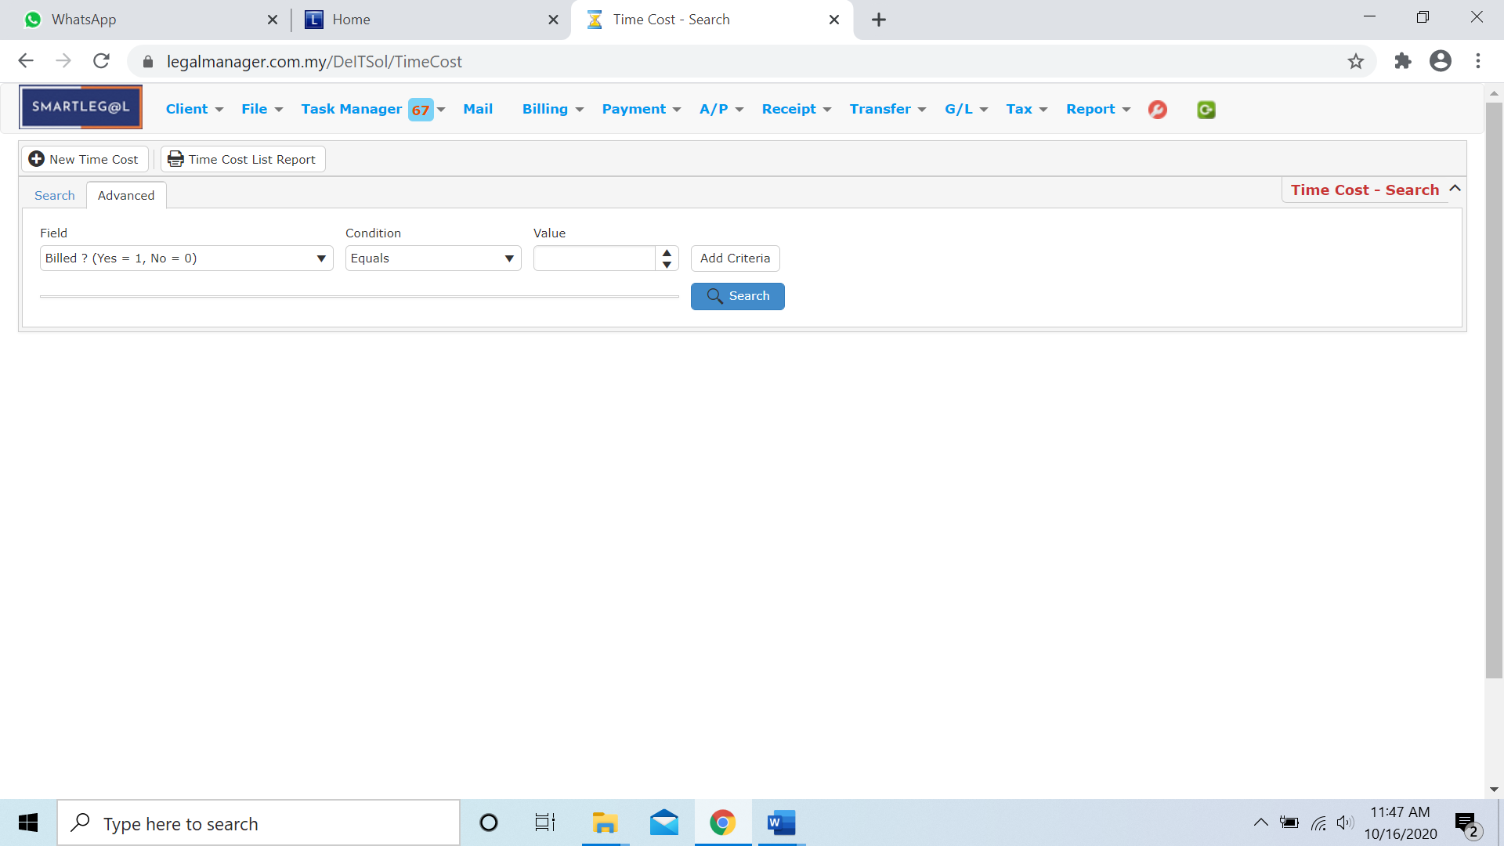

Figure: Manage Time Cost – Advanced Search

**Searched Result**

* Click ‘**Search**’ once, to show all Time Cost Record
* The Searched result will appeal at below, otherwise it will shown no record availble if the quotation you searched do not exist.
* Click ‘**Export**’ to print the desired search results in txt, excel or html format.

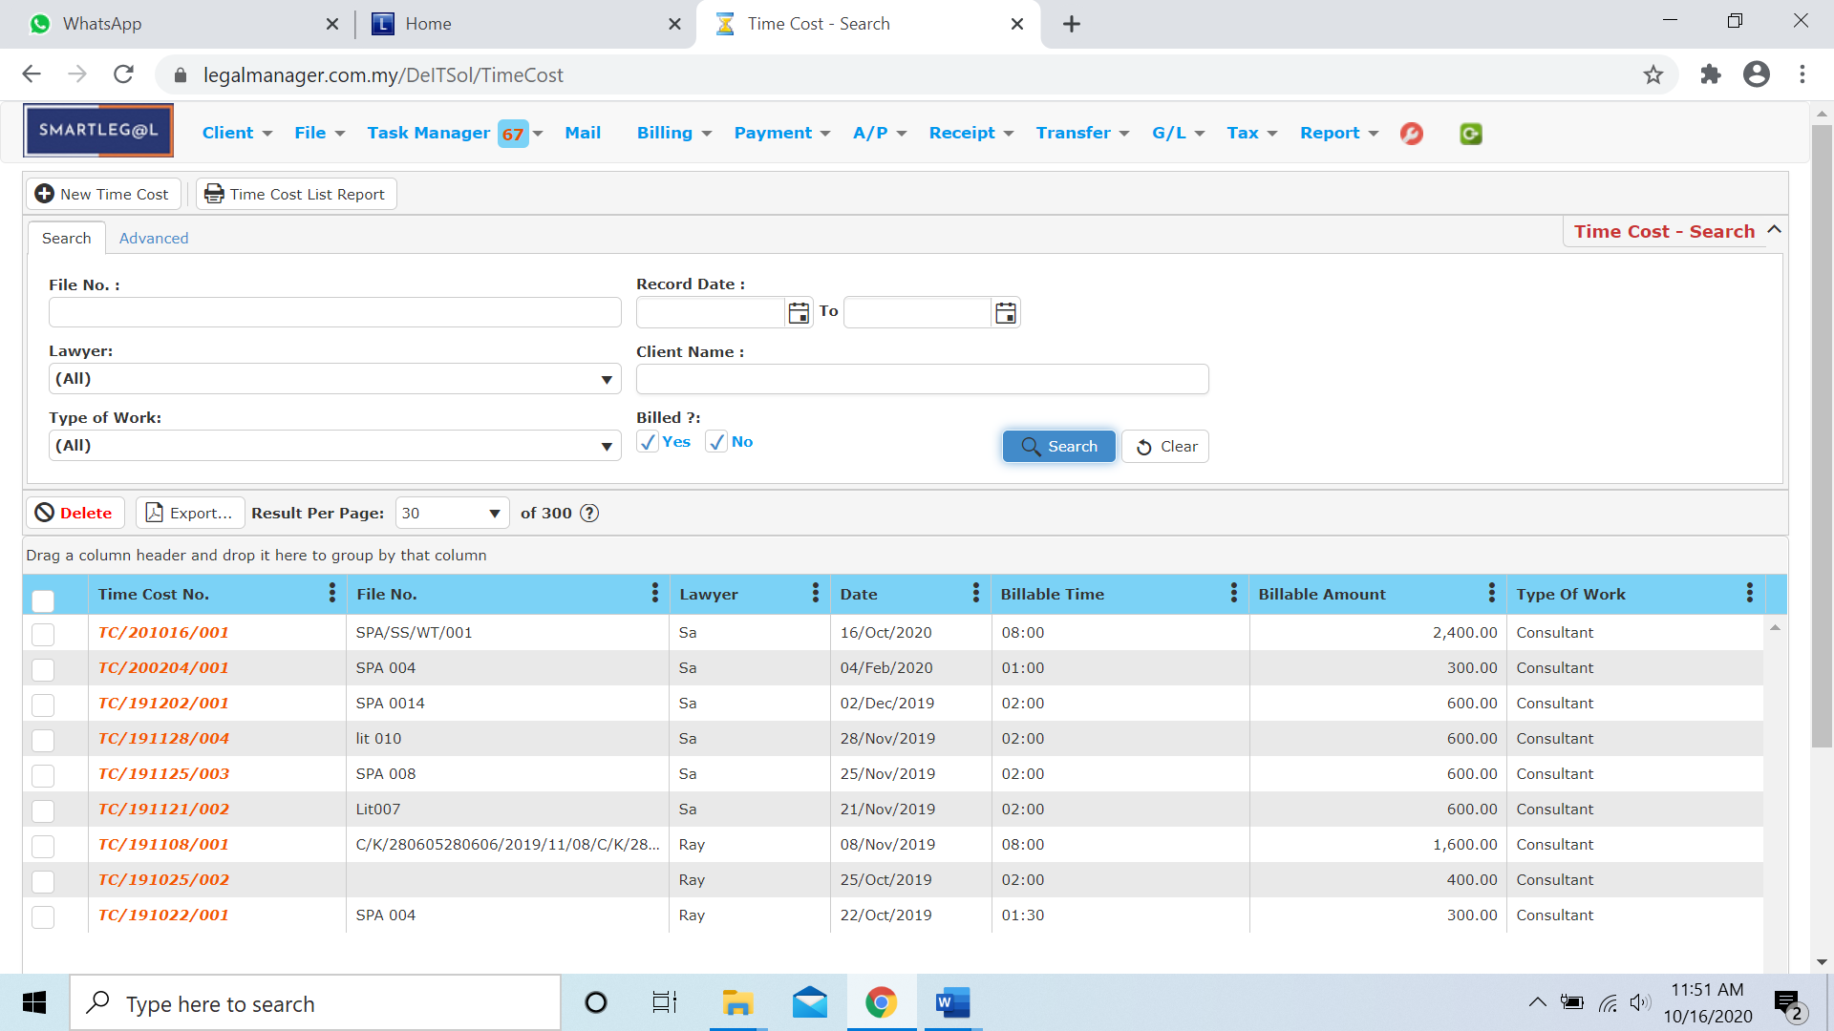

Figure: Manage Time Cost Record – Search All

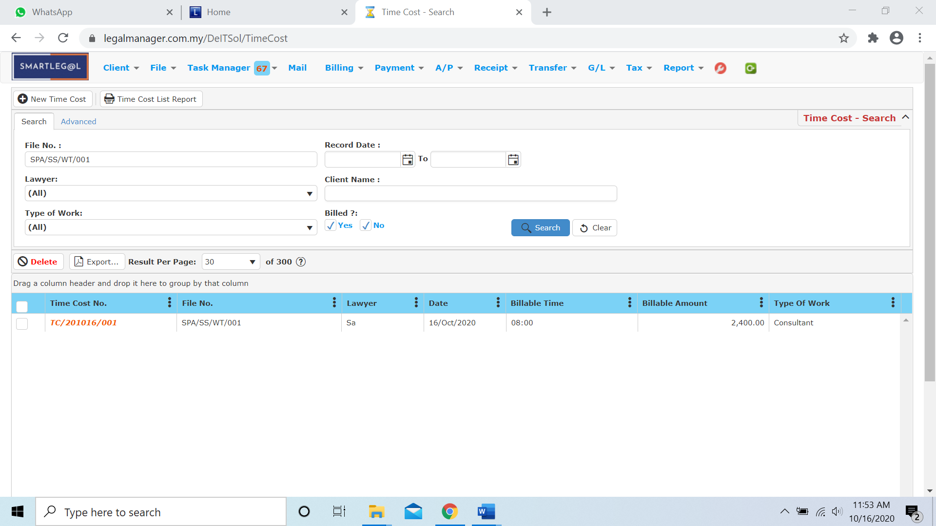

Figure: Manage Time Cost Record – Searched Result

* After the time cost record you searched appeal, you can choose to edit those details by double-clicking the record.

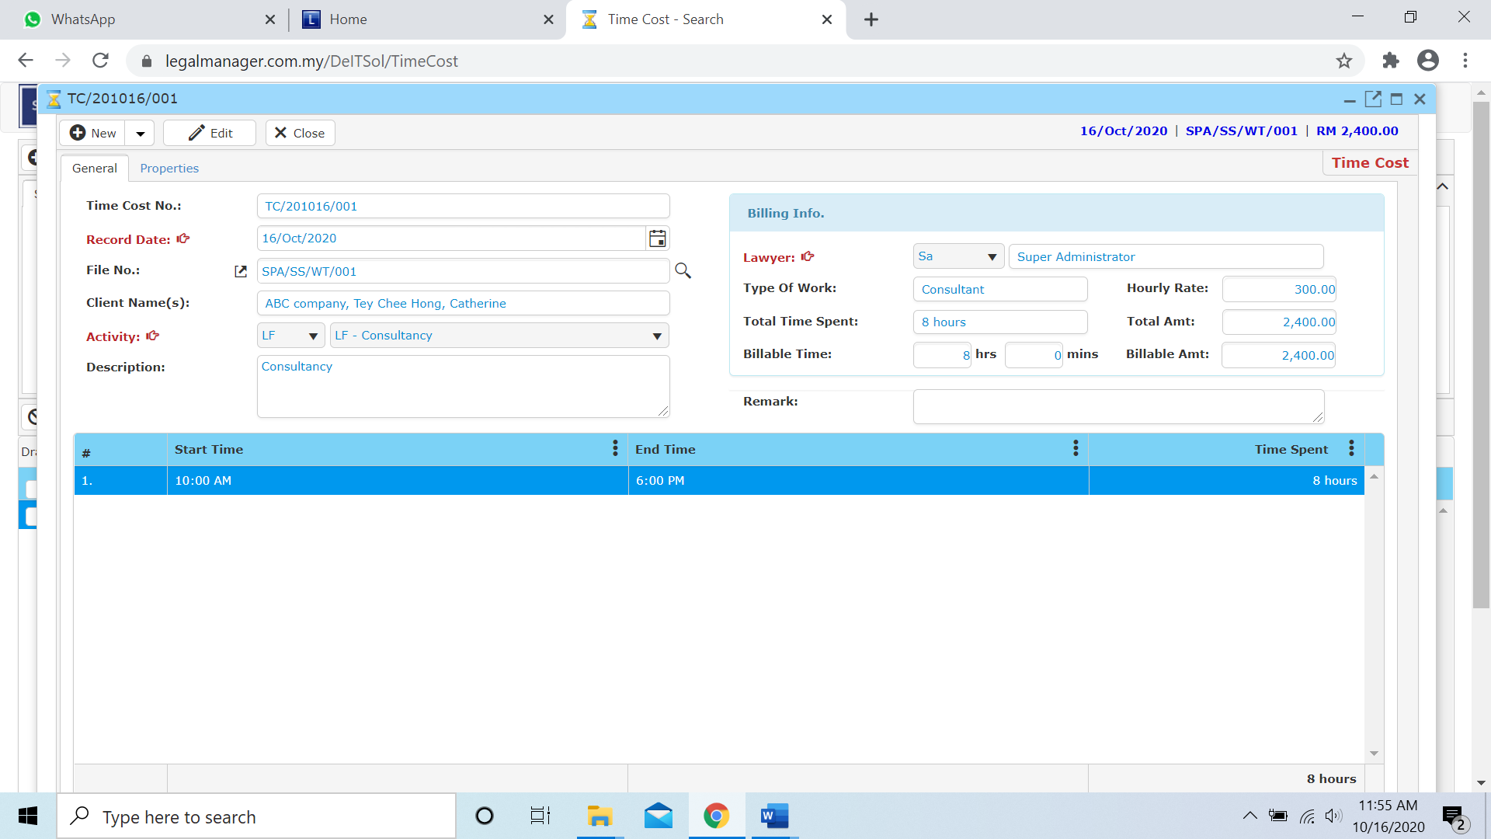

Figure: Manage Time Cost Record – Searched Result, Info

* 1. **New A/R Credit Note**
* To open New A/R Credit Note, on the **SmartLeg@l** navigation, click **Billing** and go to **New A/R Credit Note**.

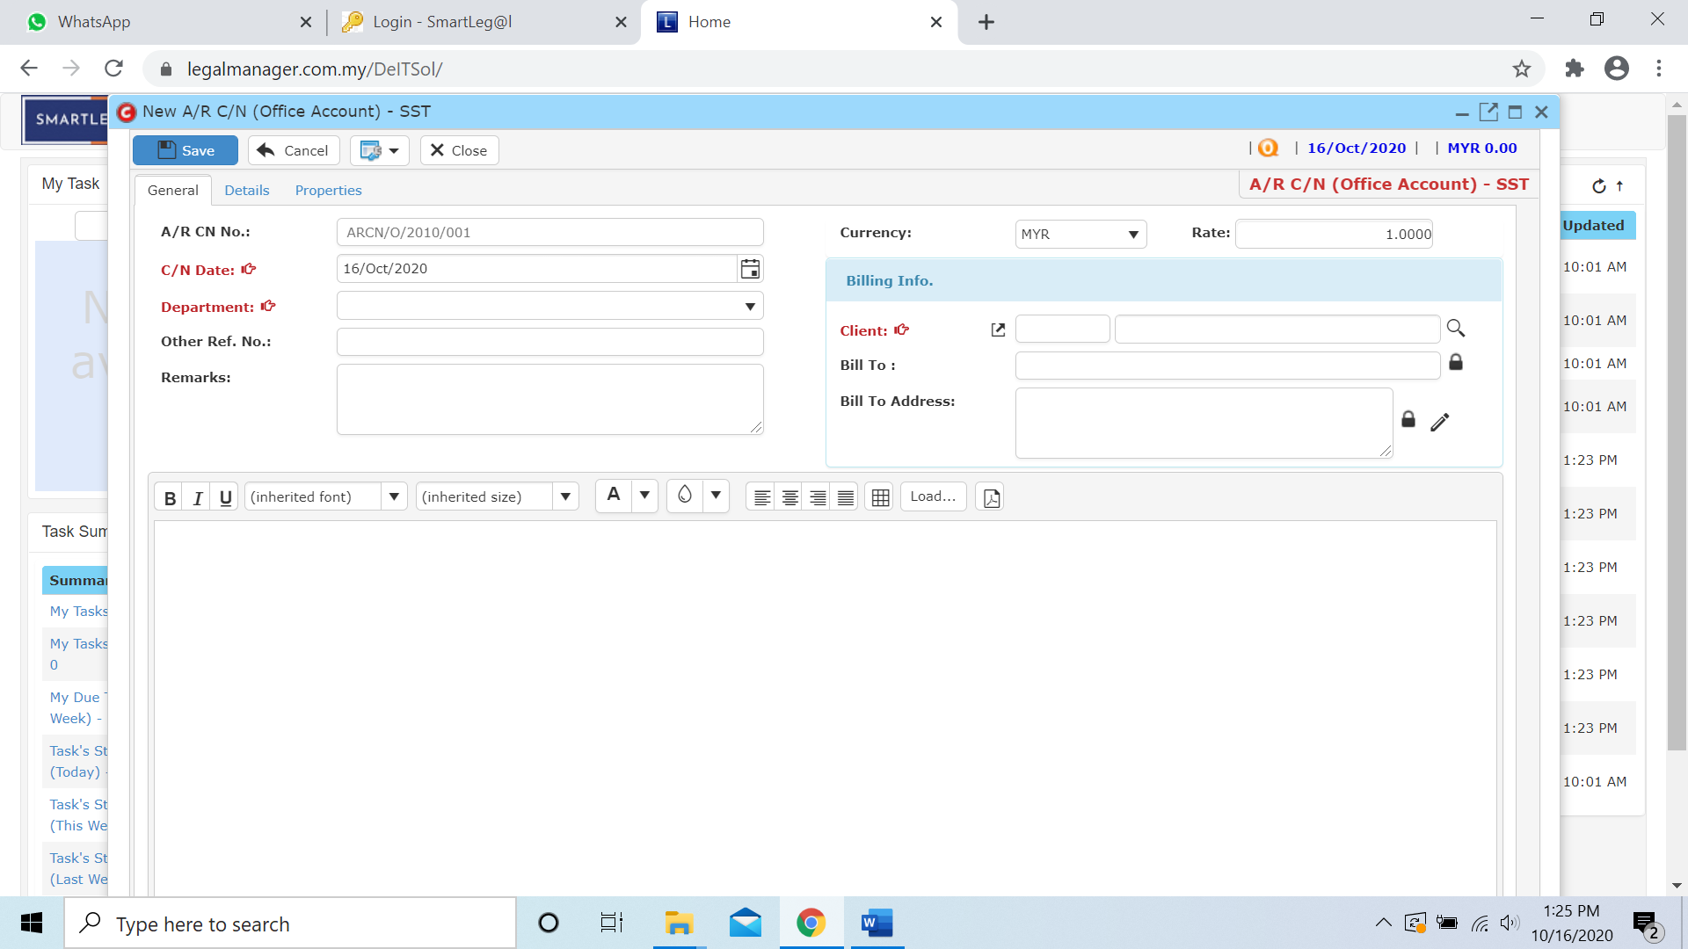

* Select C/N date and Department
* Click  icon to browse your client

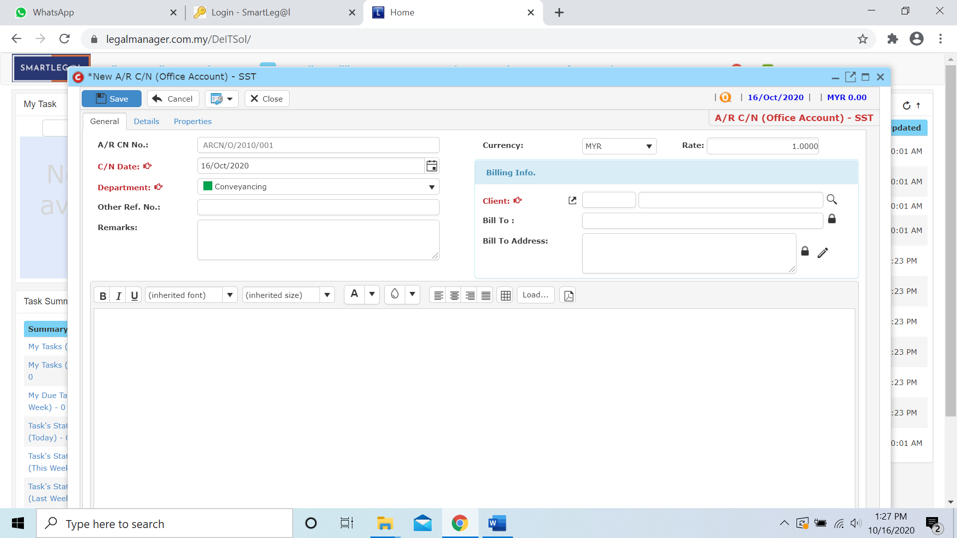

* The Search Client will pop up as figure below shown and click ‘Search’ once to show all clients

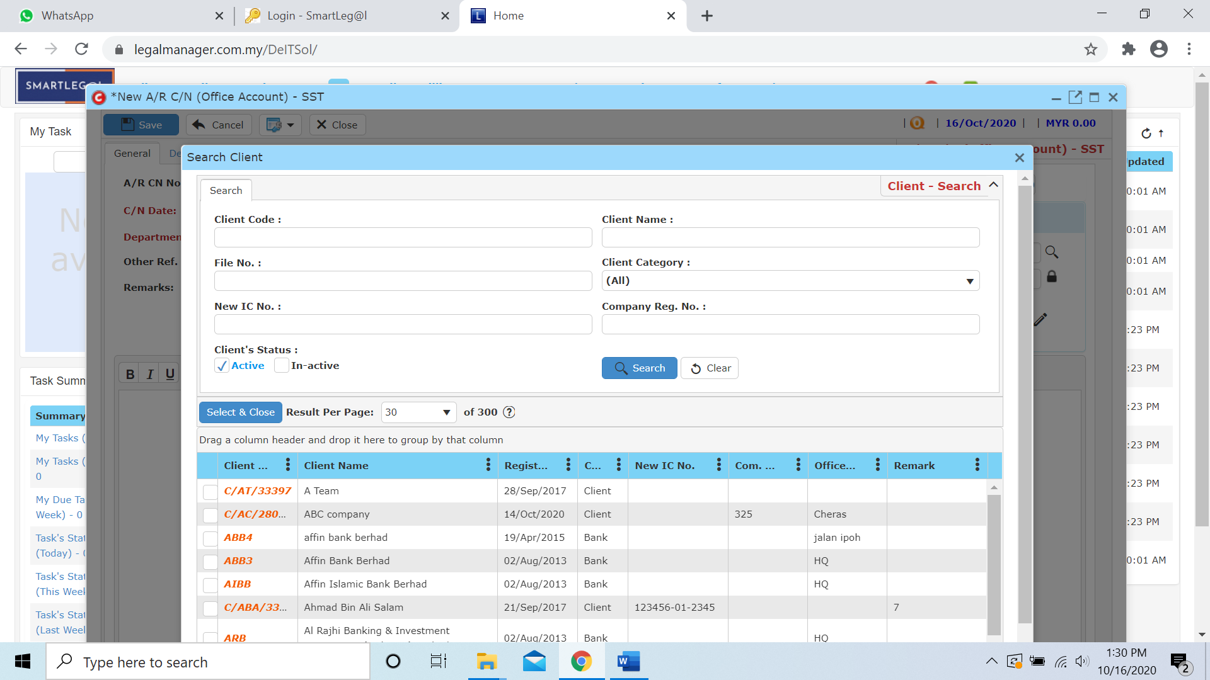

* Click to next tab ‘Details’

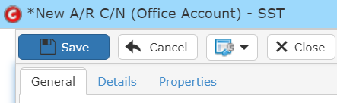

* While you click to details tab, it will auto pop up a search bill for the client you selected
* Click search to your client’s bill (e.g. Tey Chee Hong’s bill)

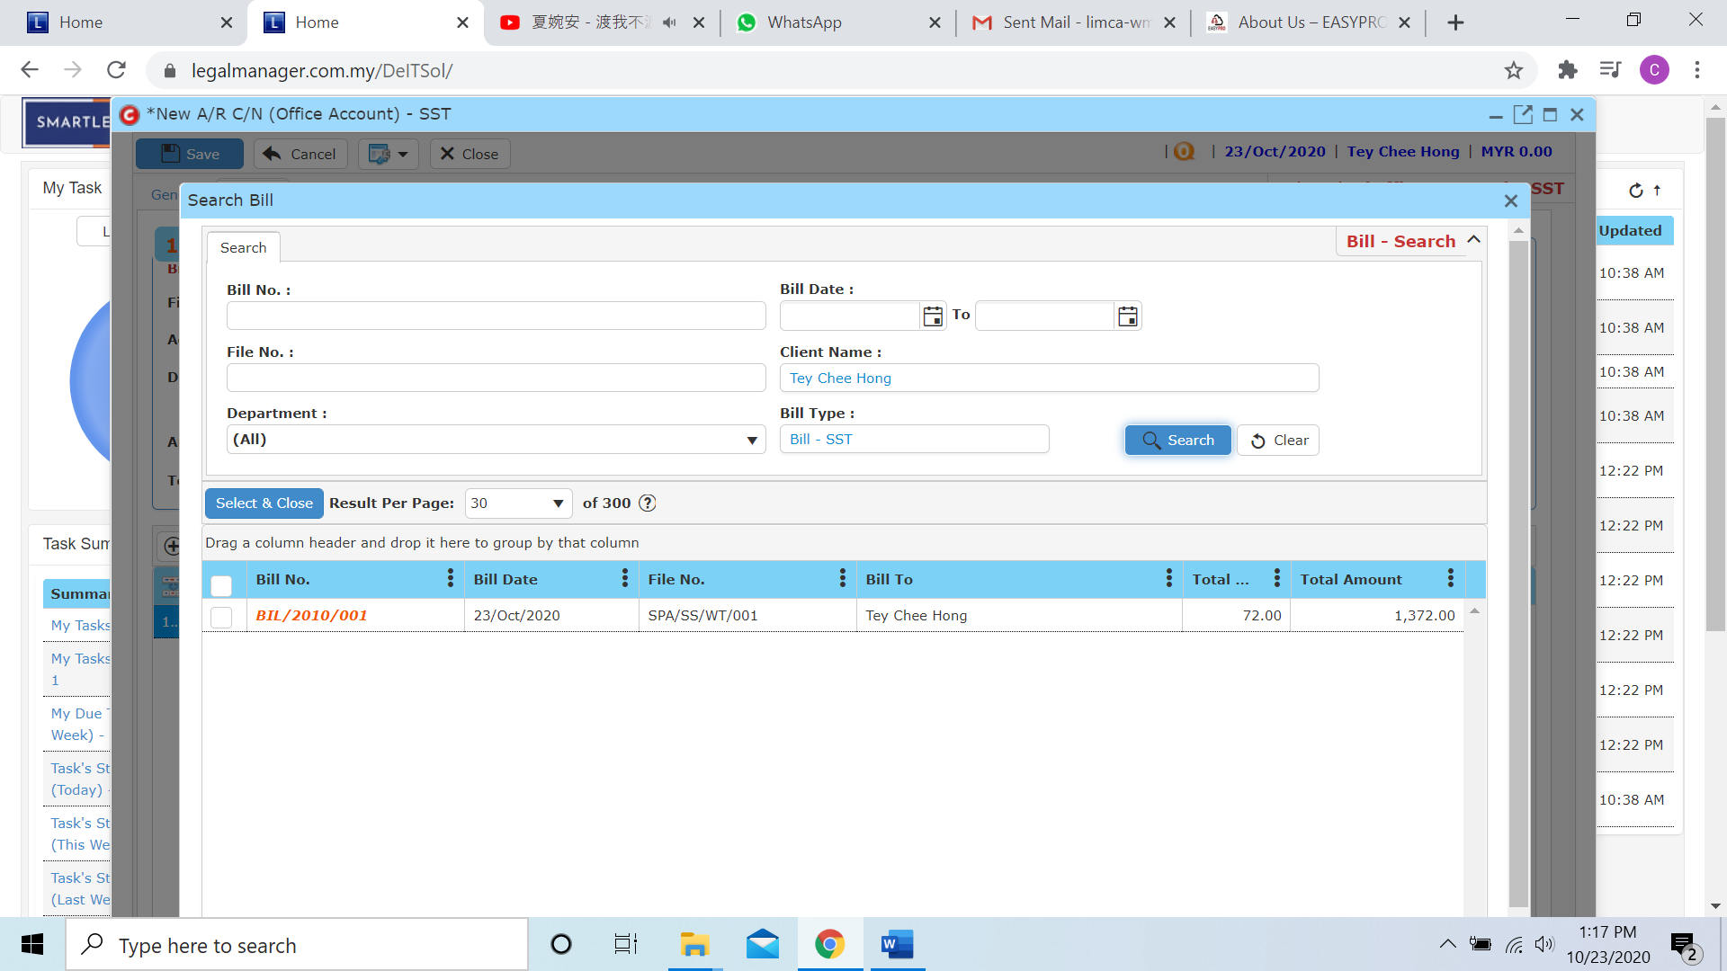

* After you select the bill, it will show to the information of the bill selected like, unsettle figure and others

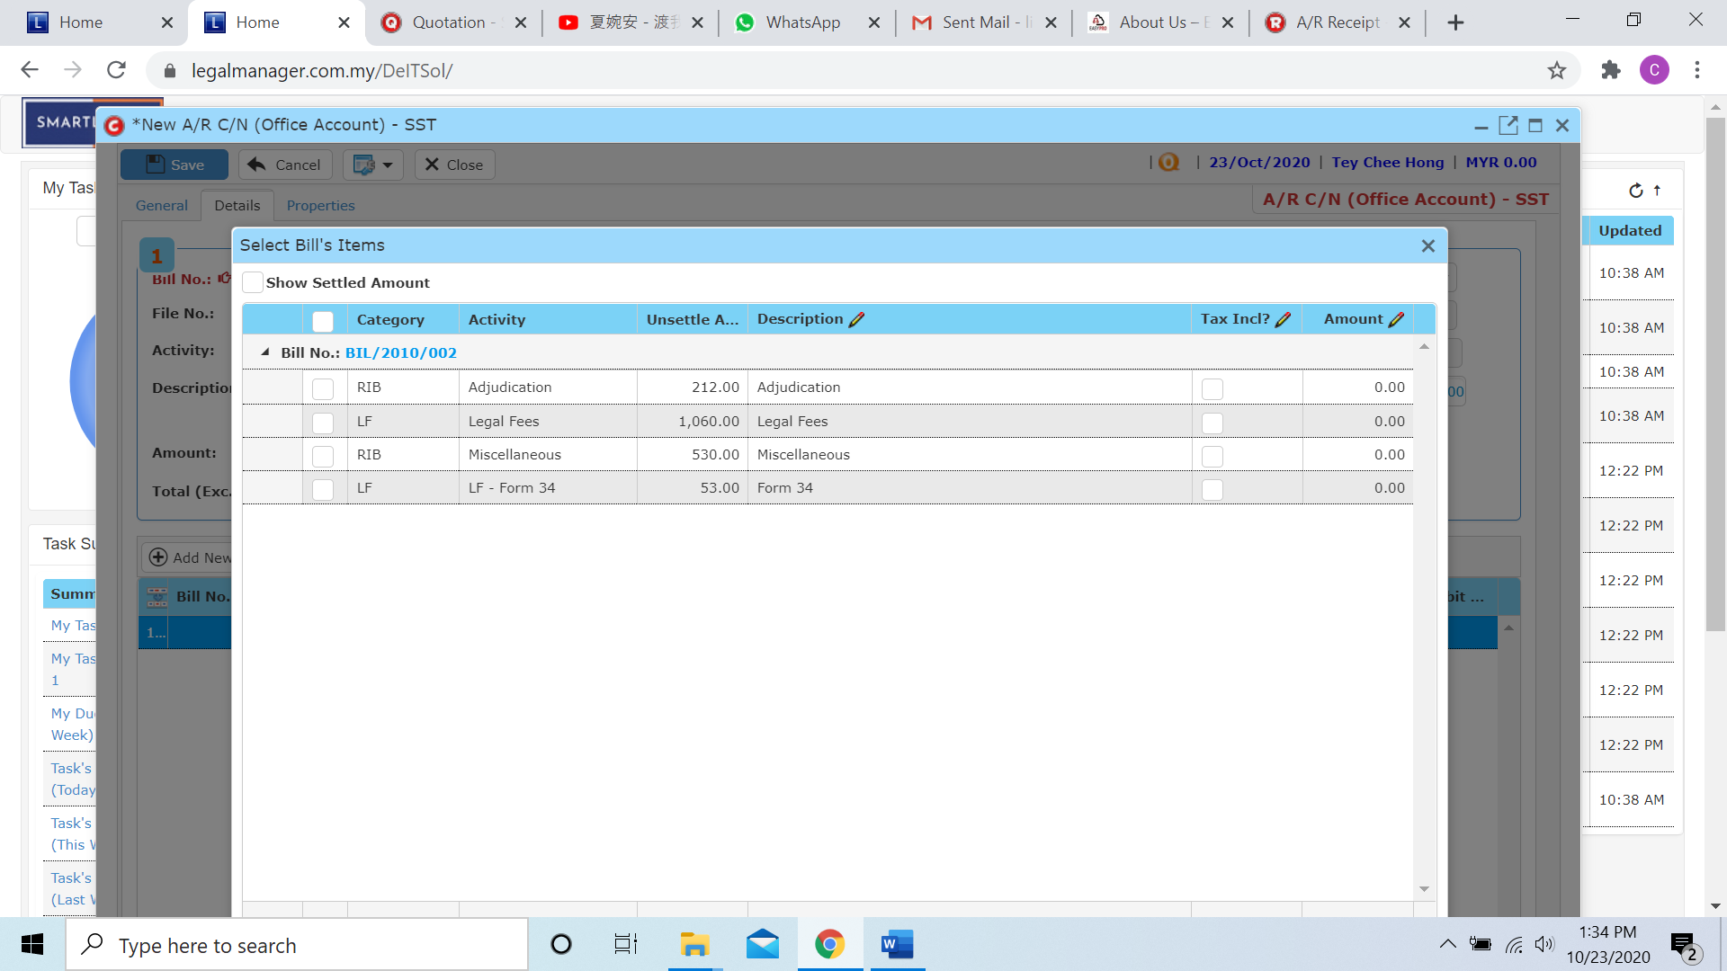

* Moreover, you can tick the Show Settled Amount it will show all the settle and unsettle amount of you client
* After that, click the unsettle amount you wish to credit then click ‘ok’

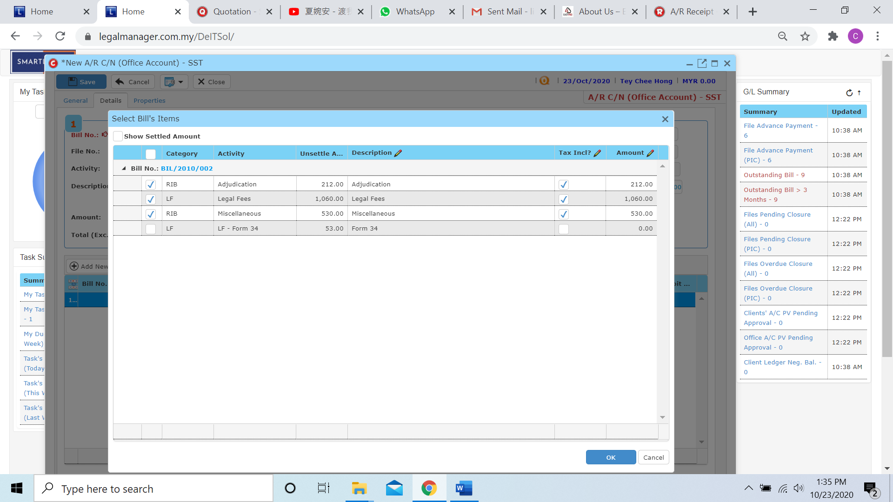

* The New A/R Credit Note will appeal the record of the bill

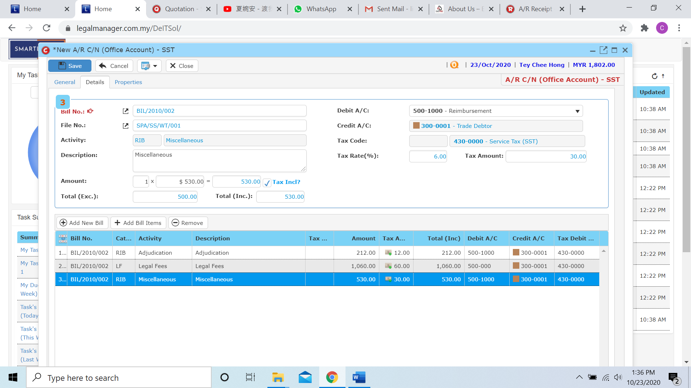

* Other than that, you can Add New Bill and Add Bill Item in this section

**Add New Bill**

* When you click ‘Add New Bill’ it will go to the search again and follow the process of above after you click to ‘Details’ tab

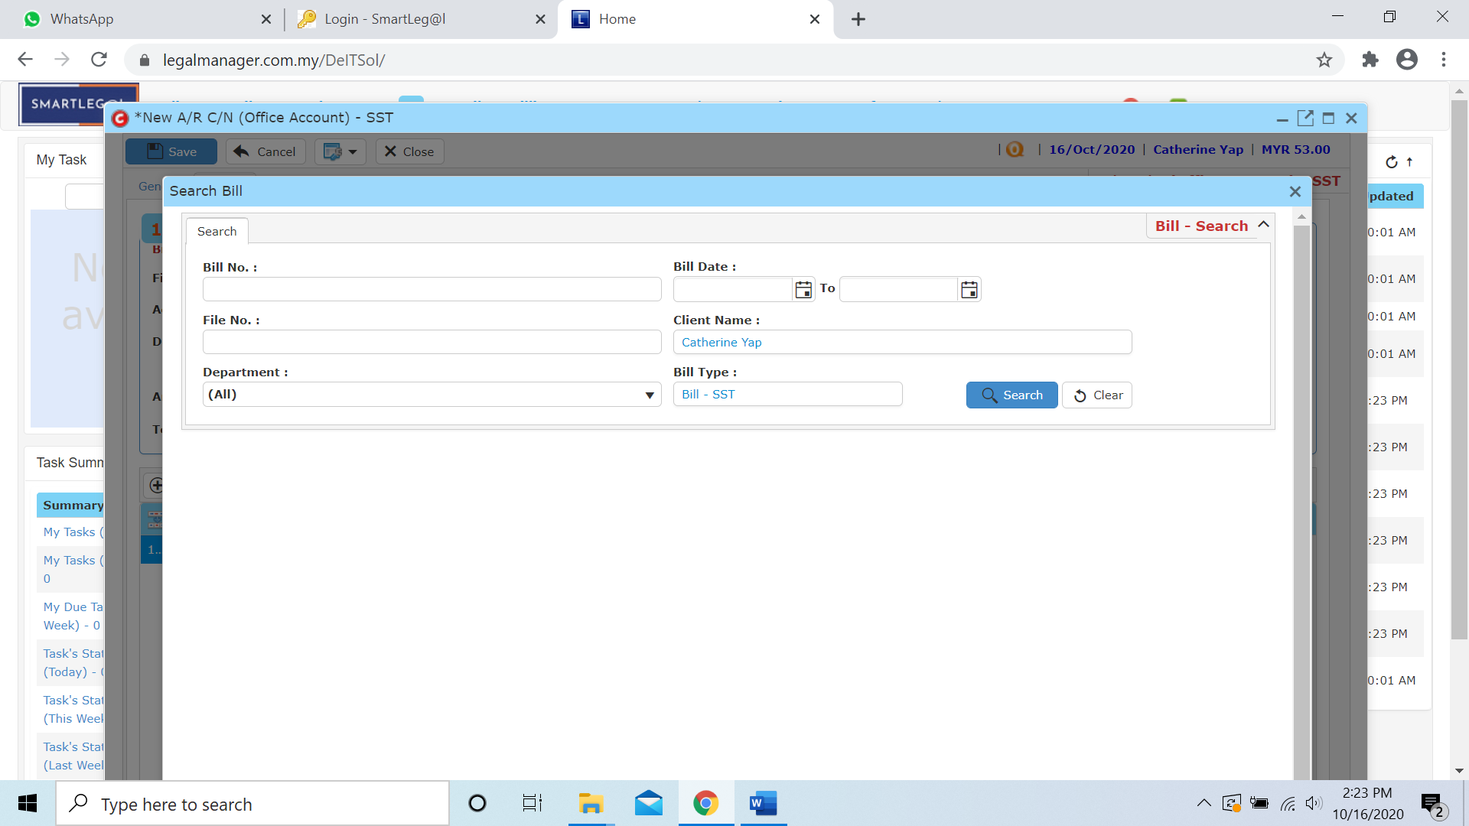

**Add Bill Items**

* When you click to ‘Add Bill Items’ it will direct go to the unsettle amount of the bill for the client you choose

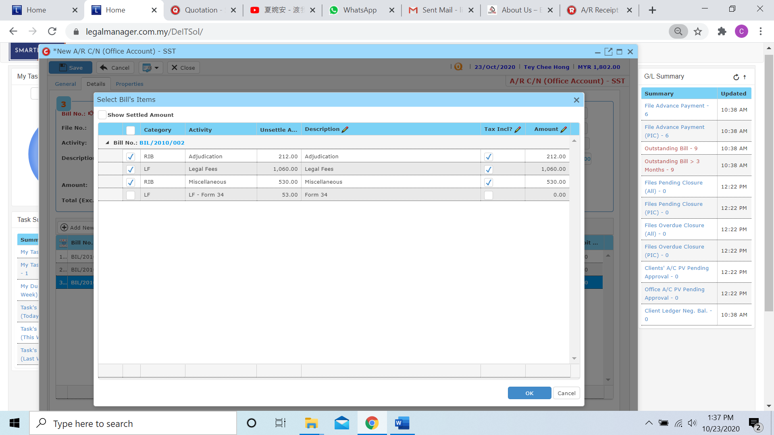

* Then you can click to the next tab ‘Properties’

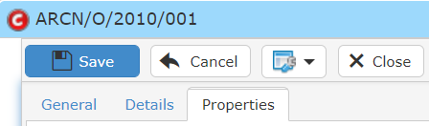

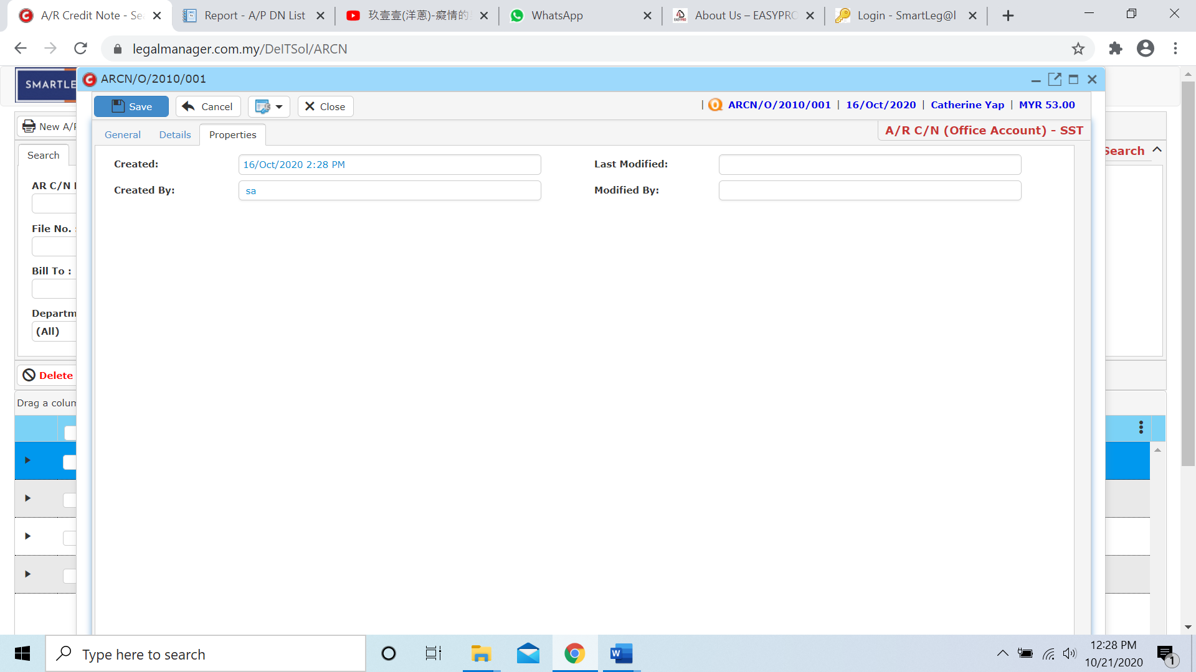

* After you finish insert all the information and details click ‘Save’
* You can view the information of the supplier once who modify the A/R Credit Note then there will show the last modified and modified by who
  1. **Manage A/R Credit Note**

This option enables you to add, edit, and delete a A/R Credit Note Record. It also allows you to keep track of your A/R Credit Note record details and all related information.

* To open Manage A/R Credit Note, on the **SmartLeg@l** navigation, click **Billing** and go to **Manage A/R Credit Note** then search the A/R Credit Note record you wish to modify.

**Manage A/R Credit Note**

* Search the A/R Credit Note record you wish to manage through type the search criteria or search by advanced.
* To start a new search or to clear the search results, click ‘**Clear**’.

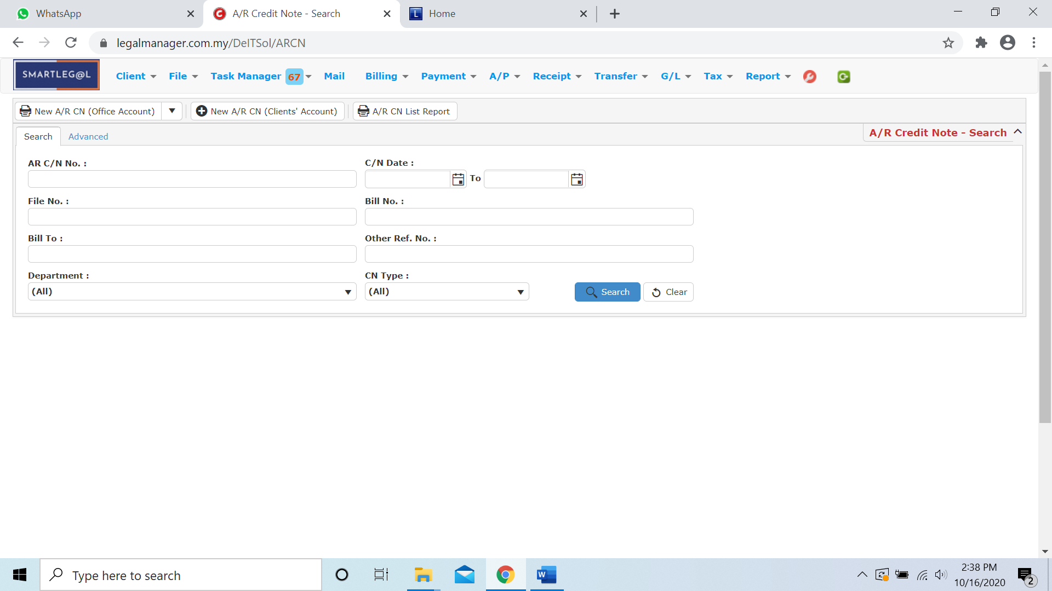

Figure: Manage A/R Credit Note - Search

**Advanced Search**

* This function can be used to find a task by searching other information that is not captured in the ‘General’ section.
* Define search criteria:

**- Field** - Choose the field you want to search.

**- Condition** - Search condition

**- Value** - Type in the detail you want to find.

* Click ‘**Add to list**’, to define more than one criteria.
* Click ‘**Find**’, search results will be displayed at search record list. You can open an item in the search results list by double-clicking.
* To start a new search or to clear the search results, click ‘**Clear**’.
* Click ‘**Export**’ to print the desired search results in txt, excel or html format.

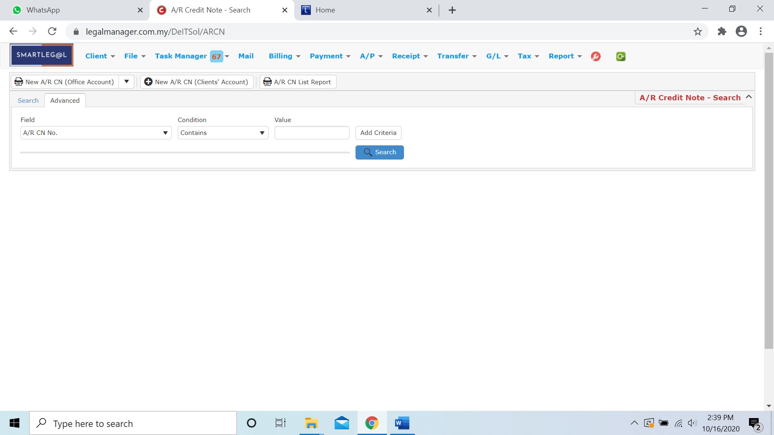

Figure: Manage A/R Credit Note– Advanced Search

* Other than Search A/R Credit Note you can create 3 type of new A/R CN of official account by clicking  and it will appeal a combo box as figure below shown

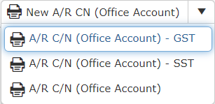

* You can also create A/R Credit Note of client’s account by clicking 
* It will pop up a input form for A/R Credit Note of client’s account

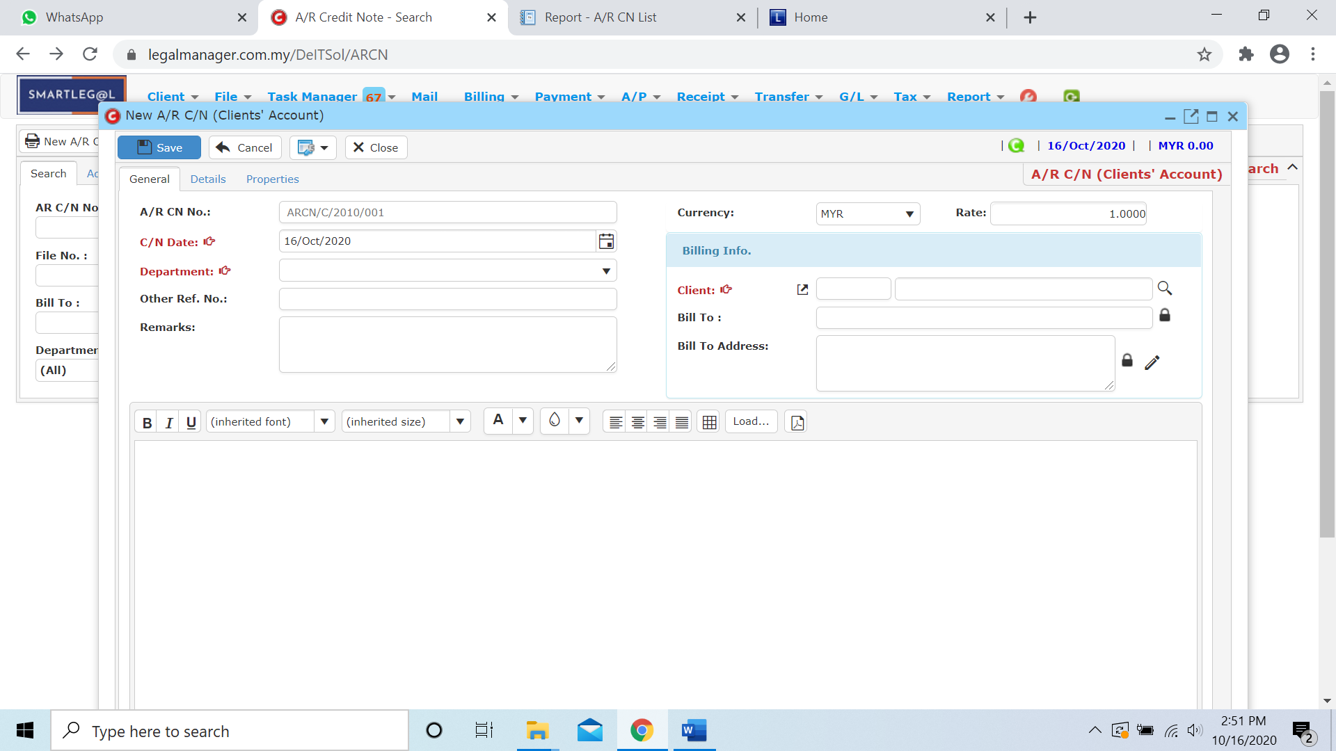

* You can print or preview the A/R Credit Note List Report while you click to 

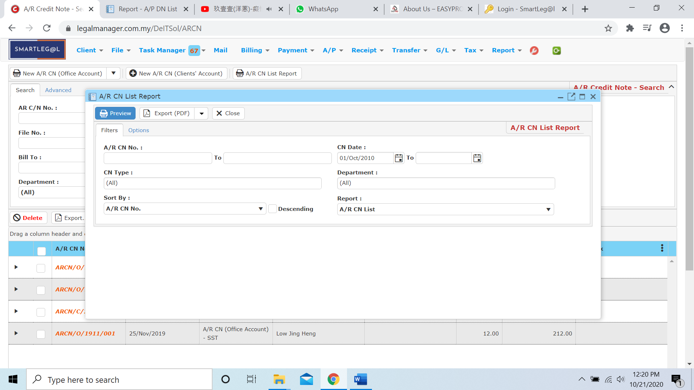

* Besides, you can preview the report as figure below shown

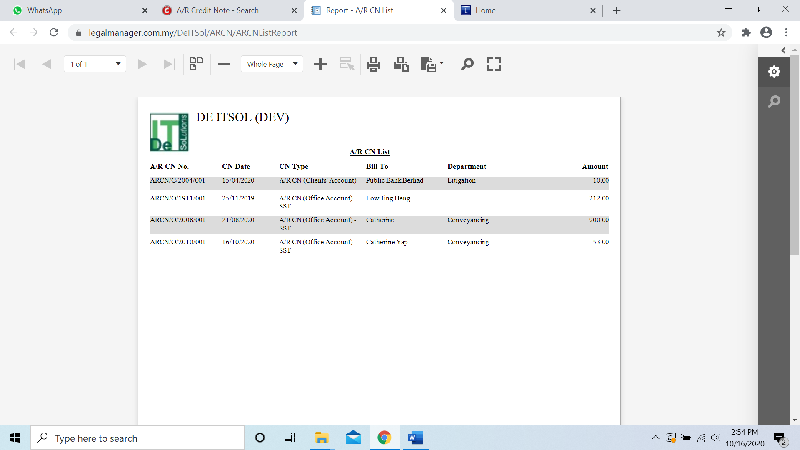

* You can also export the report into PDF or excel by clicking

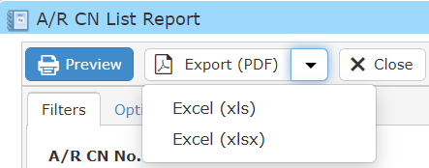

**Searched Result**

* Click ‘**Search**’ once, to show all A/R Credit Note Record
* The Searched result will appeal at below, otherwise it will shown no record availble if the quotation you searched do not exist.
* Click ‘**Export**’ to print the desired search results in txt, excel or html format.

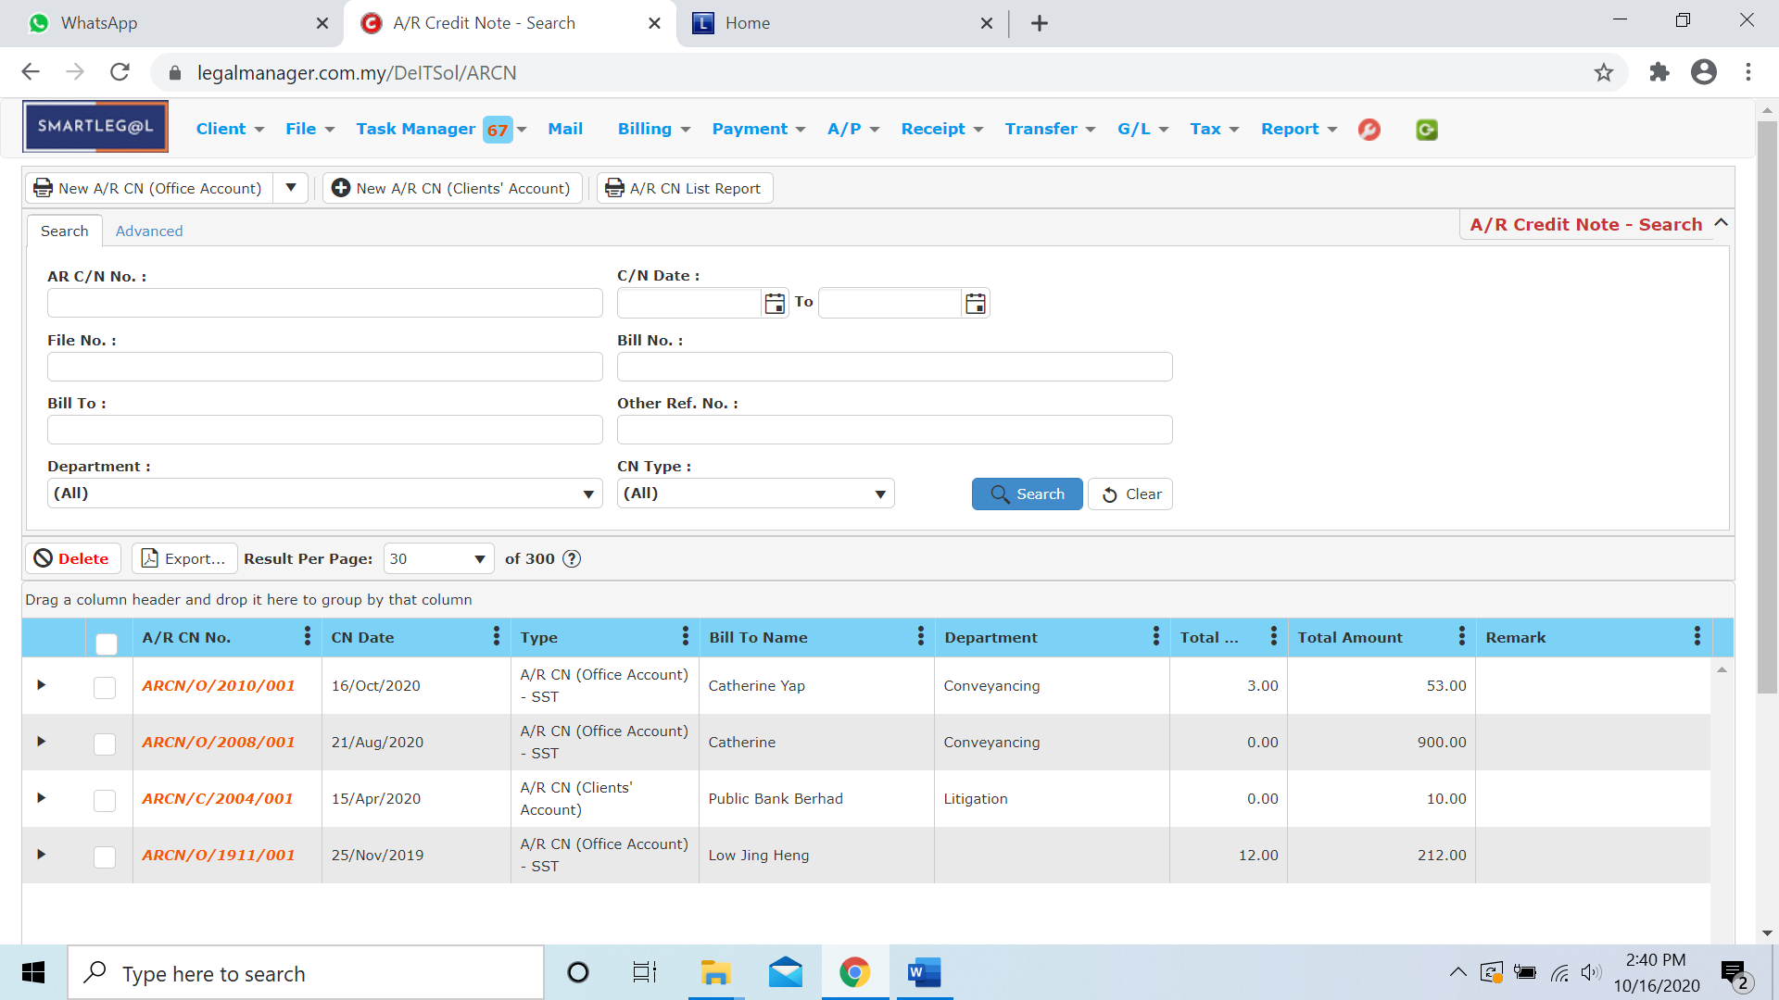

Figure: Manage A/R Credit Note – Search All

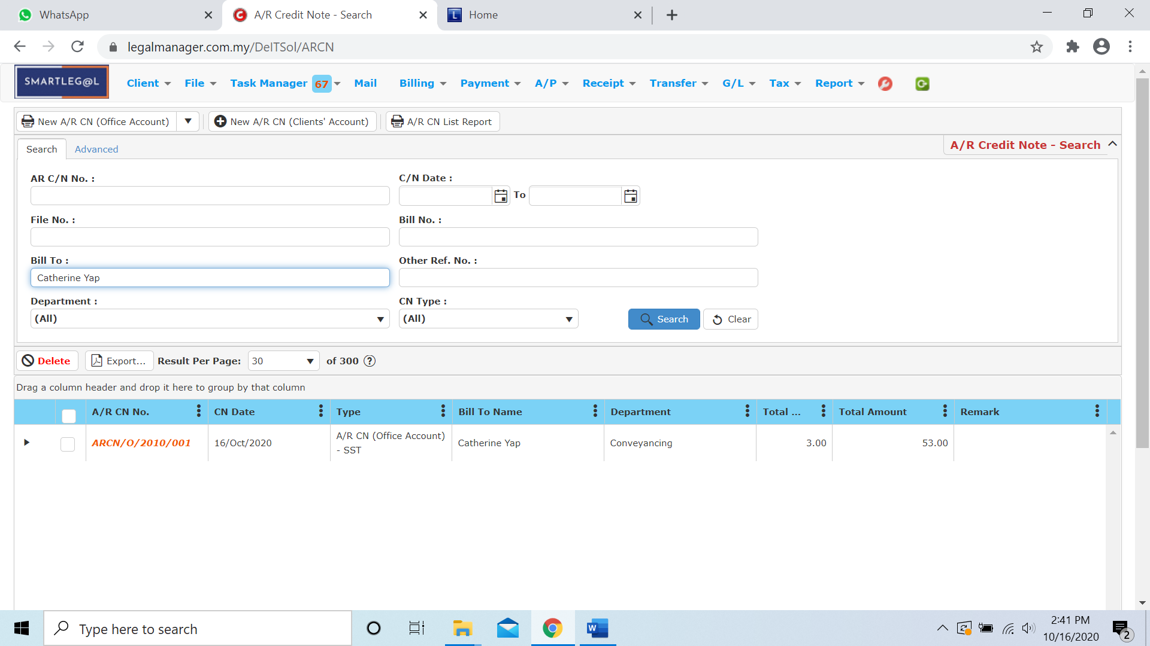

Figure: Manage A/R Credit Note – Searched Result

* After the A/R Credit Note record you searched appeal, you can choose to view, edit and preview those details by double-clicking the record.

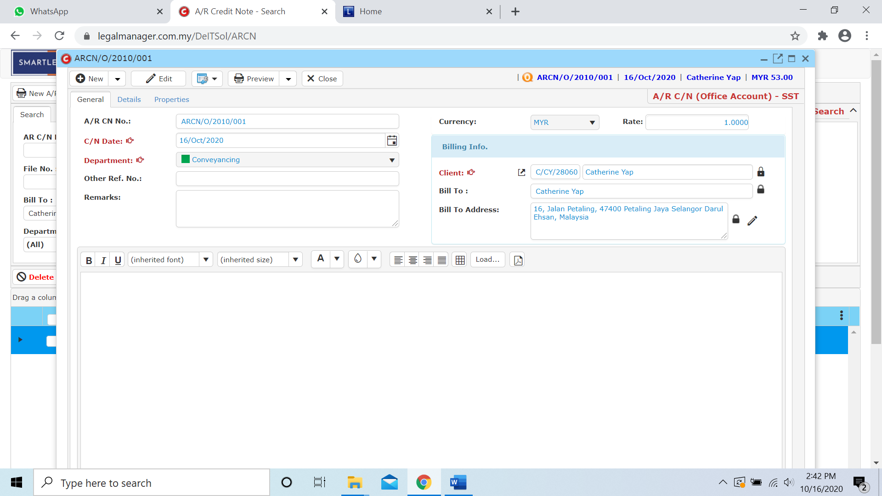

Figure: Manage A/R Credit Note Record – Searched Result, Info

* 1. **New A/R Debit Note**
* To open New A/R Credit Note, on the **SmartLeg@l** navigation, click **Billing** and go to **New A/R Debit Note**.

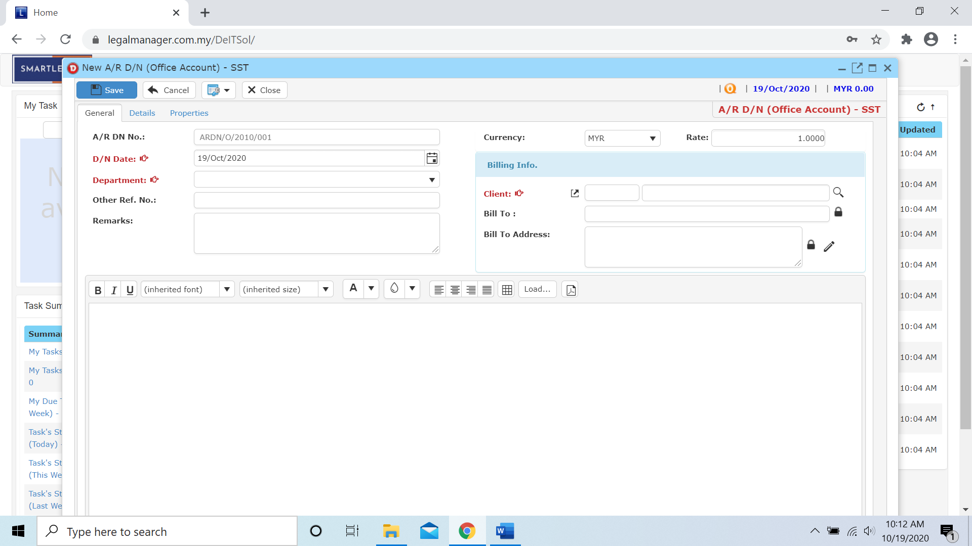

* Select C/N date and Department
* Click  icon to browse your client

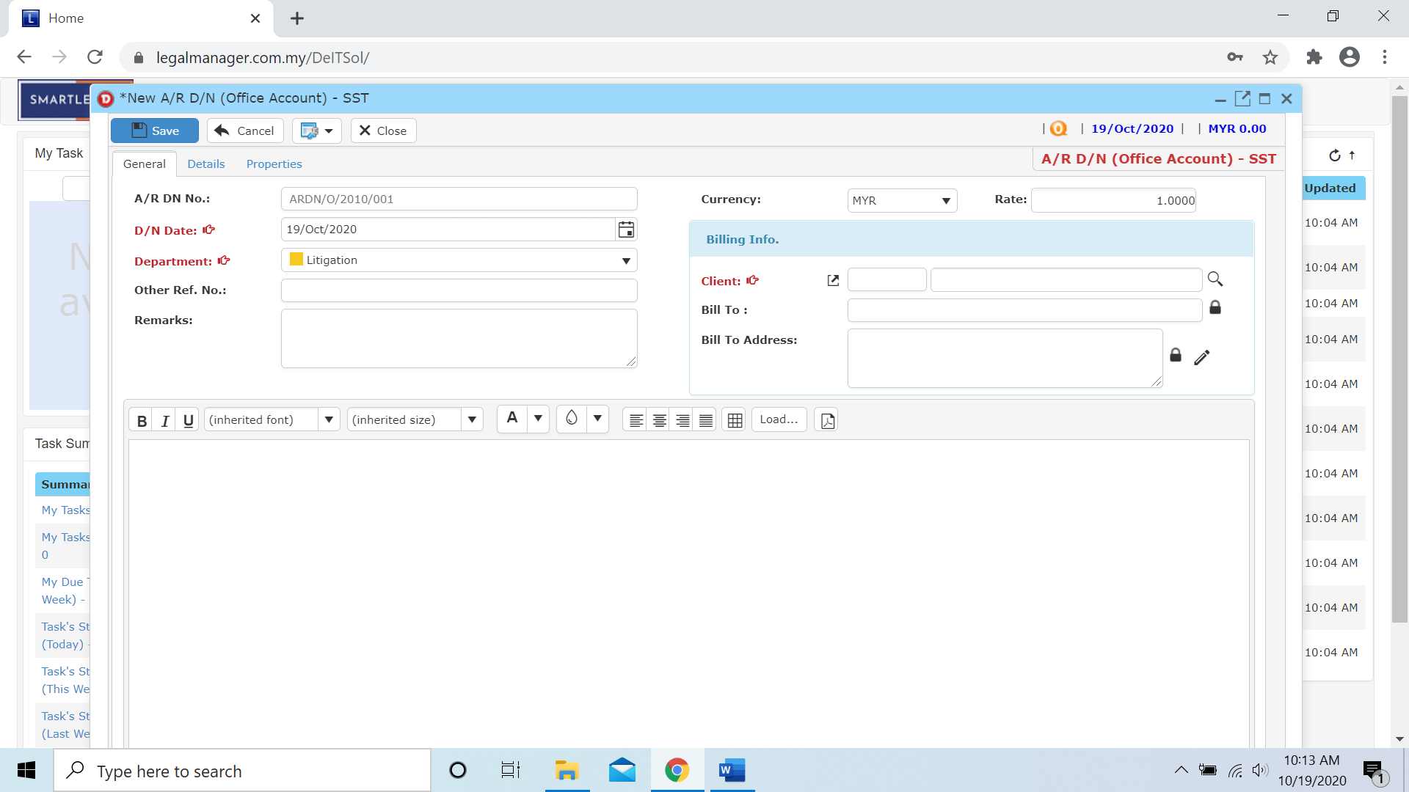

* The Search Client will pop up as figure below shown and click ‘Search’ once to show all clients

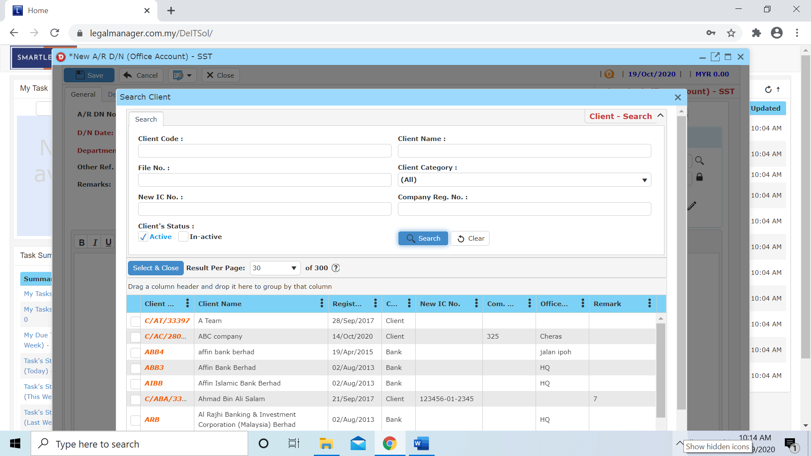

Click to next tab ‘Details’

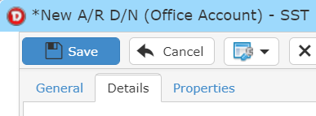

* While you click to details tab, it will auto pop up a search bill for the client you selected
* Click search to your client’s bill (e.g. Catherine Yap’s bill)

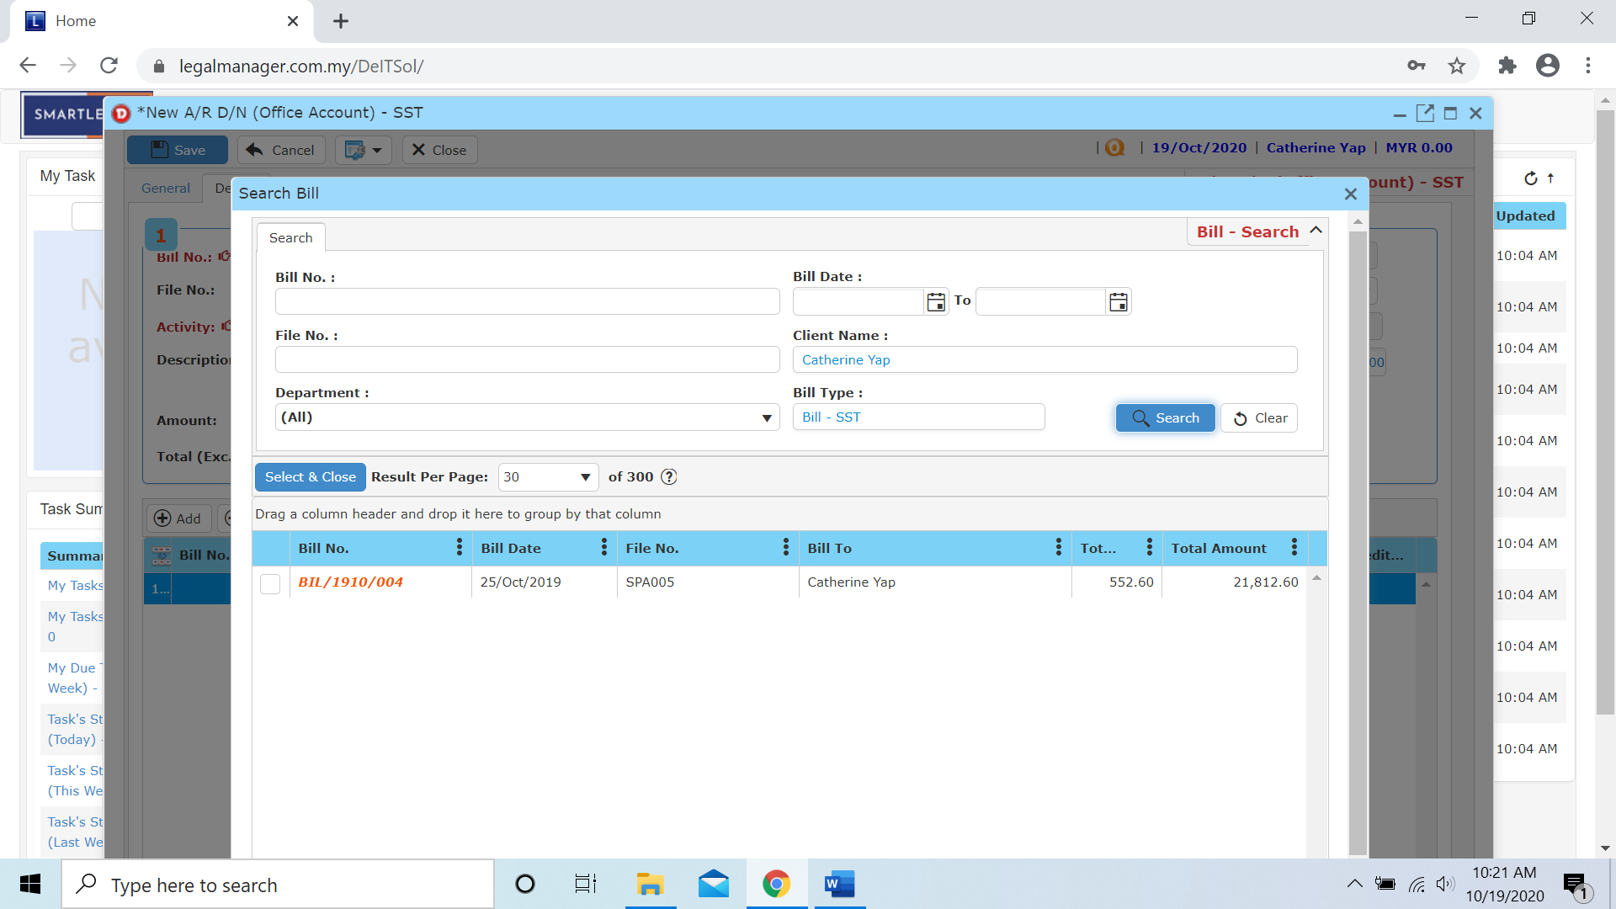

* After you select the bill, it will fill the bill no that you selected and once you insert the activity then the credit a/c will auto generate based on the activity you selected or you can select the credit a/c by yourself as well.

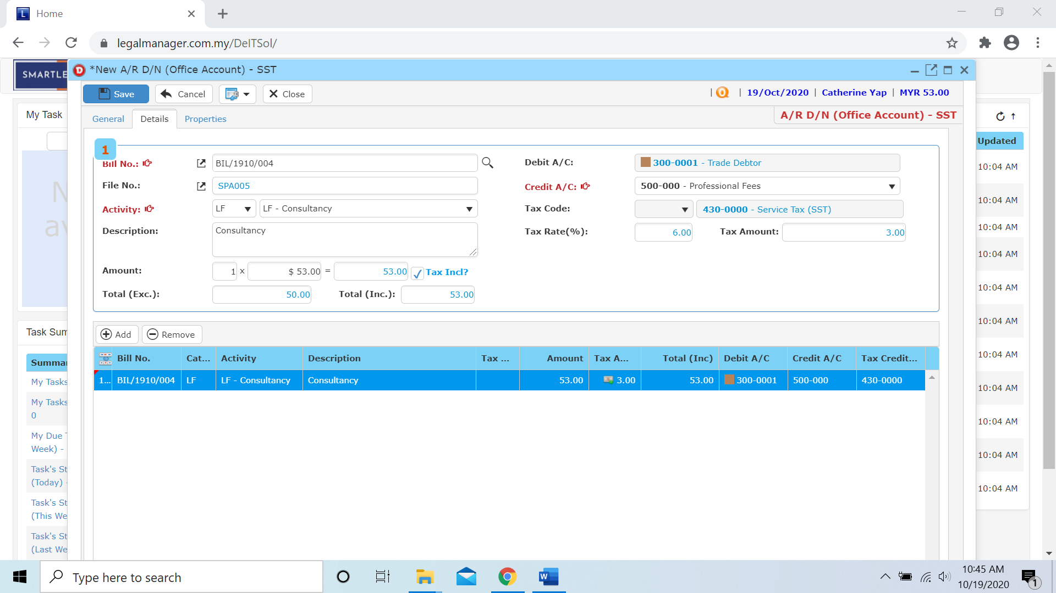

* Other than that, you can Add or Remove the bill in this section



**Add**

* When you click ‘Add’ it will come out a new row and follow the process of above select and key in the activity, credit a/c and amount.

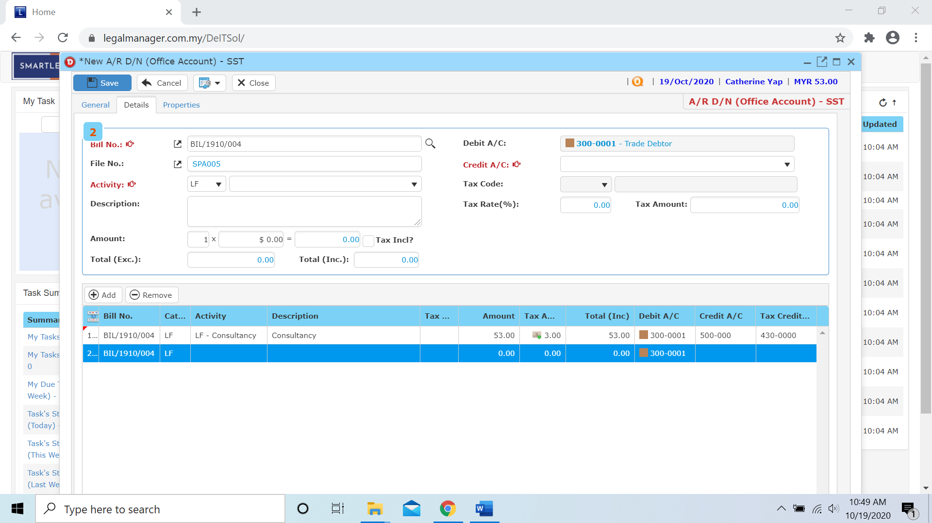

**Remove**

* For the remove, you have to select the bill in the list and click remove to erase the bill



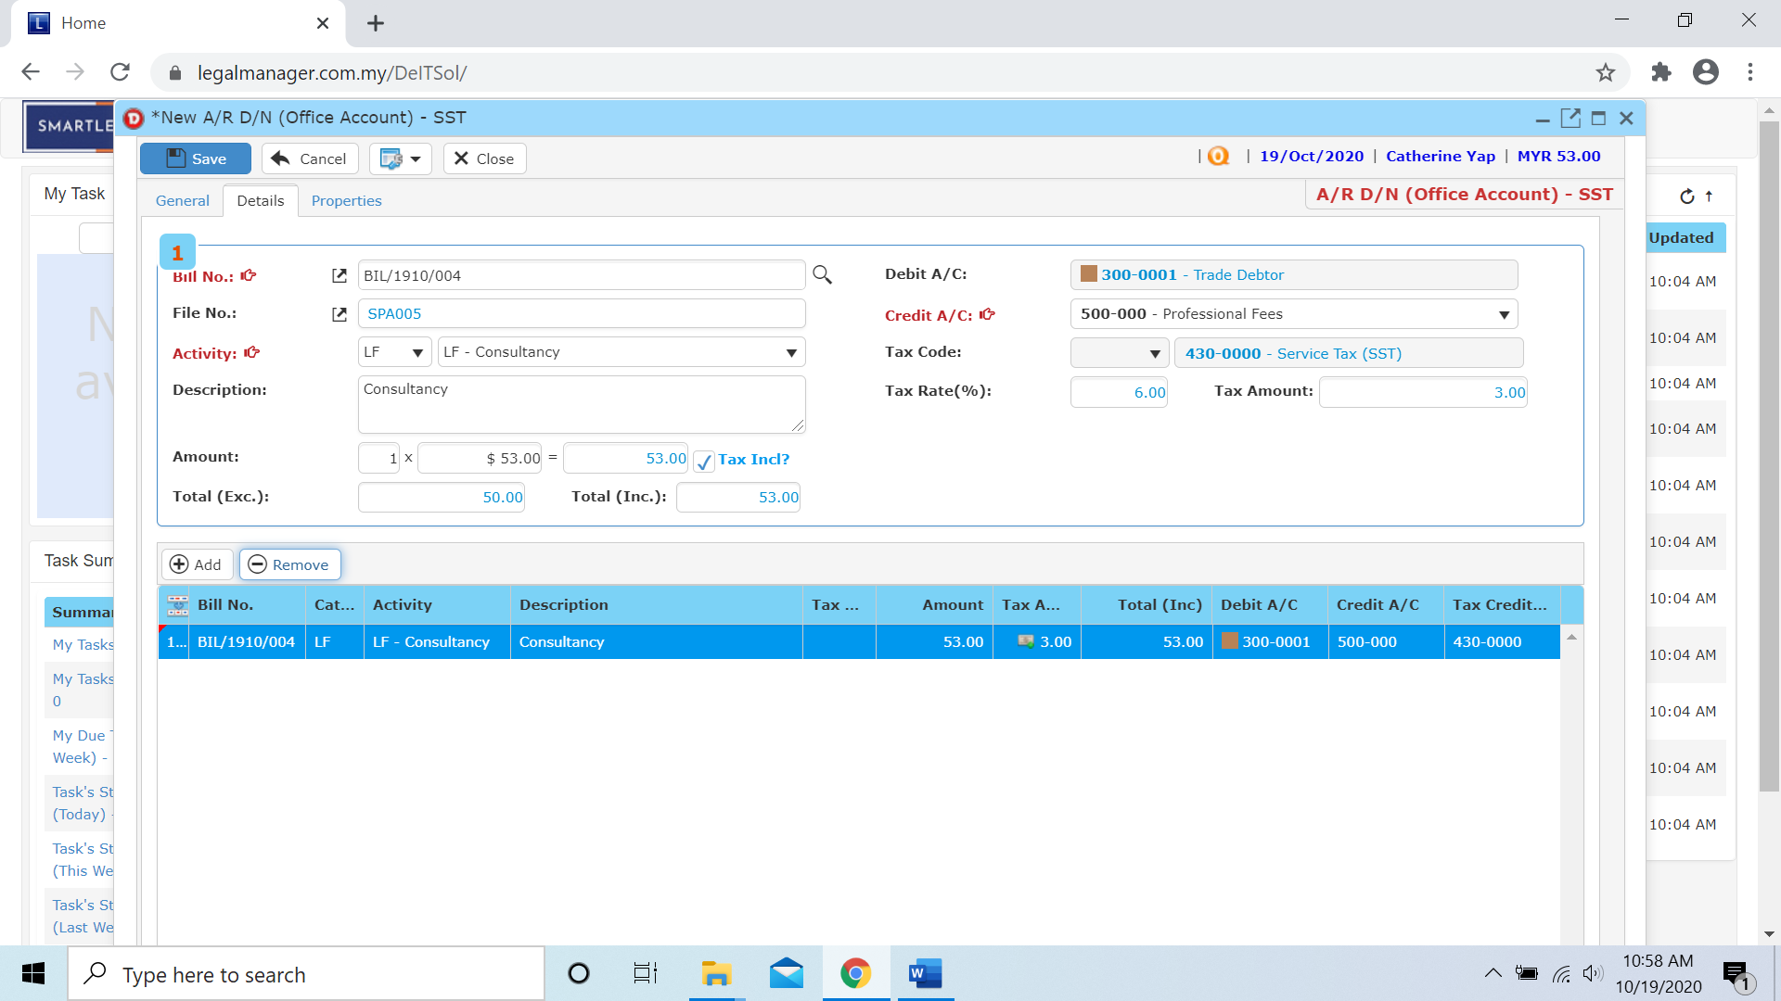

* You can click to the next tab ‘Properties’

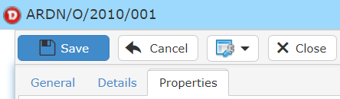

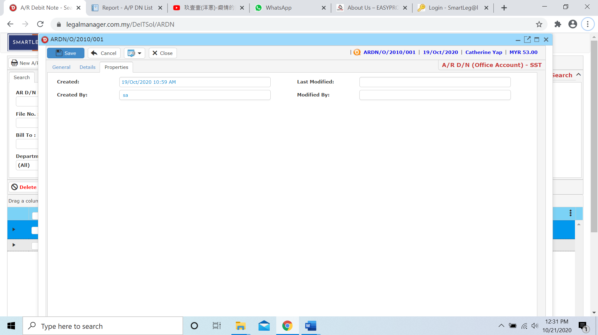

* After you finish insert all the information and details click ‘Save’
* You can view the information of the supplier once who modify the A/R Debit Note then there will show the last modified and modified by who
  1. **Manage A/R Debit Note**

This option enables you to add, edit, and delete a A/R Debit Note Record. It also allows you to keep track of your A/R Debit Note record details and all related information.

* To open Manage A/R Debit Note, on the **SmartLeg@l** navigation, click **Billing** and go to **Manage A/R Debit Note** then search the A/R Debit Note record you wish to modify.

**Manage A/R Debit Note**

* Search the A/R Debit Note record you wish to manage through type the search criteria or search by advanced.
* To start a new search or to clear the search results, click ‘**Clear**’.

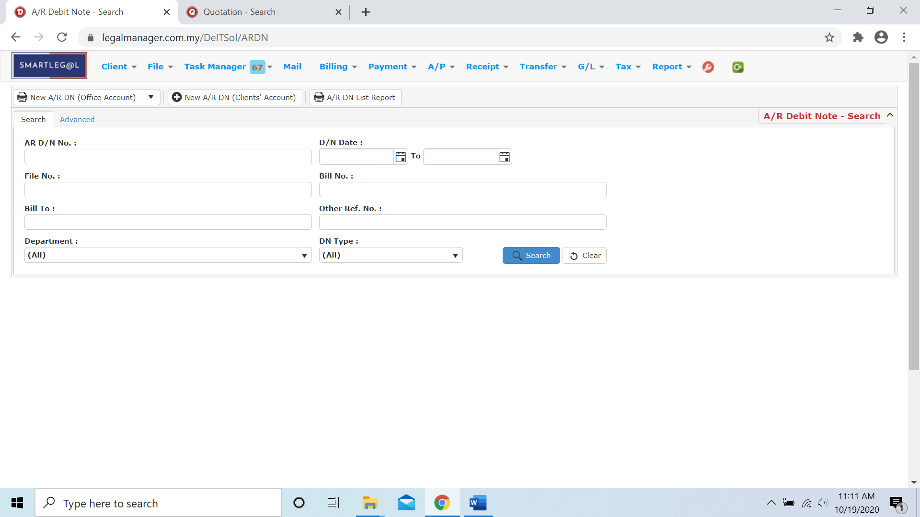

Figure: Manage A/R Debit Note - Search

**Advanced Search**

* This function can be used to find a task by searching other information that is not captured in the ‘General’ section.
* Define search criteria:

**- Field** - Choose the field you want to search.

**- Condition** - Search condition

**- Value** - Type in the detail you want to find.

* Click ‘**Add to list**’, to define more than one criteria.
* Click ‘**Find**’, search results will be displayed at search record list. You can open an item in the search results list by double-clicking.
* To start a new search or to clear the search results, click ‘**Clear**’.
* Click ‘**Export**’ to print the desired search results in txt, excel or html format.

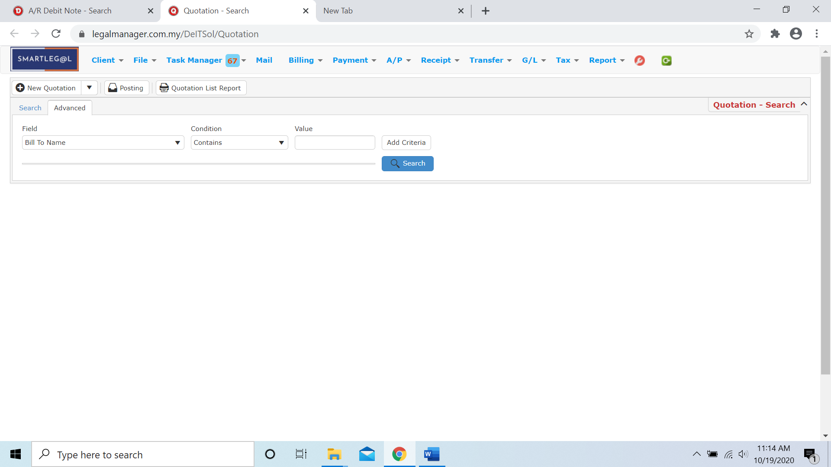

Figure: Manage A/R Debit Note– Advanced Search

* Other than Search A/R Debit Note you can create 3 type of new A/R DN of official account by clicking  and it will appeal a combo box as figure below shown

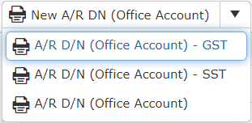

* You can also create A/R Debit Note of client’s account by clicking 
* It will pop up a input form for A/R Debit Note of client’s account

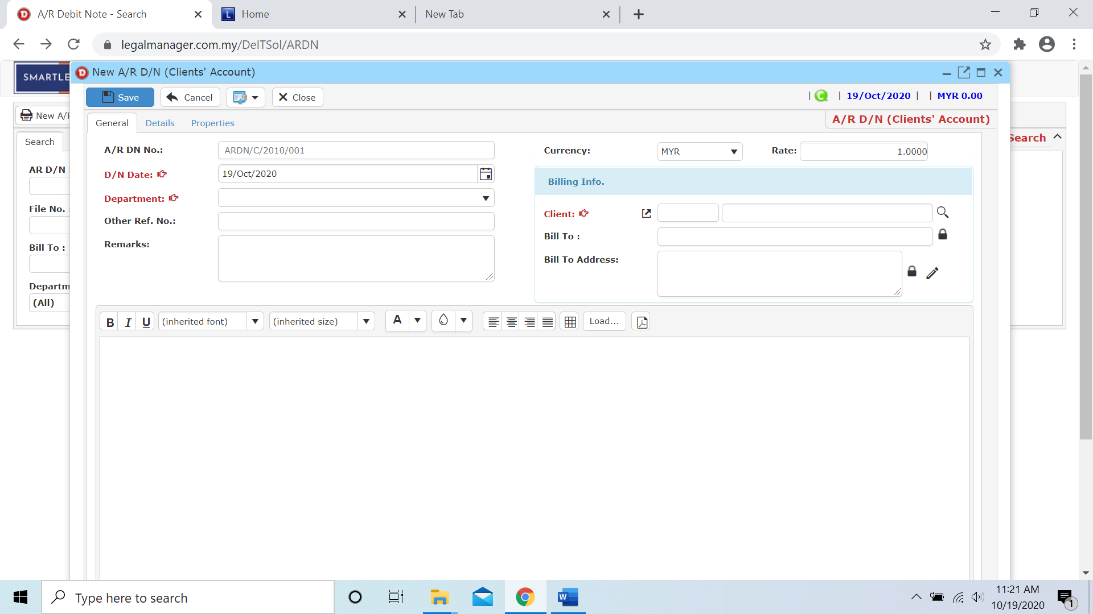

* You can print or preview the A/R Debit Note List Report while you click to 
* Then it will pop-up a A/R DN List Report you can insert your requirement and filter the report

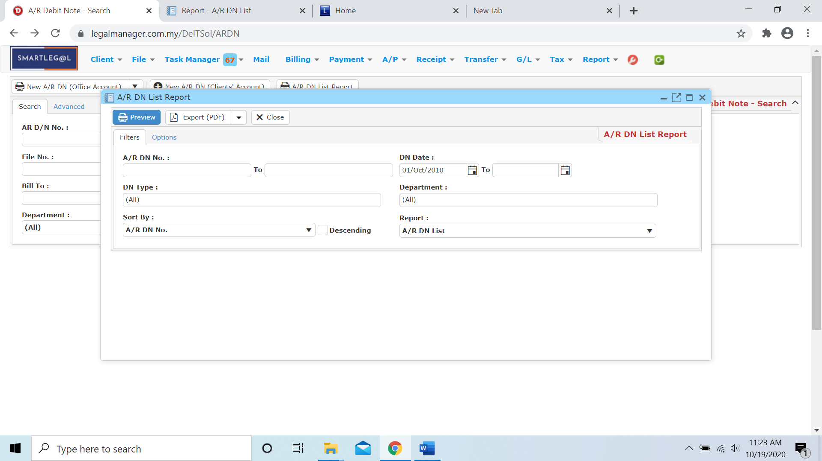

* Besides, you can preview the report as figure below shown

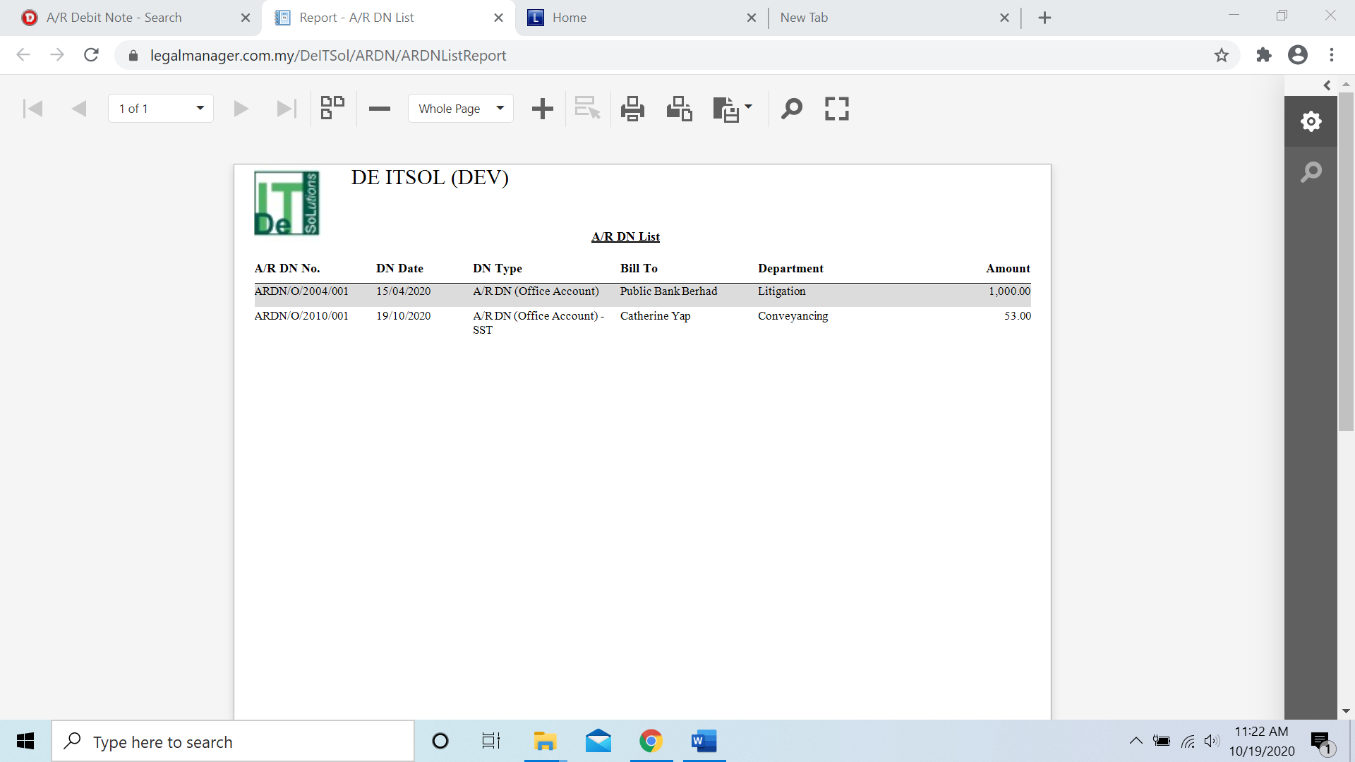

* You can also export the report into PDF or excel by clicking

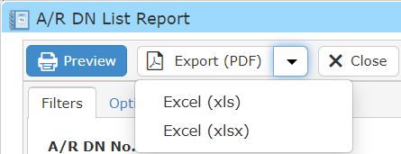

**Searched Result**

* Click ‘**Search**’ once, to show all A/R Debit Note Record
* The Searched result will appeal at below, otherwise it will shown no record availble if the quotation you searched do not exist.
* Click ‘**Export**’ to print the desired search results in txt, excel or html format.

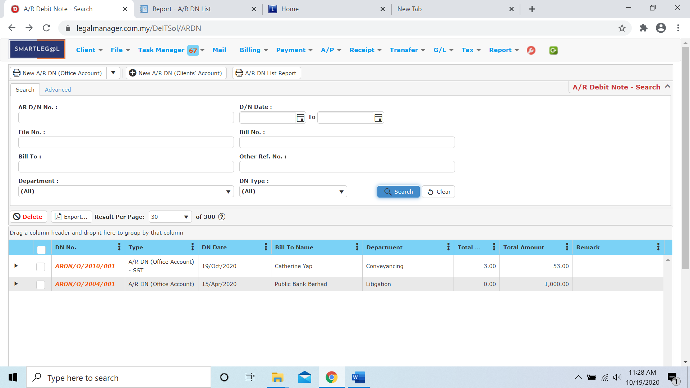

Figure: Manage A/R Debit Note– Search All

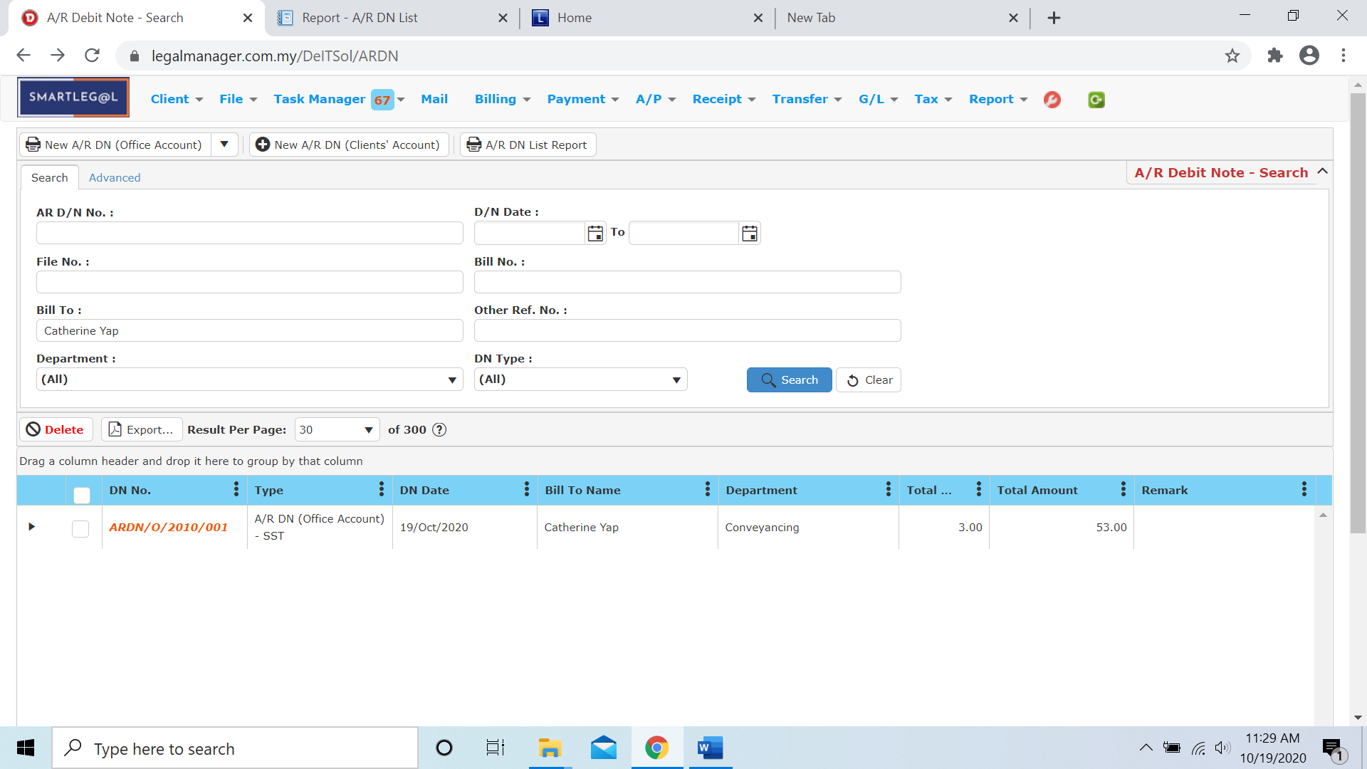

Figure: Manage A/R Debit Note – Searched Result

* After the A/R Debit Note record you searched appeal, you can choose to view, edit and preview those details by double-clicking the record.

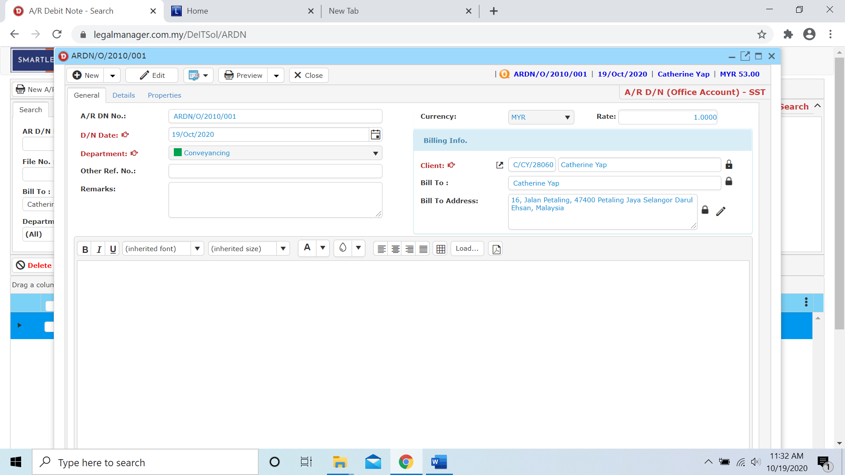

Figure: Manage A/R Debit Note Record – Searched Result, Info

* 1. **New Past Bill**
* To open New Past Bill, on the **SmartLeg@l** navigation, click **Billing** and go to **New Past Bill** then you can create a past bill.

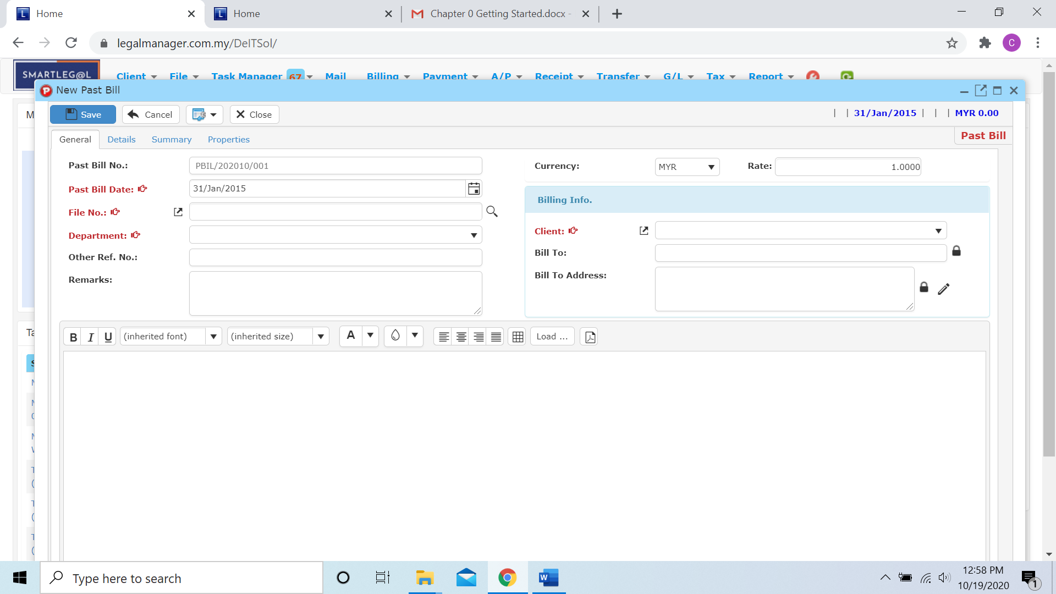

* Key in the past bill date, by default the date will auto generate by the date you click to new past bill
* You can click the calendar icon  to select a date on calendar

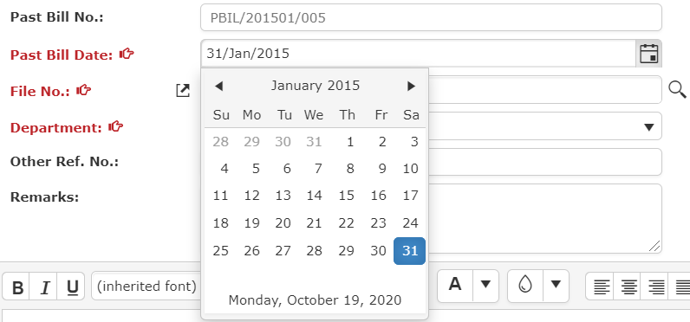

* Fill in file no and you can click the  icon to browse the file master
* Key in information to search or click once to show all files

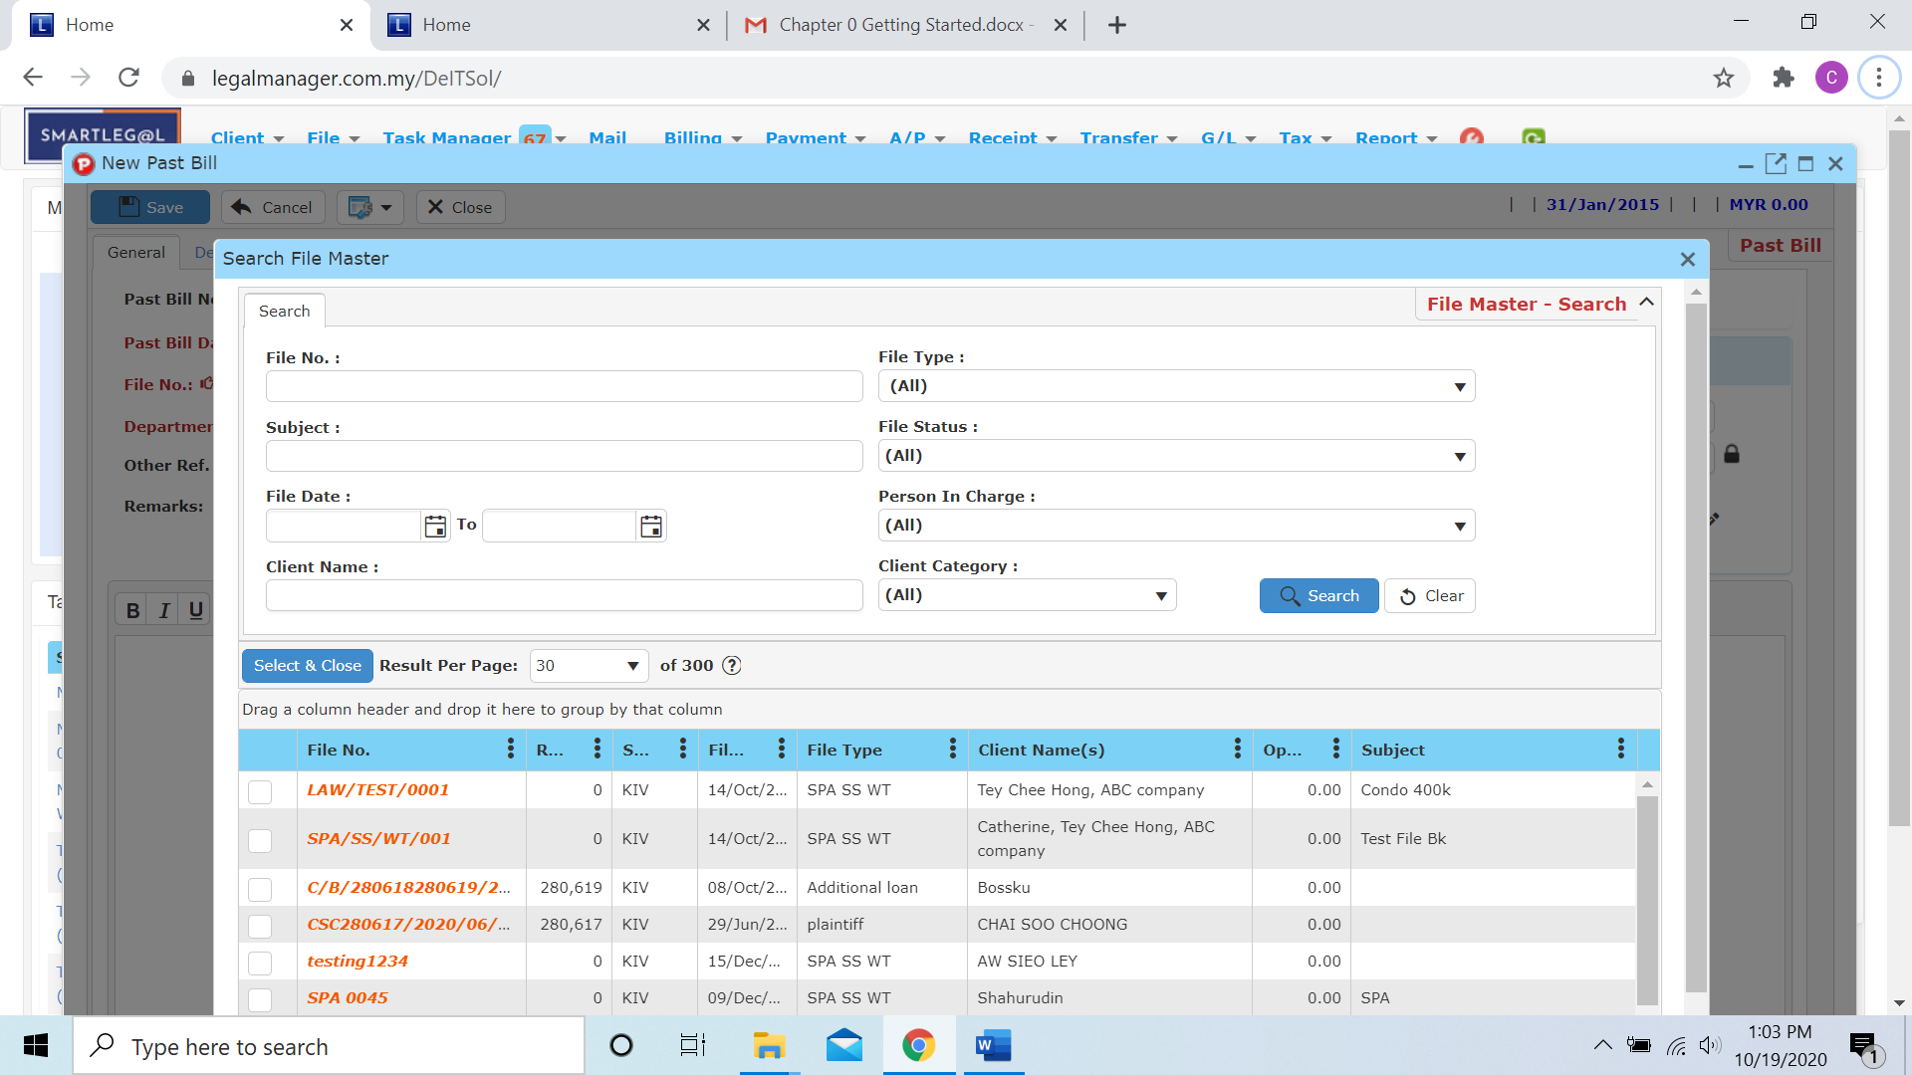

* Select a depart from the combo box

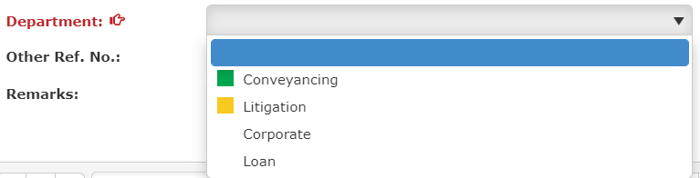

* Click to the next tab ‘Details’

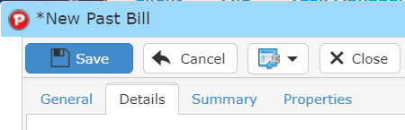

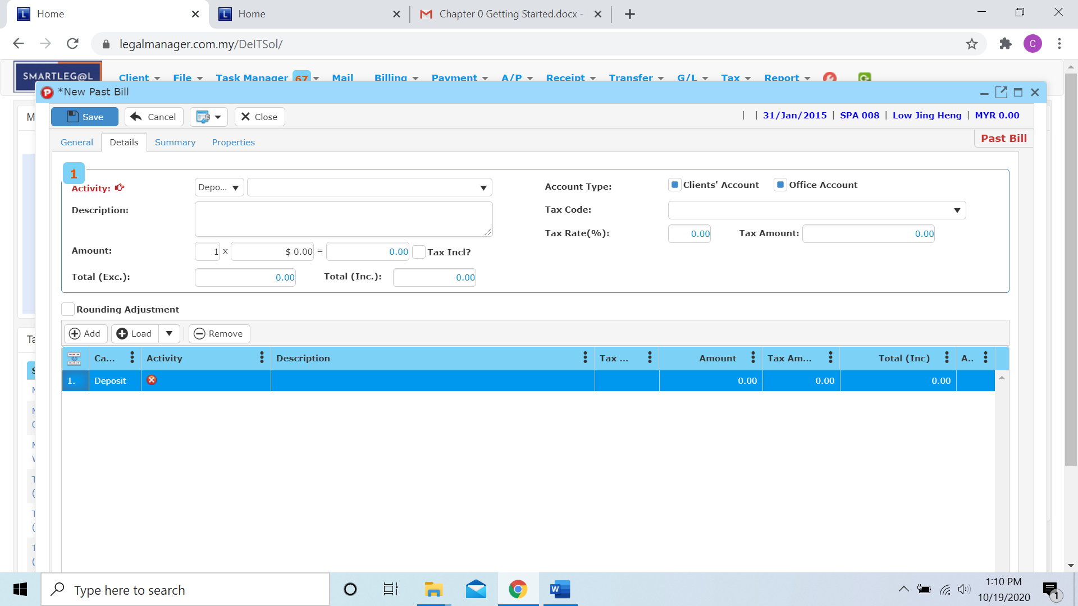

* You have to select the activity and key in the amount

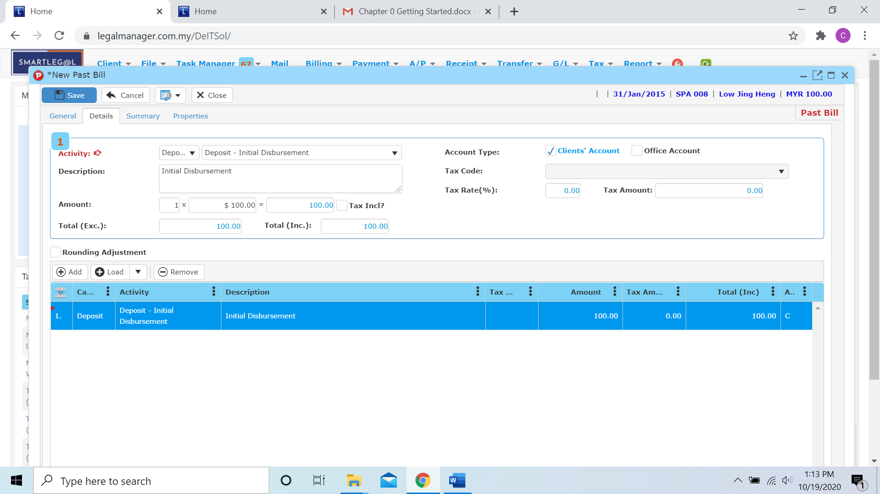

**Add**

* You can add activity to the bill by clicking  then it will generate a new row for you to insert activity and amount

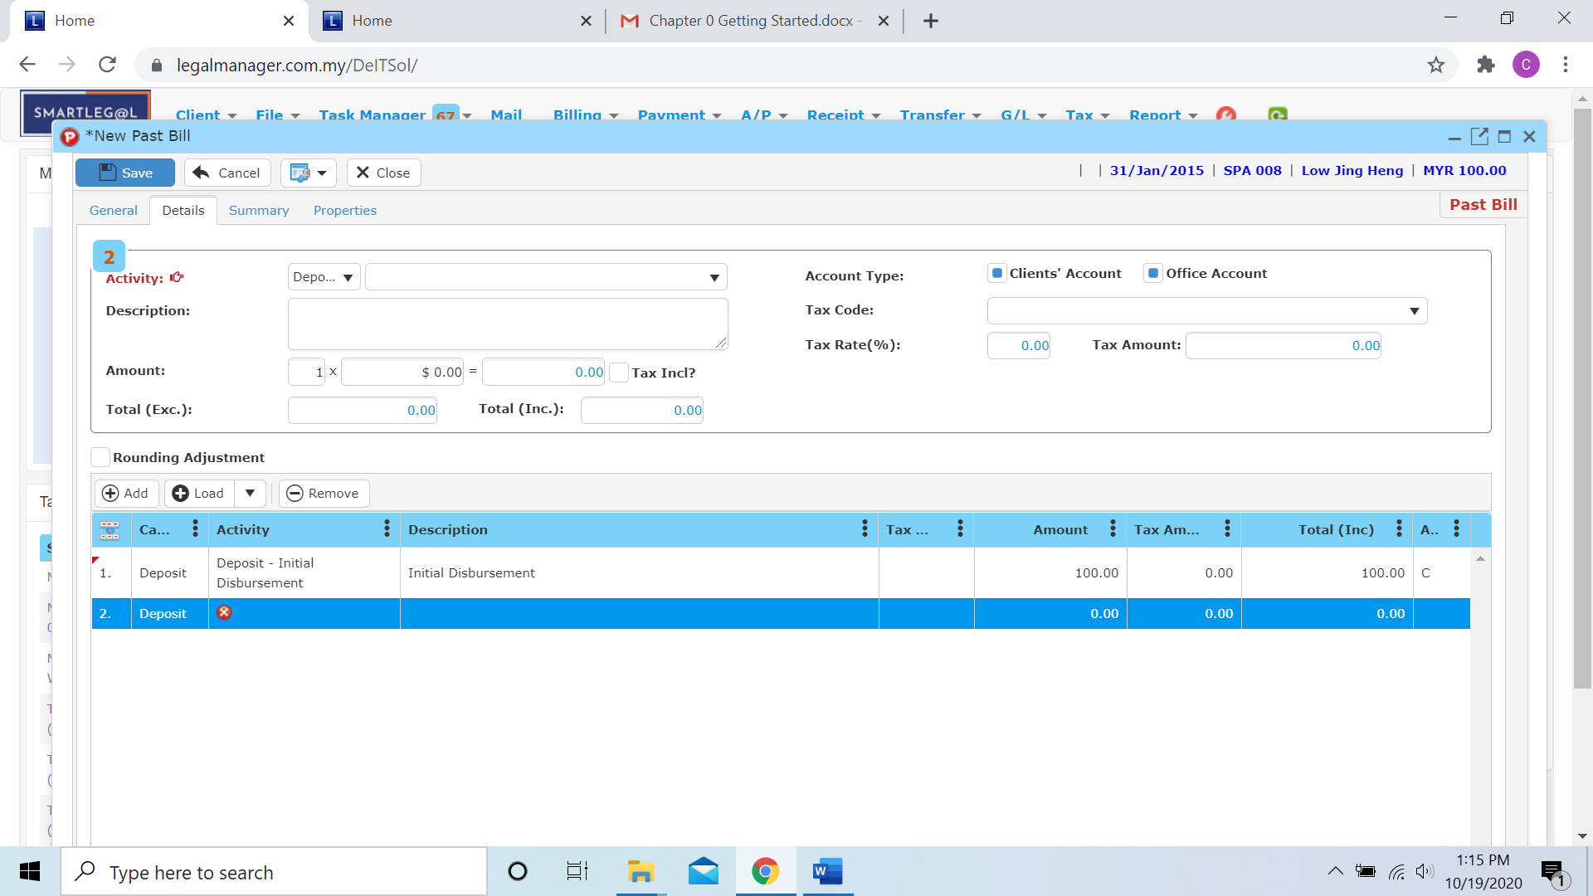

**Load**

* Besides, you can click  to load a bill template

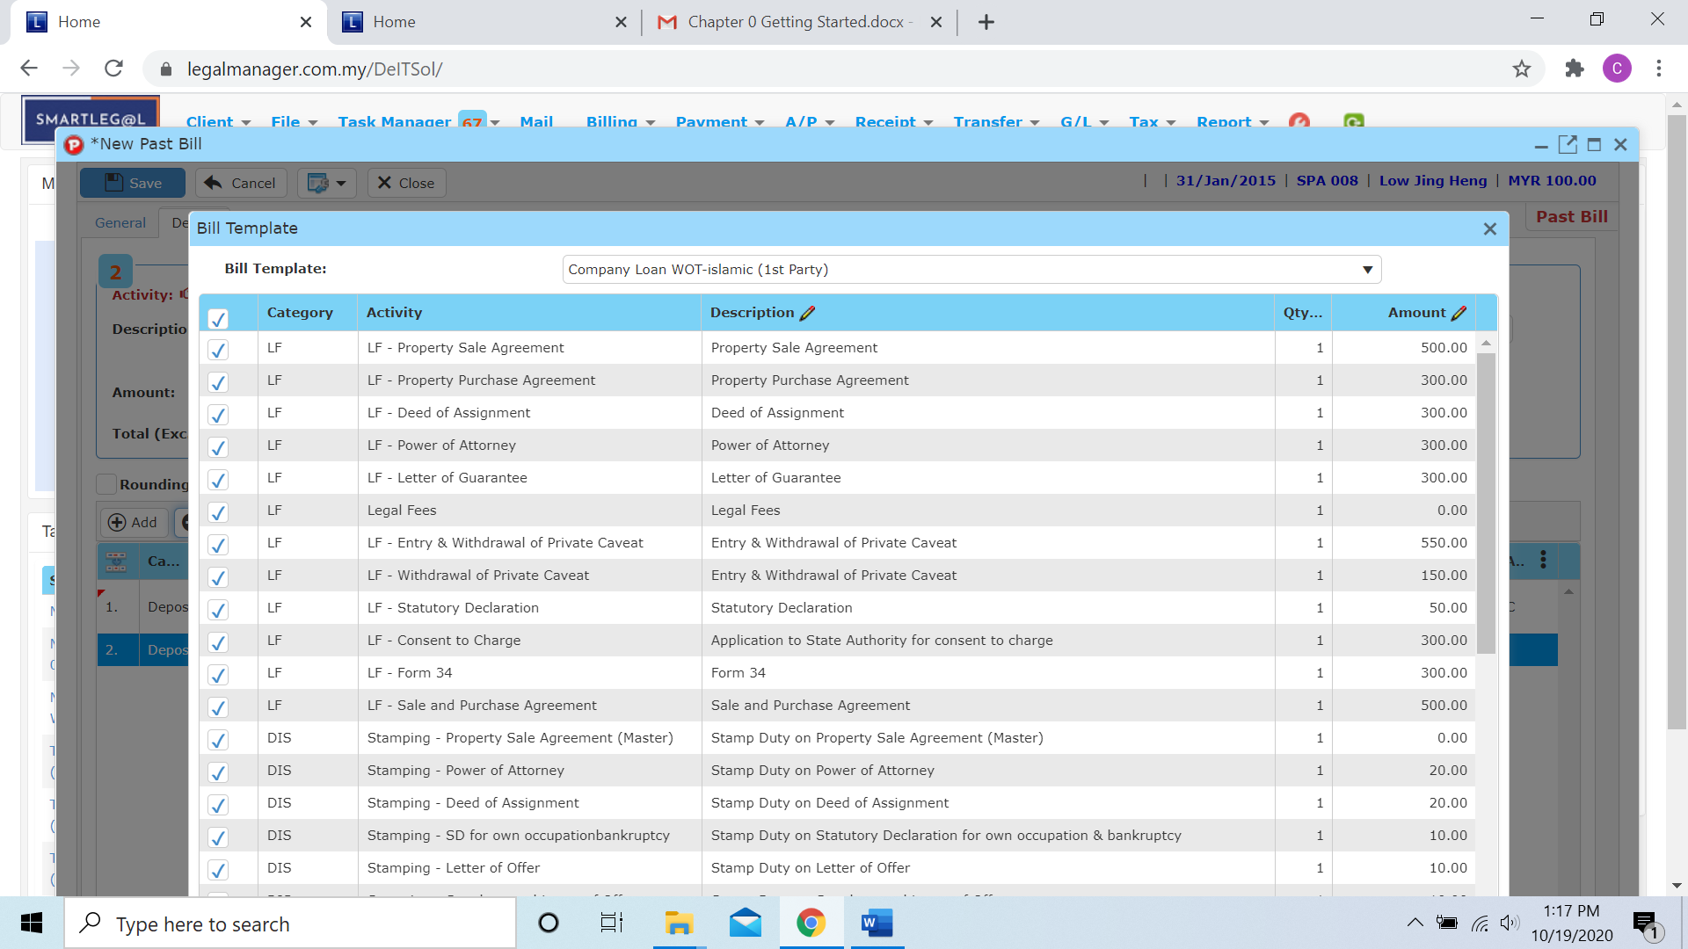

* You can select the bill template you want from the drop down box

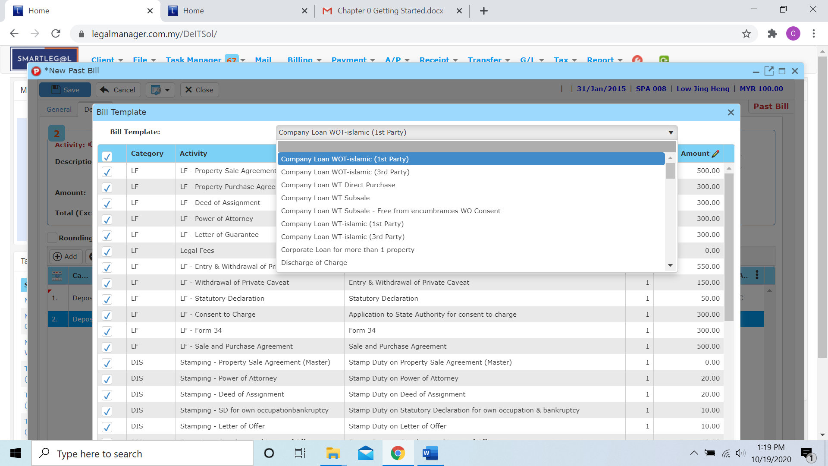

**Remove**

* You can remove any activity row by select the row you want to remove and click ‘Remove’. (e.g. I choose to the blank row)

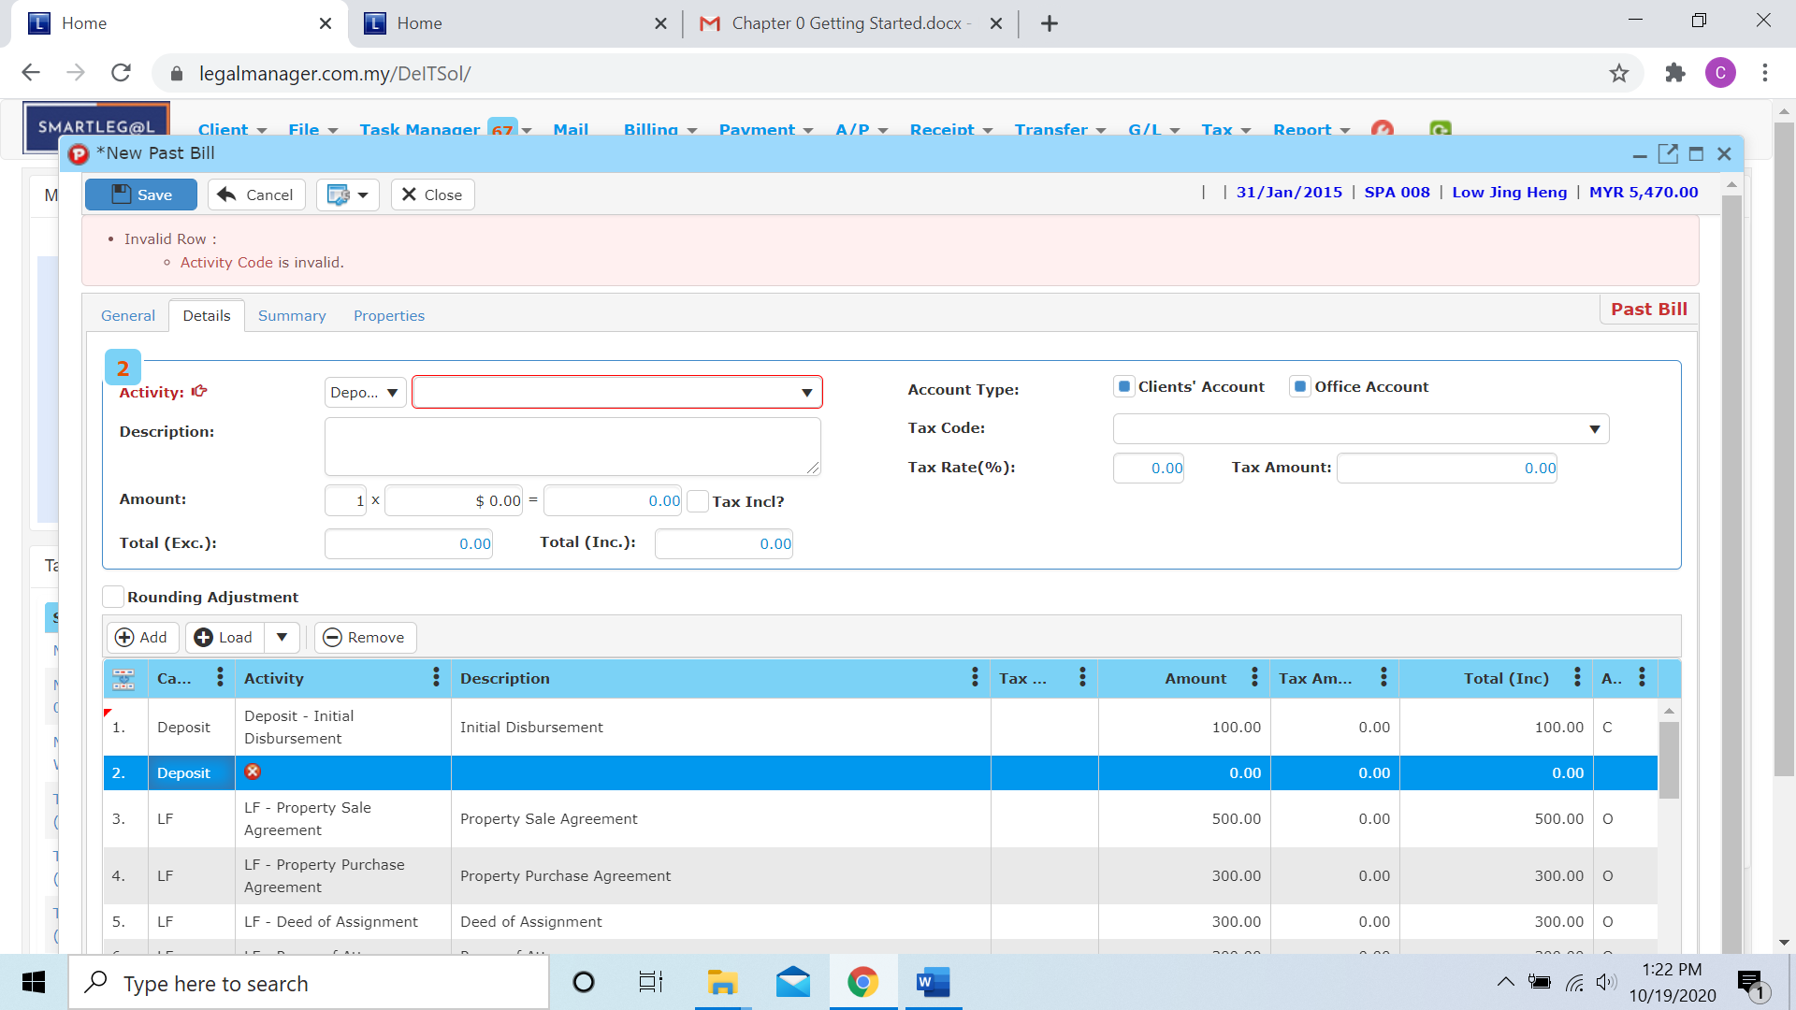

* After I click to the 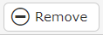 , it will delete the row

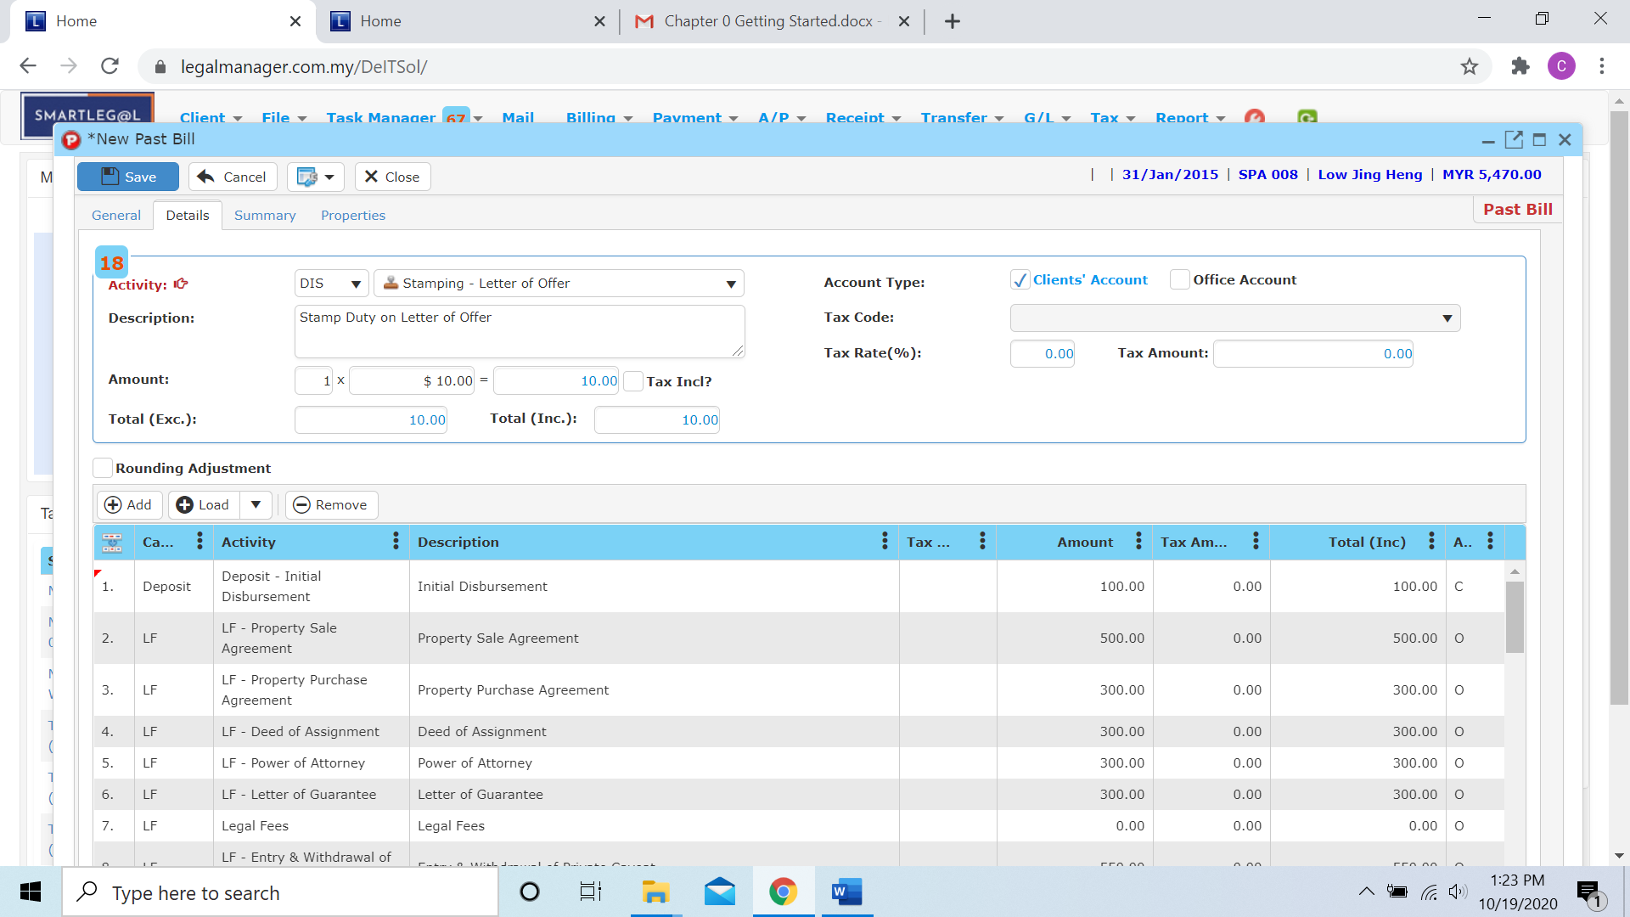

* After that, when you click to the ‘Summary’ tab

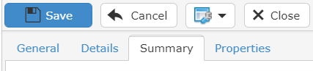

* It will calculate and generate a summary figure that based on the activity or bill template in the details

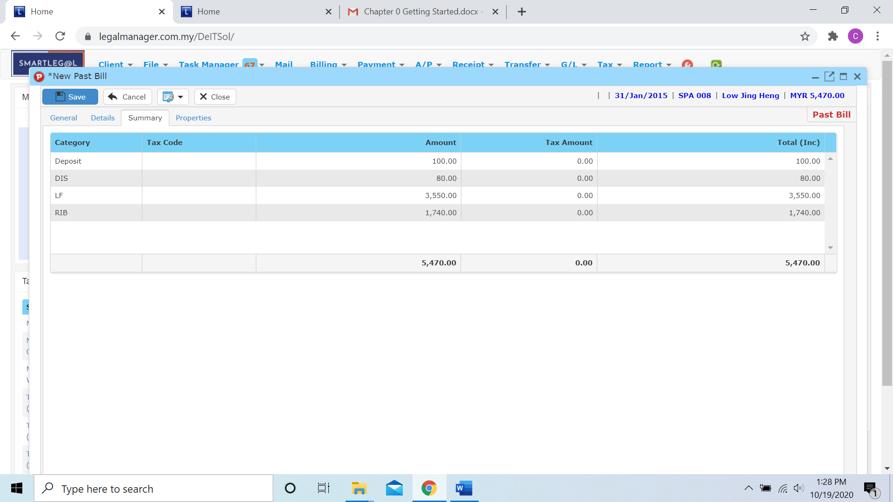

* When you click to the ‘Properties’ tab

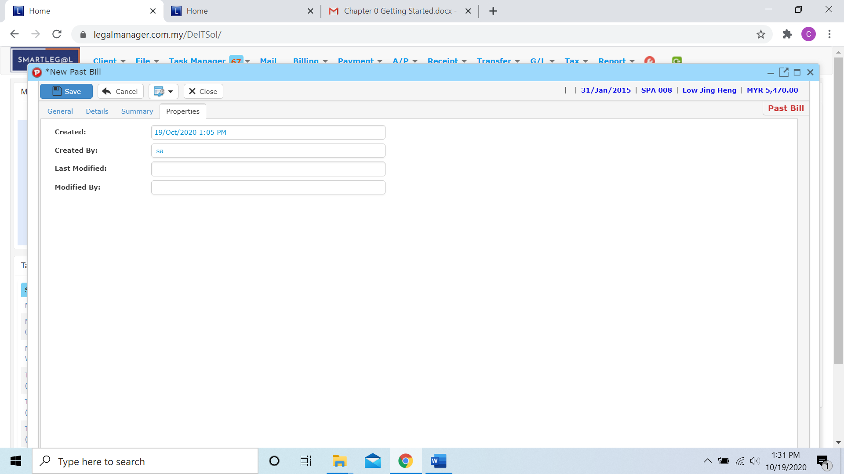

* You can view the information of the past bill once who modify the past bill then there will show the last modified and modified by who
* Once you finish all the instruction above, click ‘Save’ then you are done to create a new past bill.
  1. **Manage Past Bill**

This option enables you to add, edit, and delete a Past Bill Record. It also allows you to keep track of your past bill record details and all related information.

* To open Manage Past Bill, on the **SmartLeg@l** navigation, click **Billing** and go to **Manage Past Bill** then search the past bill record you wish to modify.

**Manage Past Bill**

* Search the past bill record you wish to manage through type the search criteria or search by advanced.
* To start a new search or to clear the search results, click ‘**Clear**’.

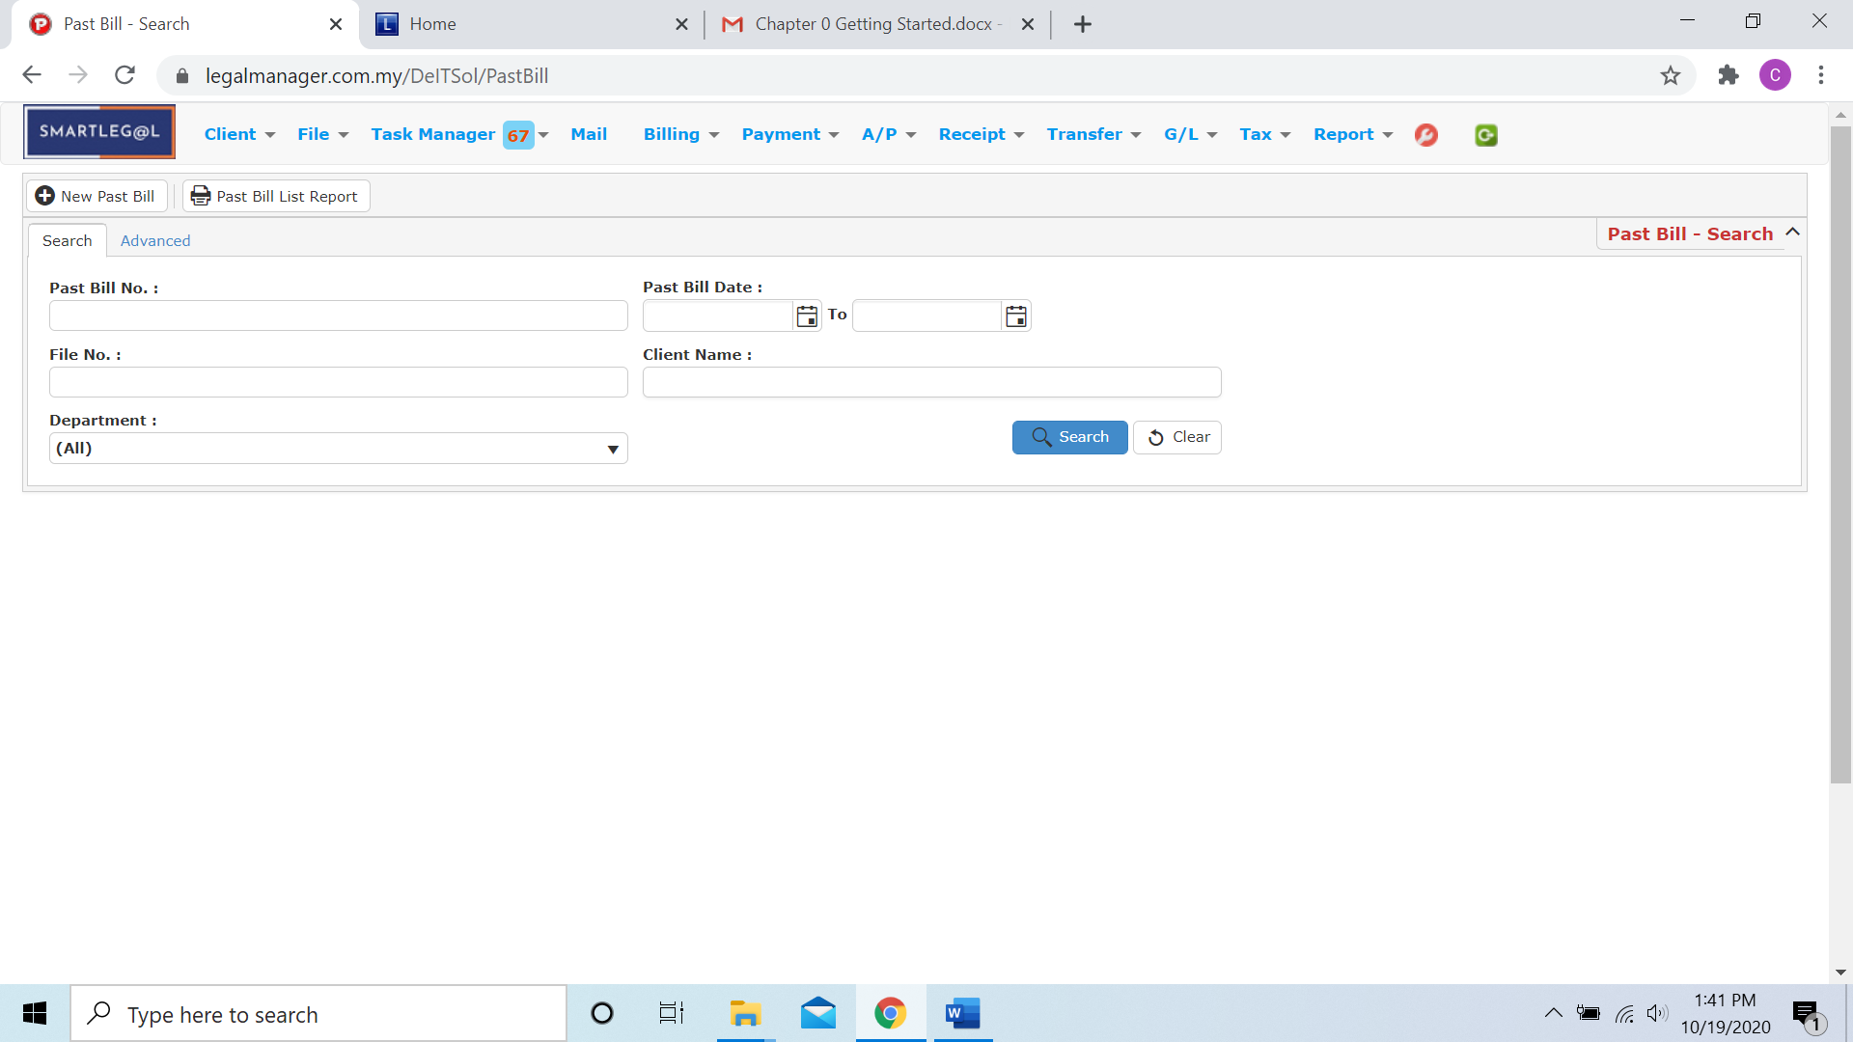

Figure: Manage Past Bill - Search

**Advanced Search**

* This function can be used to find a task by searching other information that is not captured in the ‘General’ section.
* Define search criteria:

**- Field** - Choose the field you want to search.

**- Condition** - Search condition

**- Value** - Type in the detail you want to find.

* Click ‘**Add to list**’, to define more than one criteria.
* Click ‘**Find**’, search results will be displayed at search record list. You can open an item in the search results list by double-clicking.
* To start a new search or to clear the search results, click ‘**Clear**’.
* Click ‘**Export**’ to print the desired search results in txt, excel or html format.

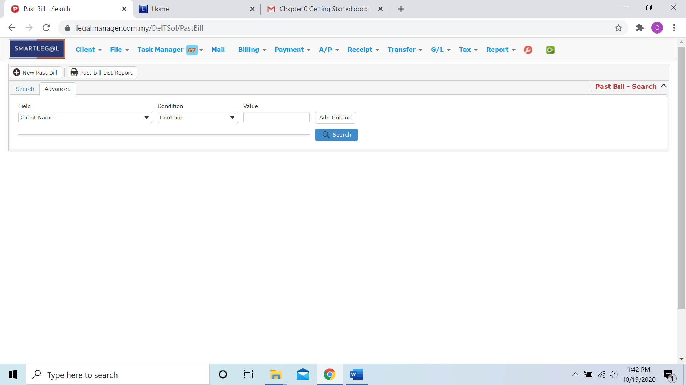

Figure: Manage Past Bill– Advanced Search

* You can choose to create a new past bill by click  and refer to ‘Chapter 5.12 New Past Bill’
* You can print or preview the Past Bill List Report while you click to 
* Then it will pop-up a Past Bill List Report you can insert your requirement and filter the report

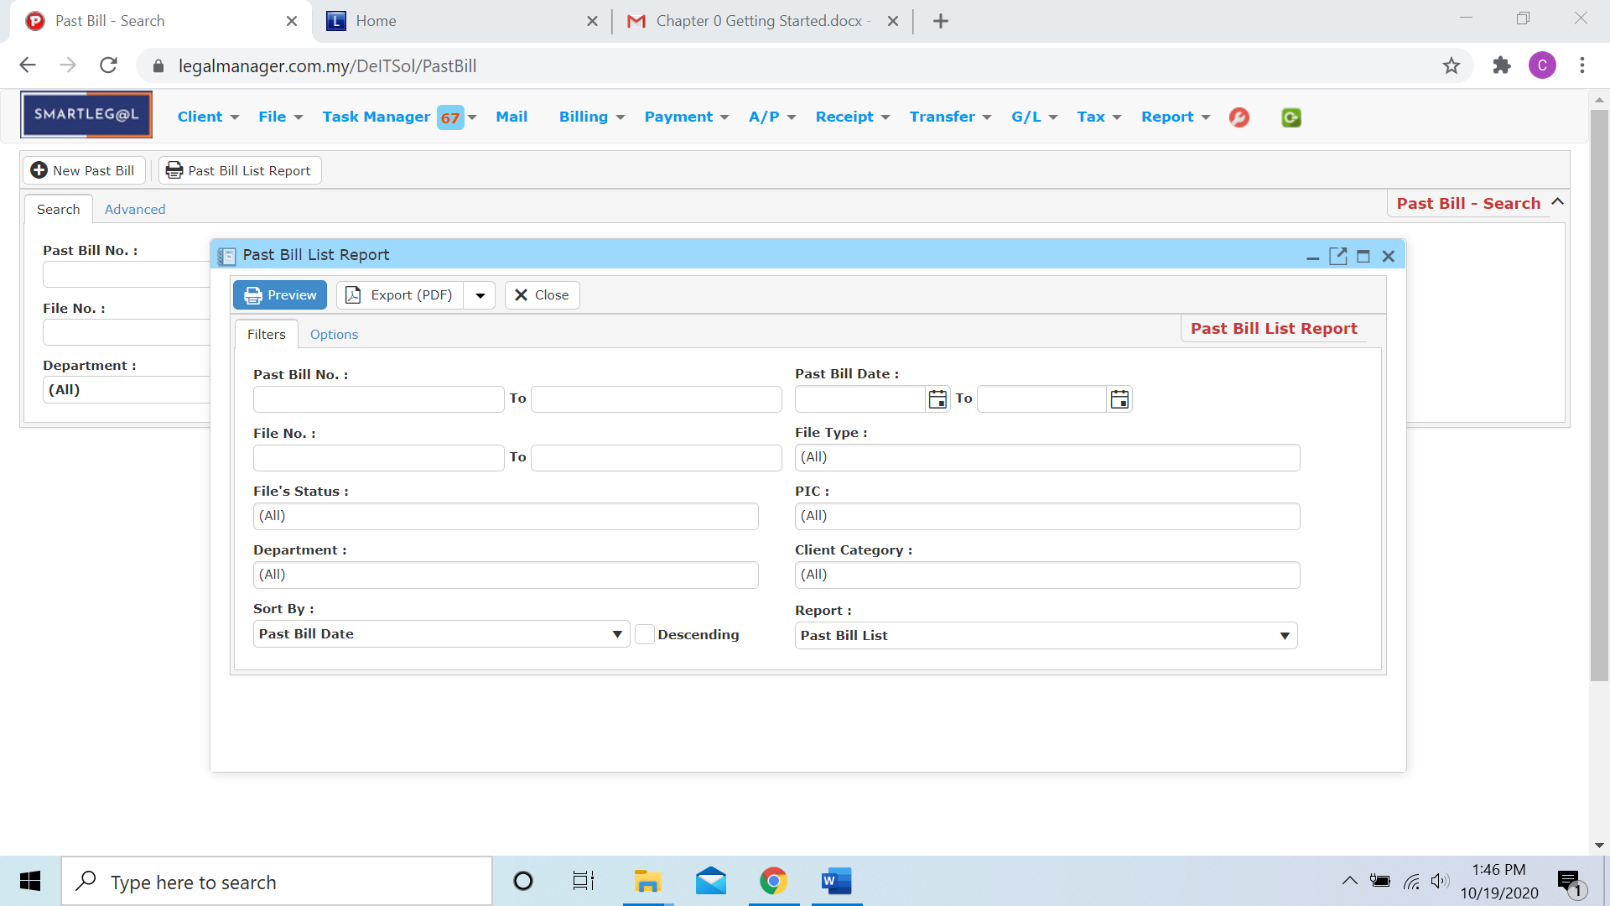

* Besides, you can preview the report as figure below shown

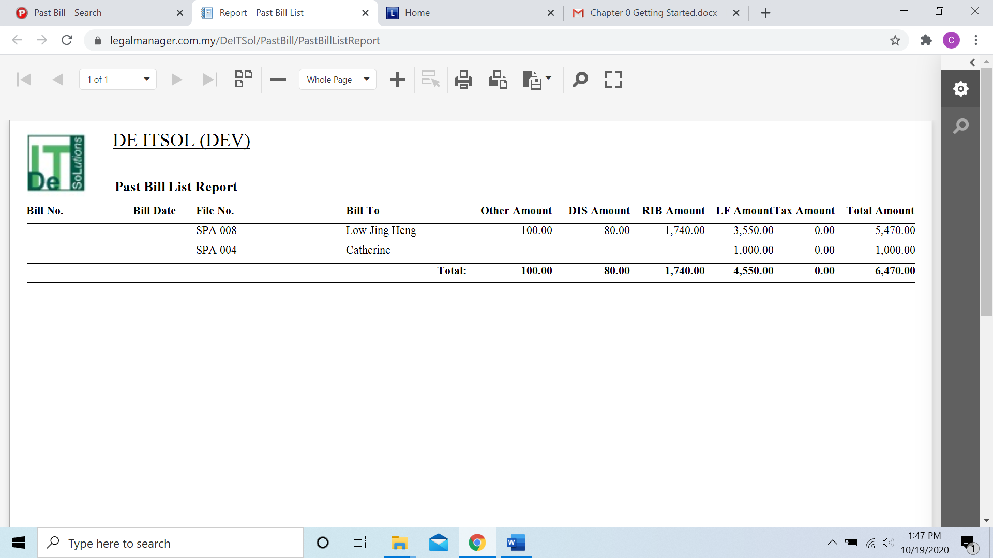

* You can also export the report into PDF or excel by clicking

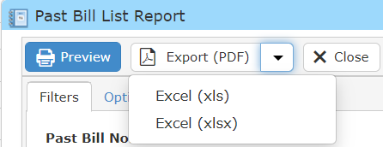

**Searched Result**

* Click ‘**Search**’ once, to show all A/R Credit Note Record
* The Searched result will appeal at below, otherwise it will shown no record availble if the quotation you searched do not exist.
* Click ‘**Export**’ to print the desired search results in txt, excel or html format.

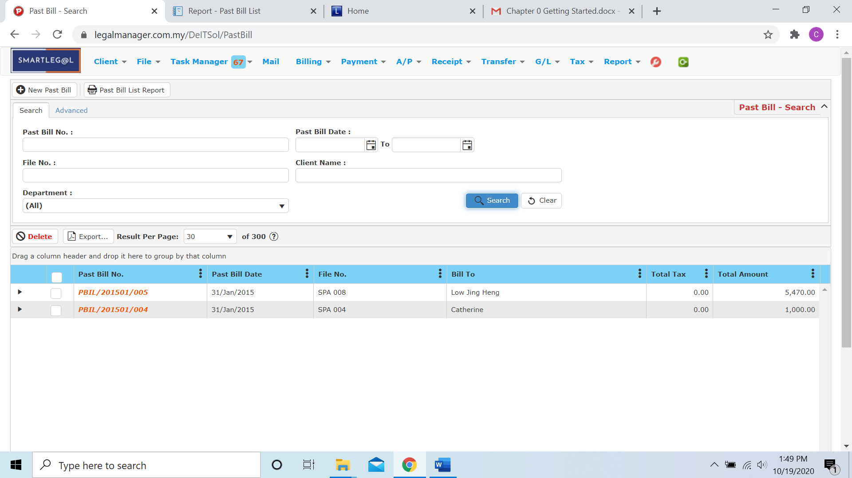

Figure: Manage Past Bill – Search All

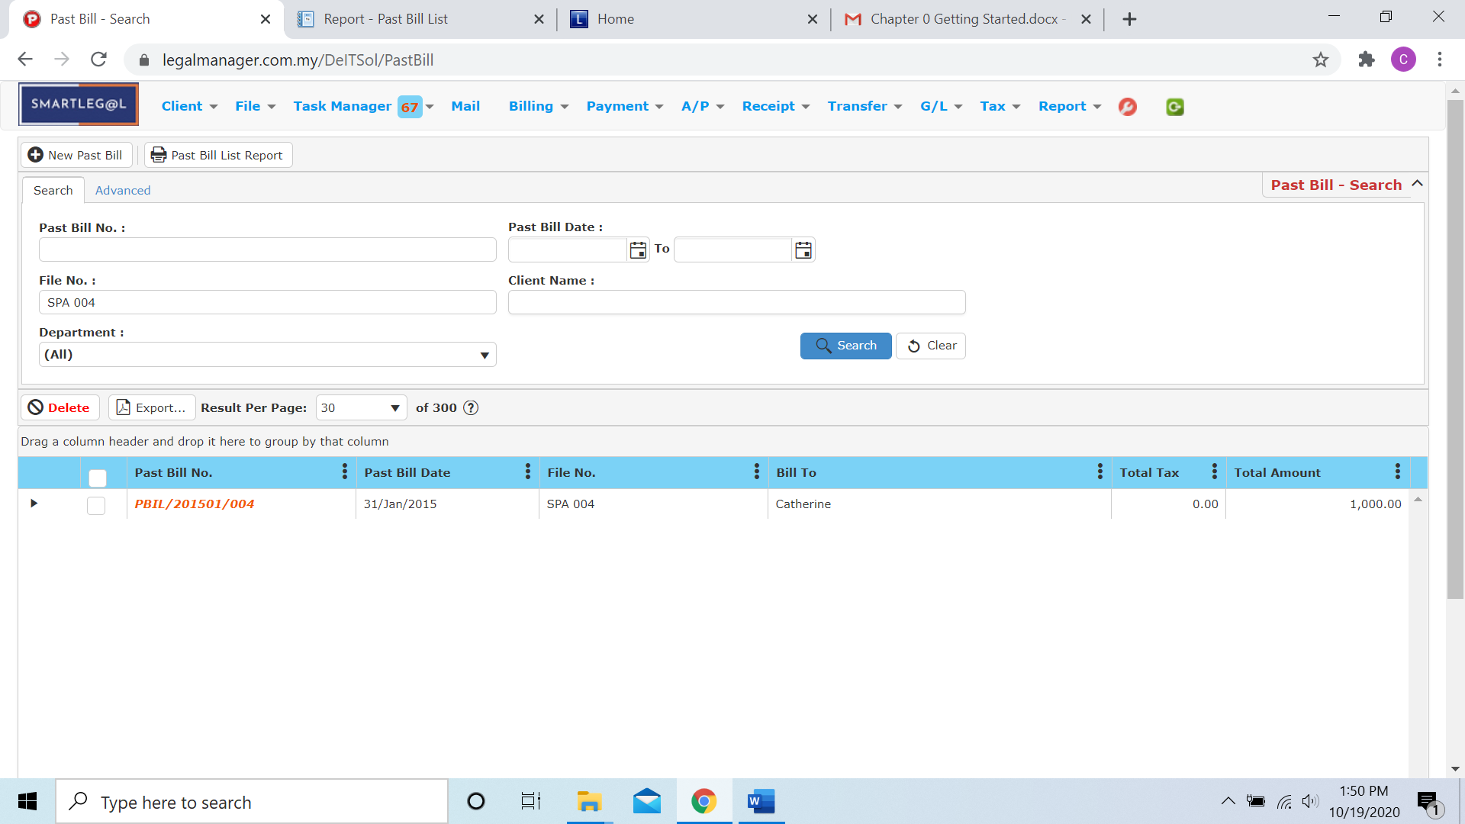

Figure: Manage Past Bill – Searched Result

* After the A/R Credit Note record you searched appeal, you can choose to view, edit and preview those details by double-clicking the record.

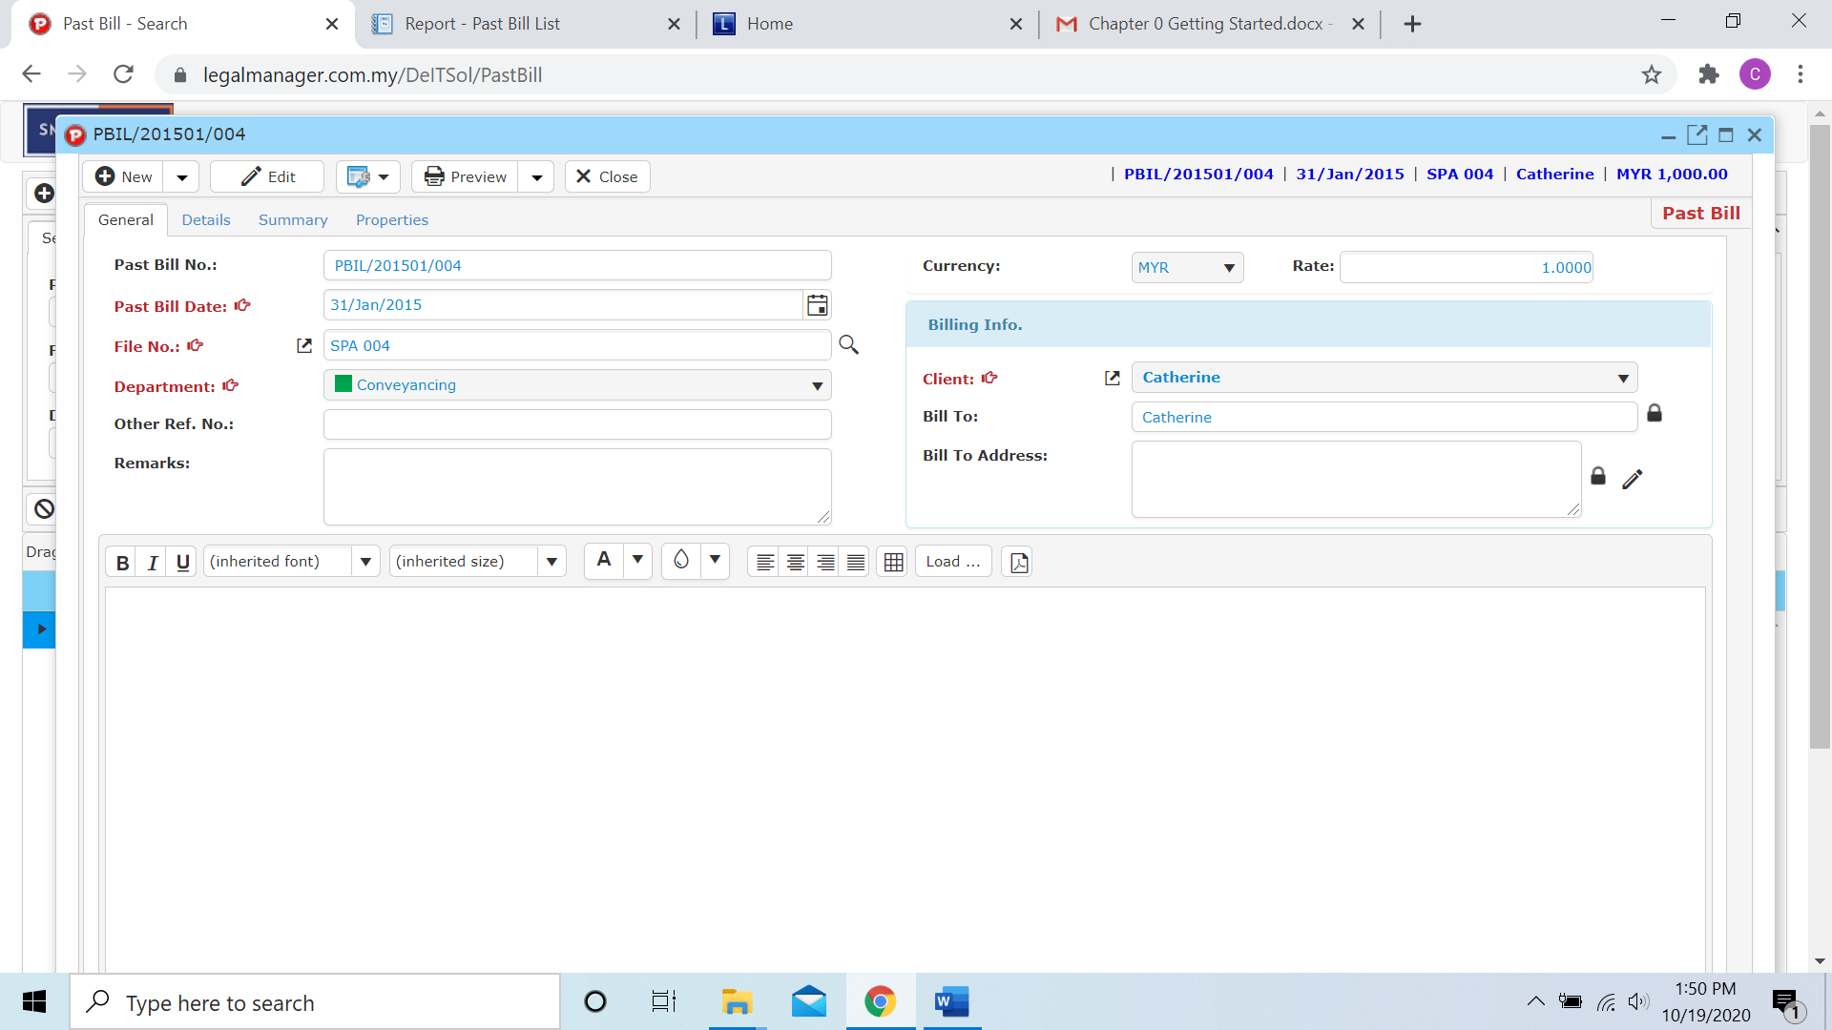

Figure: Manage Past Bill – Searched Result, Info